Veteran Health Identification Card (VHIC 4.8)

**User Guide**



Volume 2 - Reports

January 2018

Department of Veterans Affairs

Office of Information and Technology (OI&T)

Revision History

NOTE: The revision history cycle begins once changes or enhancements are requested after the document has been baselined.

|  |  |  |  |
| --- | --- | --- | --- |
| Date | Revision | Description | Author |
| 01/19/2018 | 2.1 | Re-paginated document. Readied document for creating Section 508 compliant PDF. | Donnie Canham |
| 01/02/2018 | 2.1 | Applied changes from first anomaly log dated 010418 as well as some additional internal anomalies identified by the VHIC Product Development Team. | Donnie Canham |
| 12/22/2017 | 2.1 | Updated Section 2.3 Proper Navigation of the VHIC Application with “Skip to Content” information. Updated document images to include “Skip to Content” link where necessary. Added new Section entitled “Card Destruction.” Updated Section 8.4 Auditing Report to include new functionality. Revised images where necessary to show the “Destruction” tab under the “Card” tab. Updated Appendix entitled “VHIC Roles.” | Donnie Canham |
| 08/14/2017 | 2.0 | Checked Alt text for all images and figures. Added Alt text to figures without it. Removed extra figure number from Figure 7-82 caption entitled, “On Hold Status Report query screen – Supervisor.” Re-ran TOCs and fixed content/figure pagination issues in the Word document. Document converted to Section 508 compliant PDF as part of VHIC 4.8. Updated document name to match VA naming conventions by replacing spaces in Word document name with underscores. | Donnie Canham |
| 08/01/2017 | 2.0 | Updated to reflect changes for VHIC 4.8 | Dawn Bryant, Donnie Canham |
| 08/15/2016 | 1.6 | Completed technical writer review of document. Ran Spelling and Grammar, added Alt text to all images, and re-ran TOCs. Created a footer and page numbering for document. Changed cover date from “August 2016” to match footer date of “September 2016” to match other Volumes. | Donnie Canham |
| 08/04/2016 | 1.6 | Updated content | Kristopher Todd |
| 01/06/2015 | 1.5 | Updated content and Images | Laja Geno |
| 07/07/2015 | 1.4 | Updated content and Images | Laja Geno |
| 07/07/2015 | 1.3 | Rebuilt to capture content overhaul to VHIC System and divided this guide into three separate parts | Laja Geno |
| 05/20/2015 | 1.2 | Updated Content and Images to reflect the Maintenance Releases | Laja Geno |
| 1/13/2015 | 1.1 | Updated content and Images | Laja Geno |
| 9/18/2014 | 1.0 | Rebuilt to capture content overhaul to VHIC System | Michele Custis |

**Table of Contents**

1. Introduction 1

1.1. Purpose 1

1.2. Document Orientation 1

1.2.1. Organization of the Manual 1

1.2.2. Assumptions 2

1.2.3. Disclaimers 2

1.2.3.1. Software Disclaimer 2

1.2.3.2. Documentation Disclaimer 2

1.2.4. Documentation Conventions 3

1.3. Enterprise Service Desk and Organizational Contacts 3

2. Veteran Health Identification Card – What is it? 4

2.1. Accessing the VHIC Application 4

2.2. Browser 4

2.2.1. Browser Incompatibility Issue 5

2.3. Proper Navigation of the VHIC Application 10

2.4. Roles within VHIC 11

2.4.1. VHIC Associate 11

2.4.2. VHIC Supervisor 12

2.4.3. VHIC Administrator 12

2.4.4. VHIC Technical Administrator (Tier 3) 12

2.4.5. VHIC Auditor 12

2.4.6. VHIC Read-Only User 12

3. Getting Started 13

3.1. Single Sign-On Internal (SSOi) 13

3.2. Logging On 13

3.3. System Menu 14

3.3.1. VHIC Administrator and Technical Administrator Tier 3 14

3.3.2. VHIC Associate and Supervisor 14

3.3.3. VHIC Auditor and Read-Only User 15

3.4. Changing User ID and Password 15

4. Before Requesting a VHIC Card 16

5. Creating a VHIC Card – The Card Request Process 16

6. Deactivating Cards – The Card Management Process 16

7. VHIC Reporting 17

7.1. Veteran (Direct Search) Report 21

7.2. Card Request Totals Report 27

7.3. Card Status Report 32

7.3.1. MVI (Master Veteran Index) Status Option 35

7.3.2. Card Status Option 40

7.3.3. Print Release Status Option 44

7.4. Multiple Card Requests Report 48

7.5. Card History Report 52

7.6. Card Replacement Report 57

7.7. Card Expiration Report 62

7.8. Card Request Progress Report 67

7.9. Card Swipe/Scan Report 72

7.10. Card On Hold Report 74

7.11. Card Destruction Report 81

7.12. Print Services – Processing Report 90

7.13. Print Services – Batch Error Report 95

7.13.1. Sent Not Acknowledged 97

7.13.2. Acknowledged Not Confirmed 102

7.13.3. Pending Not Sent 107

7.14. Auditing Report 112

7.15. Card Requests Report 113

8. Troubleshooting 119

Appendix A: VHIC Roles 120

Table of Figures

Figure 2‑1: Example of what the VHIC looks like 4

Figure 2‑2: Over-sized icon buttons on the Home Screen 5

Figure 2‑3: Words wrapping around the displayed photo on Step 3 5

Figure 2‑4: Content on the right of the Step 5 screen is shifted down 6

Figure 2‑5: Both the VISN and Facility selection lists are displayed and shifted to the right 7

Figure 2‑6: Internet Explorer's Toolbar Menu 8

Figure 2‑7: Tools Menu button 8

Figure 2‑8: Tools drop-down menu 9

Figure 2‑9: Compatibility View Settings screen 9

Figure 2‑10: Compatibility View Settings Screen - Close 10

Figure 2‑11: VHIC Navigation Buttons 10

Figure 2‑12: VHIC Administrator and VHIC Technical Administrator (Tier 3) menu 11

Figure 2‑13: VHIC Associate and VHIC Supervisor menu 11

Figure 2‑14: VHIC Auditor and VHIC Read-Only User menu 11

Figure 3‑1: SSOi Login Screen 13

Figure 3‑1: VHIC Administrator and VHIC Technical Administrator (Tier 3) Home screen 14

Figure 3‑3: VHIC Associate and VHIC Supervisor Home screen 15

Figure 3‑4: VHIC Auditor and VHIC Read-Only User Home screen 15

Figure 7‑1: Report Tabular Structure for the Administrator, Technical Administrator Tier 3 and the Auditor 18

Figure 7‑2: Report Tabular Structure for the Supervisor 19

Figure 7‑3: Report Tabular Structure for the Associate 20

Figure 7‑4: Report Tabular Structure for the Read-Only user 21

Figure 7‑5: Veteran Report Query Fields – Administrator, Tech Admin (Tier 3), Auditor and Supervisor 21

Figure 7‑6: Veteran Report Query Fields – Associate 22

Figure 7‑7: Veteran Report Query Fields – Read-Only User 22

Figure 7‑8: Veteran Report Search Results 23

Figure 7‑9: VHIC Veteran Detail Report 24

Figure 7‑10: VHIC Card History by Card ID 25

Figure 7‑11: VHIC Card History by Person ID 26

Figure 7‑12: Card Request Totals Report query screen – Administrators and Tech Admin (Tier 3) 27

Figure 7‑13: Card Request Totals Report query screen – Auditor 28

Figure 7‑14: Card Request Totals Report query screen – Supervisor 28

Figure 7‑15: Card Request Totals Report query screen – Associate 28

Figure 7‑16: Card Request Totals Report query screen – Read-Only User 29

Figure 7‑17: VHIC Card Request National Report 29

Figure 7‑18: VHIC Card Request Totals report – VISN 30

Figure 7‑19: VHIC Card Request Totals report – Facility 31

Figure 7‑20: Card Status Report query screen – Administrator and Tech Admin (Tier 3) 32

Figure 7‑21: Card Status Report query screen – Auditor 33

Figure 7‑22: Card Status Report query screen – Supervisor 33

Figure 7‑23: Card Status Report query screen – Associate 34

Figure 7‑24: Card Status Report query screen with MVI Status drop-down options displayed 35

Figure 7‑25: VHIC MVI Status National Summary Report – Active 36

Figure 7‑26: VHIC MVI Status VISN Summary Report – Active 37

Figure 7‑27: VHIC MVI Status Facility Summary Report – Active 38

Figure 7‑28: VHIC MVI Status Facility Detail Report – Active 39

Figure 7‑29: Card Status Report query screen with Card Status drop-down menu options displayed 40

Figure 7‑30: VHIC Card Status National Summary Report – Requested 41

Figure 7‑31: VHIC Card Status VISN Summary Report – Requested 42

Figure 7‑32: VHIC Card Status Facility Summary Report– Requested 43

Figure 7‑33: VHIC Card Status Facility Detail Report – Requested 44

Figure 7‑34: Card Status Report query screen with Print Release Status drop-down menu options displayed 45

Figure 7‑35: VHIC Print Status National Summary Report – Mailed 46

Figure 7‑36: VHIC Print Release Status Summary Report - VISN – Mailed 46

Figure 7‑37: VHIC Print Release Status Summary Report - Facility – Mailed 47

Figure 7‑38: VHIC Print Status Detail Report - Facility – Mailed 47

Figure 7‑39: Multiple Card Requests Report query screen – Administrator and Tech Admin (Tier 3) 48

Figure 7‑40: Multiple Card Requests Report query screen – Auditor 49

Figure 7‑41: Multiple Card Requests Report query screen – Supervisors 49

Figure 7‑42: Multiple Card Requests Report query screen – Associate 50

Figure 7‑43: VHIC National Summary Report for Number of Cards Requested 50

Figure 7‑44: VHIC VISN Summary Report for Number of Cards Requested 51

Figure 7‑45: VHIC Facility Summary Report for Number of Cards Requested 51

Figure 7‑46: VHIC Facility Detail Report for Number of Cards Requested 52

Figure 7‑47: Card History Report query screen – Administrators, Tech Administrator (Tier 3), and Auditors 53

Figure 7‑48: Card History Report query screen – Supervisor 53

Figure 7‑49: Card History Report query screen – Associate 53

Figure 7‑50: Card History Report query screen – Read-Only User 53

Figure 7‑51: VHIC Card History by Card ID Report 54

Figure 7‑52: Card History by Person ID Report 55

Figure 7‑53: Card History Report Status History 56

Figure 7‑54: VHIC Card Replacement Report query screen – Administrators and Tech Administrators (Tier 3) 57

Figure 7‑55: VHIC Card Replacement Report query screen – Auditors 58

Figure 7‑56: Card Replacement Report query screen – Supervisors 58

Figure 7‑57: VHIC Card Replacement Report query screen – Associates 59

Figure 7‑58: VHIC Card Replacement Summary Report – National 59

Figure 7‑59: VHIC Card Replacement Facility Report – Summary 60

Figure 7‑60: VHIC Card Replacement Facility Sub Reason Report – Summary 60

Figure 7‑61: VHIC Card Replacement Facility Sub Reason Detail report 61

Figure 7‑62: Card Expiration Report query screen – Administrators and Tech Administrators (Tier 3) 62

Figure 7‑63: Card Expiration Report query screen – Auditors 63

Figure 7‑64: Card Expiration Report query screen – Supervisors 63

Figure 7‑65: Card Expiration Report query screen – Associates 63

Figure 7‑66: VHIC Card Expiration National Summary Report 64

Figure 7‑67: VHIC Card Expiration VISN Summary Report 65

Figure 7‑68: VHIC Card Expiration Facility Summary Report 65

Figure 7‑69: VHIC Card Expiration Facility Detail Report 66

Figure 7‑70: Card Request Progress Report query screen - Administrators and Tech Administrators (Tier 3) 67

Figure 7‑71: Card Request Progress Report query screen – Auditors 68

Figure 7‑72: Card Request Progress Report query screen – Supervisors 68

Figure 7‑73: Card Request Progress Report query screen – Associates 69

Figure 7‑74: VHIC Card Request Progress National Summary Report 69

Figure 7‑75: VHIC Card Request Progress VISN Summary Report 70

Figure 7‑76: VHIC Card Request Progress Facility Summary Report 71

Figure 7‑77: VHIC Card Request Progress Facility Detail Report 72

Figure 7‑78: VHIC Card Swipe/Scan Report query screen - Administrators, Tech Administrators (Tier 3), and Auditors 72

Figure 7‑79: No Swipe/Scan data for the card ID entered message 73

Figure 7‑80: VHIC Card Swipe/Scan Report 73

Figure 7‑81: On Hold Status Report query screen – Administrator and Tech Administrator (Tier 3) 74

Figure 7‑82: On Hold Status Report query screen – Supervisor 75

Figure 7‑83: On Hold Status Report query screen – Associate 75

Figure 7‑84: VHIC On Hold Card Status National Summary Report 76

Figure 7‑85: VHIC On Hold Card Status VISN Summary Report 76

Figure 7‑86: VHIC On Hold Card Status Facility Summary Report 77

Figure 7‑87: VHIC On Hold Card Status Facility Detail Report 78

Figure 7‑88: VHIC Veteran Detail Report 79

Figure 7‑89: VHIC Card History by Card ID 80

Figure 7‑90: Card Destruction Report – Administrators and Tech Administrators (Tier 3) 81

Figure 7‑91: Card Destruction Report – Auditors 81

Figure 7‑92: Card Destruction Report – Pending Destruction – Last Name Hyperlink 82

Figure 7‑93: Veteran Detail Report 83

Figure 7‑94: Card Destruction Report – Pending Destruction – Last Name Hyperlink 84

Figure 7‑95: VHIC Card History by Card ID Report 85

Figure 7‑96: VHIC Card History by Card ID Report 86

Figure 7‑97: Veteran Detail Report 87

Figure 7‑98: VHIC Card Destruction Report - Destroyed - Card ID Hyperlink 88

Figure 7‑99: VHIC Card History by Card ID Report 89

Figure 7‑100: VHIC Print Services Processing Status Summary Report – Administrators and Tech Administrators (Tier 3) 90

Figure 7‑101: VHIC Print Services Processing Status Summary Report – Auditors 91

Figure 7‑102: VHIC Print Services Processing Status Summary Report – Supervisors 91

Figure 7‑103: VHIC Print Services Processing Status Summary Report query screen – Associates 91

Figure 7‑104: VHIC Print Services Processing Status Summary Report 92

Figure 7‑105: VHIC Print Services Processing Status VISN Summary Report 93

Figure 7‑106: VHIC Print Services Processing Status Facility Summary Report 93

Figure 7‑107: VHIC Print Services Processing Status Facility Detail Report 94

Figure 7‑108: Print Services – Print Error Status Report query screen – Administrators and Tech Administrators (Tier 3) 95

Figure 7‑109: Print Services - Print Error Status Report query screen – Auditors 96

Figure 7‑110: Print Services - Print Error Status Report query screen – Supervisors 96

Figure 7‑111: VHIC Print Error Status Facility Summary Report – Sent Not Acknowledged 97

Figure 7‑112: VHIC Print Error Status National Summary Report – Sent Not Acknowledged 98

Figure 7‑113: VHIC Print Error Status VISN Summary Report – Sent Not Acknowledged 99

Figure 7‑114: VHIC Print Error Status Facility Summary Report – Sent Not Acknowledged 100

Figure 7‑115: VHIC Batch File Processing Error Status Detail Report - Not Acknowledged 101

Figure 7‑116: VHIC Print Error Status Facility Detail Report – Acknowledged Not Confirmed 102

Figure 7‑117: VHIC Print Error Status National Summary Report – Acknowledged Not Confirmed 103

Figure 7‑118: VHIC Print Error Status VISN Summary Report – Acknowledged Not Confirmed 104

Figure 7‑119: VHIC Print Error Status Facility Detail Report – Acknowledged Not Confirmed 105

Figure 7‑120: VHIC Print Error Status Facility Detail Report – Acknowledged Not Confirmed 106

Figure 7‑121: VHIC Print Error Status National Summary Report – Pending Not Sent 107

Figure 7‑122: VHIC Print Error Status National Summary Report – Pending Not Sent 108

Figure 7‑123: VHIC Print Error Status VISN Summary Report – Pending Not Sent 109

Figure 7‑124: VHIC Batch File Processing Error Status Summary Report – Facility 110

Figure 7‑125: VHIC Print Error Status Facility Detail Report – Pending Not Sent 111

Figure 7‑126: Audit Report query screen – Administrators, Tech Administrators (Tier 3), and Auditors 112

Figure 7‑127: Audit Report query screen – Supervisors 112

Figure 7‑128: VHIC Auditing Report 113

Figure 7‑129: Card Requests query screen – Administrators, Tech Administrators (Tier 3), and Auditors 114

Figure 7‑130: Card Requests query screen – Supervisors 114

Figure 7‑131: VHIC Card Requests by User Summary Report – National 115

Figure 7‑132: VHIC Card Requests by User VISN Summary Report 115

Figure 7‑133: VHIC Card Requests by User Facility Summary Report 116

Figure 7‑134: VHIC Card Requests by User Detail Report – Last Name Hyperlink 116

Figure 7‑135: Veteran Detail Report 117

Figure 7‑136: VHIC Card Requests by User Detail Report – Card ID Hyperlink 118

Figure 7‑137: VHIC Card History by Card ID Reportk 119

Table of Tables

Table 1 Documentation Symbols and Descriptions 3

Table 2: Enterprise Service Desk Contact Information 3

Table 4: Veteran Report at a Glance 21

Table 5: Card Request Totals Report at a Glance 27

Table 6: Card Status Report at a Glance 32

Table 7: Multiple Request Report at a Glance 48

Table 8: Card History Report at a Glance 52

Table 9: Card Replacement Report at a Glance 57

Table 10: Card Expiration Report at a Glance 62

Table 11: Card Request Progress Report at a Glance 67

Table 12: Card Swipe/Scan Report at a Glance 72

Table 13: On Hold Status Report at a Glance 74

Table 13: Card Destruction Report at a Glance 81

Table 14: Batch Summary Report at a Glance 90

Table 15: Batch Error Report at a Glance 95

Table 16: Audit Report at a Glance 112

Table 17: Card Request Report at a Glance 113

# Introduction

## Purpose

The purpose of this User Guide is to provide general system information, as well accessibility and user roles with the VHIC application. This User Guide will provide a detailed walkthrough of creating Veteran Health Identification Card requests using the VHIC application. This User Guide will also provide the detailed steps on how VHIC Administrators can deactivate all of the VHICs associated to a selected Veteran.

## Document Orientation

### Organization of the Manual

This User Guide is divided into eight sections to allow you to quickly obtain the information you need.

The first section will provide an overview of what a VHIC is and what the eligibility requirements are, and the various user roles and their accessibility within the VHIC application.

In order to be able to receive a VHIC, a Veteran must meet the following eligibility criteria:

* Be eligible for VA medical benefits
* Be enrolled in the VA Healthcare system
* Be Level 2 proofed at a VA medical facility
* Veteran identity must be recognized in the Master Veteran Index (MVI), which is managed by the Identity and Access Management (IAM) of the VA

***NOTE:*** *The level 2 proofing process is a method to verify the identity of Veterans. VA requires Veterans to provide approved identification documents to access Personal Identifiable Information (PII), Personal Health Information (PHI) and request a Veterans Health Identification Card (VHIC).*

The second and third sections will walk the user through the steps needed to access the VHIC application, as well as some general guidelines on using the VHIC application.

The fourth section will give the user an overview of what they need to do before starting a card request for a Veteran. The VHIC user must verify the Veteran’s Identity Proofing Level is at Level 2 in the Identity Management Toolkit.

The fifth section explains the process involved with creating a VHIC for a Veteran.

The sixth section covers how to request card deactivation all of the VHICs for a specific Veteran.

The seventh section will provide information on the different reports available to VHIC Associates and the types of metrics that can be obtained. There are four tabs for each of the reports that can be generated:

* **Veteran** – direct report to search for a Veteran
* **Card** – includes Request Totals, Status, Multiple Requests, History, Replacement, Expiration, Request Progress, Swipe/Scan, and On Hold
* **Print** **Services** – includes Processing, No Member ID, and Error
* **Auditing** – provides information on all User’s activity in the system

Reports can be exported in PDF format, and there are a variety of search criteria available for each report.

The last section covers some troubleshooting issues and solutions that will help the VHIC user to be better able to support the Veteran and ensure that the VHIC requests are processed properly.

### Assumptions

This guide was written with the following assumed experience/skills of the audience:

* User has basic knowledge of the operating system (such as the use of commands, menu options, and navigation tools).
* User has been provided the appropriate active roles, menus, and security keys required for the VHIC application.
* User is using Internet Explorer to do their job of either Creating VHIC Card Requests, Running Reports, or Deactivating VHICs depending on user roles.
* User has validated access to the VHIC application.
* User has completed any prerequisite training.

### Disclaimers

#### Software Disclaimer

*This software was developed at the Department of Veterans Affairs (VA) by employees of the Federal Government in the course of their official duties. Pursuant to title 17 Section 105 of the United States Code this software is not subject to copyright protection and is in the public domain. VA assumes no responsibility whatsoever for its use by other parties, and makes no guarantees, expressed or implied, about its quality, reliability, or any other characteristic. We would appreciate acknowledgement if the software is used. This software can be redistributed and/or modified freely provided that any derivative works bear some notice that they are derived from it, and any modified versions bear some notice that they have been modified.*

#### Documentation Disclaimer

*The appearance of external hyperlink references in this manual does not constitute endorsement by the Department of Veterans Affairs (VA) of this Web site or the information, products, or services contained therein. The VA does not exercise any editorial control over the information you may find at these locations. Such links are provided and are consistent with the stated purpose of the VA.*

### Documentation Conventions

This manual uses several methods to highlight different aspects of the material.

* Various symbols are used throughout the documentation to alert the reader to special information. The following table gives a description of each of these symbols:

Table 1 Documentation Symbols and Descriptions

| **Symbol** | **Description** |
| --- | --- |
| Symbol for additional information (letter "i") inside a circle. | **NOTE:** Used to inform the reader of general information including references to additional reading material |

* Descriptive text is presented in a proportional font (as represented by this font).
* “Screenshots” of computer online displays (i.e., character-based screen captures/dialogs) and are shown in a non-proportional font and enclosed within a box. Also included are Graphical User Interface (GUI) Microsoft Windows images (i.e., dialogs or forms).
* User's responses to online prompts (e.g., manual entry, taps, clicks, etc.) will be **[boldface]** type and enclosed in brackets.

## Enterprise Service Desk and Organizational Contacts

The support contact information documented herein are intended to restore normal service operation as quickly as possible and minimize the adverse impact on business operations, ensuring that the best possible levels of service quality and availability are maintained.

The following table lists the contact information needed by site users for troubleshooting purposes. Support contacts are listed by description of the incident escalation, and contact information (phone number and options to select).

Table 2: Enterprise Service Desk Contact Information

| **Issue** | **Contact Info** |
| --- | --- |
| For Provisioning Issues | Contact the Enterprise Service Desk at (855) 673-4357, option 3 (Applications), then option 1.  When contacted by a support specialist, be ready to supply the employee’s full name, VA user ID and email address. |
| For Proofing Issues | Contact the Enterprise Service Desk at (855) 673-4357, option 3 (Applications), then option 1.  When contacted by a support specialist, be ready to supply the Veterans' full name, full SSN, and DOB. |
| For All Other VHIC System Issues | Contact the Enterprise Service Desk at (855) 673-4357, option 3 (Applications), then option 1. When contacted by a support specialist, be ready to supply the Veterans' full name, full SSN, and DOB. |

# Veteran Health Identification Card – What is it?

The VHIC serves as an identification mechanism for Veterans that are enrolled in the VA Healthcare system and supports efficiencies at VA medical facilities throughout the United States. Although not required by Veterans to receive medical care at a VA facility, it does enable Veterans to check in for VA appointments more quickly. The VHIC system is a web-based application that VHIC associates use to issue VHICs to enrolled Veterans.

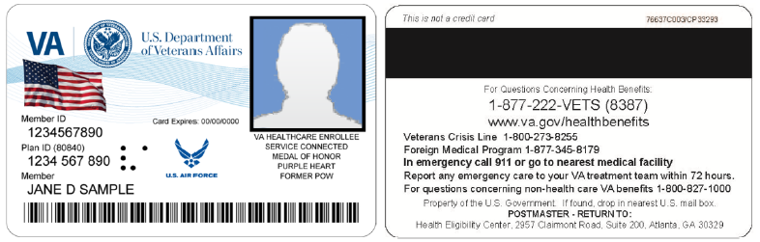

Figure ‑: Example of what the VHIC looks like

## Accessing the VHIC Application

VHIC is a web based application which users will access via a web browser. The recommended browser is Internet Explorer (currently version 11). The VHIC URL is <https://vic.iam.va.gov/VIC/faces/index.jsf> and is **case sensitive** – it must be entered exactly as shown. After successfully logging in to the VHIC application, users should bookmark this site for easy access in the future. Instructions on how to do just that can be found here: <http://windows.microsoft.com/en-us/internet-explorer/add-view-organize-favorites#ie=ie-11-win-7>.

The best time to bookmark the site is after the user is in the application itself rather than attempting to bookmark the Login screen.

## Browser

Once users are logged into their VA desktop, they will access VHIC using Internet Explorer (IE) by either entering the URL listed above or via the bookmark saved during an earlier session. Please do **NOT** use the *Refresh* button at the top of your browser window if you mistype the VHIC URL. The *Refresh* button will redirect you to the VA website. Please re-enter the VHIC URL and try again.

### Browser Incompatibility Issue

In some instances, users may experience image misplacement or misalignment. This is most likely due to the current browser compatibility settings. You will want to ensure that the browser is not set to Compatibility View.

Examples of Image Misplacement and Other Misalignments:

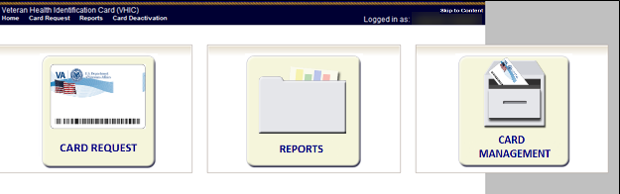

Figure ‑: Over-sized icon buttons on the Home Screen

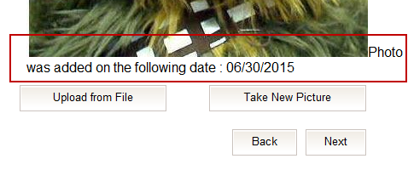

Figure ‑: Words wrapping around the displayed photo on Step 3

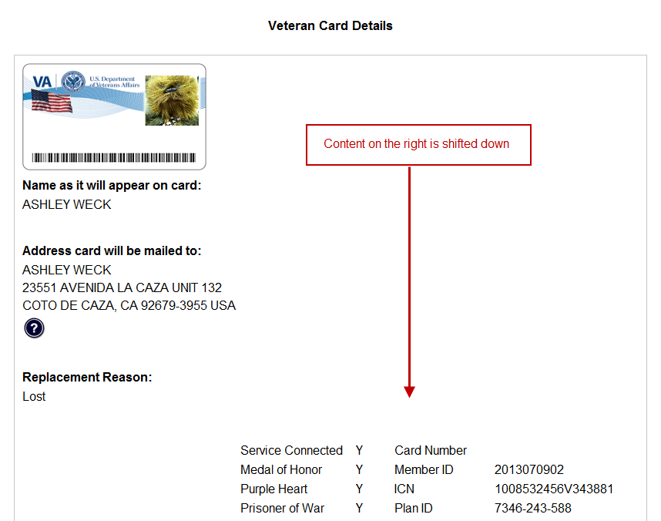

Figure ‑: Content on the right of the Step 5 screen is shifted down

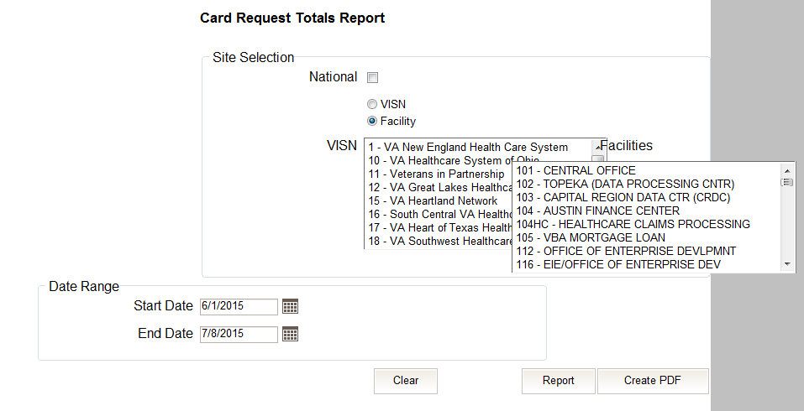

Figure ‑: Both the VISN and Facility selection lists are displayed and shifted to the right

If you are experiencing misalignment issues, follow these steps to verify/update your browser compatibility settings:

1. With Internet Explorer open, right click in the blue area at the top of the browser window.
2. Click on Command Bar to display the Command Tool Bar.

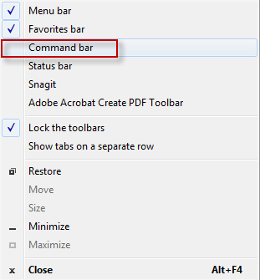

Figure ‑: Internet Explorer's Toolbar Menu

1. Click on the Tools menu button.



Figure ‑: Tools Menu button

1. Click on Compatibility View Settings.

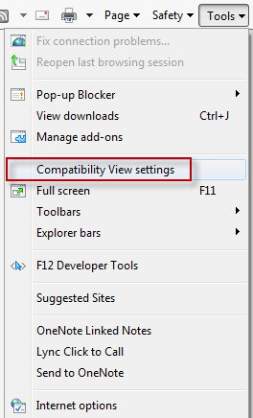

Figure ‑: Tools drop-down menu

1. Uncheck the box next to Display intranet sites in Compatibility View.

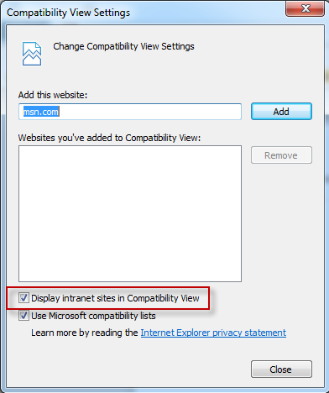

Figure ‑: Compatibility View Settings screen

1. Click the Close button.

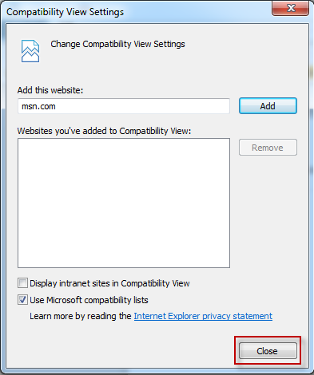

Figure ‑: Compatibility View Settings Screen - Close

*****NOTE:*** *Compatibility mode does need to be turned on in order to access other applications such as Notes in NUMI’s CERMe and the Beneficiary Travel Dashboard. You can turn compatibility mode back on by following the above directions and checking the Display intranet sites in Compatibility View checkbox*.

## Proper Navigation of the VHIC Application

The correct way to navigate through the VHIC application is to use the *Back* and *Next* buttons that are located at the bottom of each screen instead of using the Browser’s built in Back button. Please do **NOT** use the *Back* button at the top of your browser window to navigate back to a previous screen; this will cause errors to occur.



Figure ‑: VHIC Navigation Buttons

The VHIC user can also navigate to the different features within the VHIC application by clicking on one of the navigation links located in the header near the top left of the screen. The user’s assigned role will determine which links are available as seen below. To see the full home screens for each user role, refer to the 3.2 System Menu section.



Figure ‑: VHIC Administrator and VHIC Technical Administrator (Tier 3) menu



Figure ‑: VHIC Associate and VHIC Supervisor menu



Figure ‑: VHIC Auditor and VHIC Read-Only User menu

**NOTE:** The “Skip To Content” link is a Section 508 compliance feature that skips repetitive navigation links so that page content can be quickly accessed.

## Roles within VHIC

The VHIC application is built to accommodate a specific set of pre-established user roles. During the provisioning process, the VHIC user will have a role assigned to them, which will determine what aspects of the VHIC application are available to them. The following breaks down the specific roles and the areas of access that accompany each role.

If, while utilizing the VHIC application, a user finds they do not have access to items they feel they should have access to or find that they have access to items they should not, based on the definitions listed below, the VHIC user should report this information to their VHIC Supervisor. The VHIC Supervisor should then verify that the proper role has been assigned.

### VHIC Associate

The VHIC Associate role shall be assigned to individuals responsible for processing card requests and resolving card request issues. Associates have the ability to create card requests and have access to a limited number of reports.

### VHIC Supervisor

The VHIC Supervisor shall automatically inherit all access and privileges given to the VHIC Associate. The VHIC Supervisor role is allowed to submit a request for user access to the VHIC application. VHIC Supervisors have the ability to create card requests and have access to most available reports (excluding national versions).

### VHIC Administrator

The VHIC Administrator role is reserved for the VHIC Business (HEC) team members responsible for the creation and maintenance of all other VHIC accounts/roles. The VHIC Administrator shall automatically inherit privileges given to the VHIC Supervisor. Administrators have the ability to create card requests, deactivate cards, and have access to all available reports.

### VHIC Technical Administrator (Tier 3)

The VHIC Technical Administrator (Tier 3) automatically inherits all access and privileges given to the VHIC Administrator. Technical Administrators (Tier 3) have the ability to create card requests and have access to all available reports as well as access to the Administration page.

### VHIC Auditor

The VHIC Auditor role shall be assigned to users with read-only access to the VHIC System. The VHIC Auditor does not have the ability to create card requests, but does have access to all available reports.

### VHIC Read-Only User

The VHIC Read-Only User role shall be assigned to users with read-only access to the VHIC System. The VHIC Read-Only user does not have the ability to create card requests, but does have access to a limited number of reports.

# Getting Started

## Single Sign-On Internal (SSOi)

Once users are logged into their VA desktop, they will access VHIC using Internet Explorer (IE) by either entering the URL listed above or via the bookmark saved during an earlier session.

Users will be presented with the Single Sign On – internal (SSOi) login screen (*shown below*).

Here the VHIC user will need to use their PIV card to log into the VHIC application.

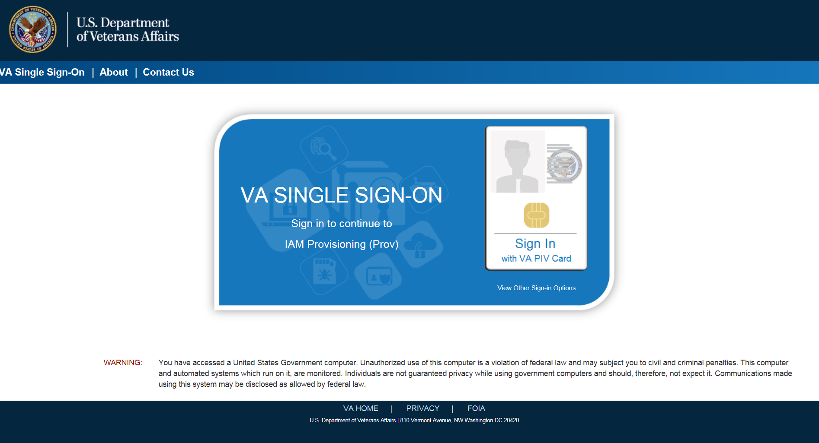

Figure ‑: SSOi Login Screen

## Logging On

The VHIC application is built to accommodate a specific set of pre-established user roles. During the provisioning process, the VHIC user will have a role assigned to them, which will determine what aspects of the VHIC application are available to them. The roles are listed below. For more information on the areas of access that accompanies each role, please refer to section 2.4.

* VHIC Associate
* VHIC Supervisor
* VHIC Administrator
* VHIC Technical Administrator (Tier 3)
* VHIC Auditor
* VHIC Read-Only User

## System Menu

Depending on the VHIC users’ role, they will be presented different Home screens upon logging to the VHIC application.

### VHIC Administrator and Technical Administrator Tier 3

The VHIC Administrator and VHIC Technical Administrator Tier 3 users will be presented with three menu options: Card Requests, Reports and Card Deactivation. They can navigate to each of these application modules by either clicking on one of the links located in the header at the top left of the screen or by clicking on one of the icon buttons in the middle of the screen.

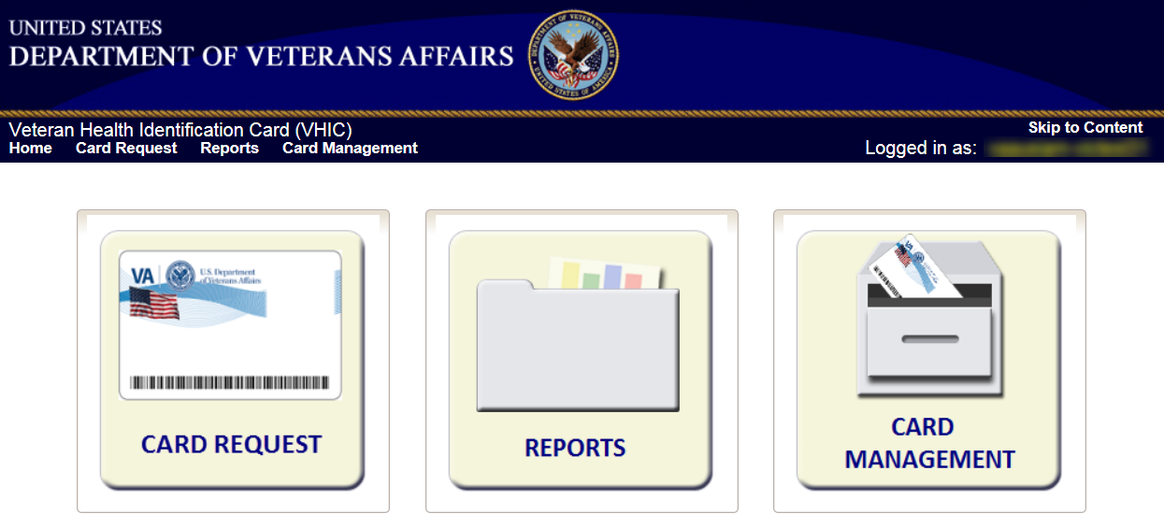

Figure ‑: VHIC Administrator and VHIC Technical Administrator (Tier 3) Home screen

### VHIC Associate and Supervisor

The VHIC Associate and VHIC Supervisor users will be presented with two menu options: Card Requests and Reports. They can navigate to each of these application modules by either clicking on one of the links located in the header at the top left of the screen or by clicking on one of the icon buttons in the middle of the screen.

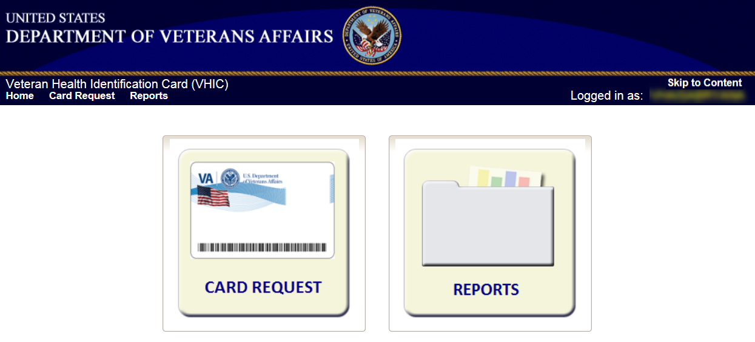

Figure ‑: VHIC Associate and VHIC Supervisor Home screen

### VHIC Auditor and Read-Only User

The VHIC Auditor and VHIC Read-Only users will be presented with the Reports menu option. They can navigate to Reports by clicking on the icon button in the middle of the screen.

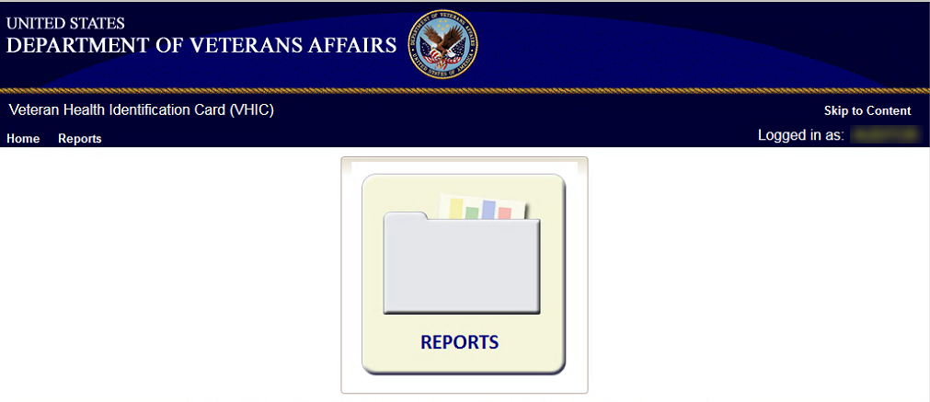

Figure ‑: VHIC Auditor and VHIC Read-Only User Home screen

## Changing User ID and Password

If you have any questions or need help with your User ID or your Password; Contact the Enterprise Service Desk at (855) 673-4357, option 1 (Account or Password Reset), then option 1.

# Before Requesting a VHIC Card

For detailed step-by-step process of how to access and complete the Identity Proofing Verification task in the Identity Management Toolkit application, please refer to section 4 in the **Veteran Health Identification Card (VHIC 4.8) User Guide - Volume 1 - Card Requests** **– All Users** document.

# Creating a VHIC Card – The Card Request Process

For a step-by-step process on how to navigate through the Card Request screens in the VHIC application and an explanation of the process involved in creating a VHIC for a Veteran, please refer to section 5 in the **Veteran Health Identification Card (VHIC 4.8) User Guide - Volume 1 - Card Requests** **– All Users** document.

# Deactivating Cards – The Card Management Process

For detailed information that will help the VHIC Administrator navigate through the card deactivation screens in the VHIC application that will allow them to deactivate all of the VHICs for a specific Veteran, please refer to section 6 in the **Veteran Health Identification Card (VHIC 4.8) User Guide - Volume 3 - Card Management - Admins** document.

# VHIC Reporting

The VHIC application offers a variety of reporting options divided into four main reporting tabs. Certain tabs may contain sub-tabs. Not all VHIC user roles have access to all reports, or all of the available functionality of certain reports (*i.e., national option or multi-select option*).

The **National search option** returns results, which includes every available VISN and Facility. This option, triggered by selecting the **National** checkbox, is only available to those user roles with authorization to use this feature. Since the results returned consist of all VISNs/Facilities, checking the **National** checkbox removes any available VISN and/or Facility options.

The ability to **Multi-select** is available on certain reports that have VISN and/or Facility selection criteria and is available to Administrators, and Tech Admin (Tier 3) roles. This feature works by holding down the **[Control]** button (Ctrl) on the keyboard and single clicking on each desired list items.

All reports, with the exception of the Veteran Detail report, give the user the option to select either **[Report]** or **[Create PDF]** once they have entered their search criteria. Clicking the **[Report]** button will generate the query results in a new tab. This allows the user to return to the original query tab in order to modify their search criteria if needed. Keep in mind, while date ranges may be generous, results are limited to 3000 lines.

The user selects the desired reporting option by clicking on the appropriate tab or sub-tab. A tab highlighted in blue, lets the user know which report they are viewing. Once they select a report, the user will need to provide certain search criteria based on the specific requirements of the report selected.

Some reports contain **Hyperlinks**. Clicking the hyperlinks (indicated by blue font) allow the VHIC user to access more detailed information. For instance, if the user wants to keep the **Summary** **Report** for a VISN open while reviewing the **Detail** **Report** for a specific Facility, they can hold down the **[Control]** button (Ctrl) on the keyboard while clicking on the hyperlink for the Facility they wish to view. This opens the **Facility** **Detail** **Report** in another browser window allowing the user to view both reports and have the ability to select another Facility in which to view.

The following graphic represents the VHIC tabular report structure for the Administrator, Technical Administrator Tier 3 and the Auditor:

Figure ‑: Report Tabular Structure for the Administrator, Technical Administrator Tier 3 and the Auditor

The following graphic represents the VHIC tabular report structure for the Supervisor user:

Figure ‑: Report Tabular Structure for the Supervisor

The following graphic represents the VHIC tabular report structure for the Associate user:

Figure ‑: Report Tabular Structure for the Associate

The following graphic represents the VHIC tabular report structure for the Read-Only user:

Figure ‑: Report Tabular Structure for the Read-Only user

## Veteran (Direct Search) Report

Table 4: Veteran Report at a Glance

| **At a Glance…** |  |
| --- | --- |
| Who can access this report? | *Administrator, Supervisor, Associate, Tech Admin (Tier 3), Auditor, Read-Only* |
| Who can access National version? | *N/A* |
| Date Range Allowed | *N/A* |
| Search Criteria Available | *Last Name, First Name, Date of Birth, Last four of SSN, ICN, Member ID, Card ID, Person ID* |

The *Veteran Report* (*a.k.a. Direct Search or Veteran Detail Report*) is the first report query screen presented to the VHIC user when accessing the reporting section of VHIC. This report provides a comprehensive overview of all of the information the VHIC application has on a particular Veteran, including their photo.

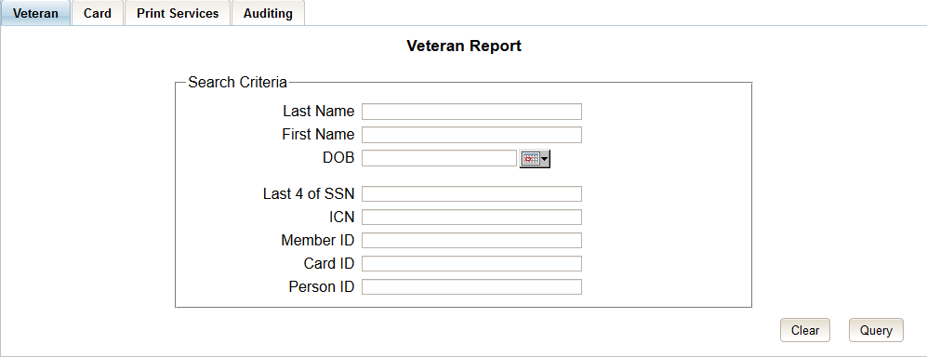

Figure ‑: Veteran Report Query Fields – Administrator, Tech Admin (Tier 3), Auditor and Supervisor

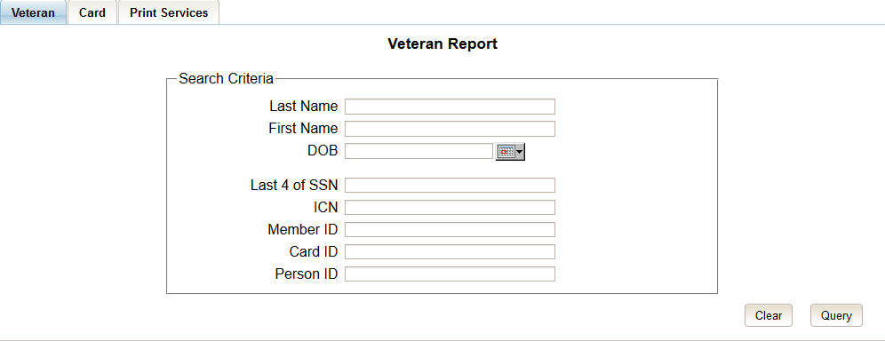

Figure ‑: Veteran Report Query Fields – Associate

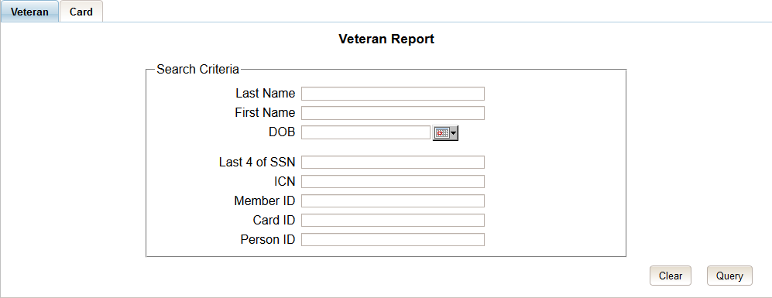

Figure ‑: Veteran Report Query Fields – Read-Only User

After entering the appropriate search traits and clicking the [Query] button, a screen will appear with a summary listing of potential matches.

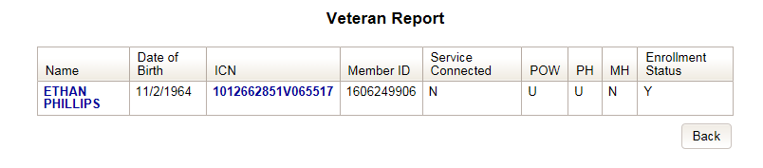

Figure ‑: Veteran Report Search Results

The query result displays a summary view of Veteran information consisting of:

* Name
  + Hyperlink to the detailed Veteran Report
* Date of Birth
* ICN
  + Hyperlink to the Veteran Detail Report
* Member ID
* Service Connected
* POW – Prisoner of War
* PH – Purple Heart
* MH – Medal of Honor
* Enrollment Status

Clicking on the *Veteran’s* name, or on their *ICN*, displays a comprehensive level of this report, a.k.a. the “VHIC Veteran Detail Report.”

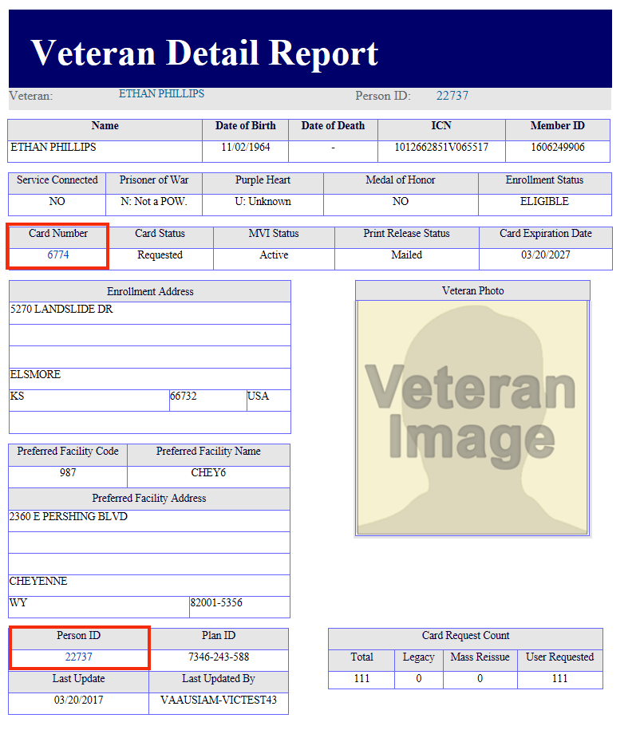

Figure ‑: VHIC Veteran Detail Report

The “VHIC Veteran Report” contains a hyperlink in the “Card Number” area. Clicking this hyperlink takes the user to the “VHIC Card History” by **Card ID** report. This user guide covers Card History Reports in section 7.5.

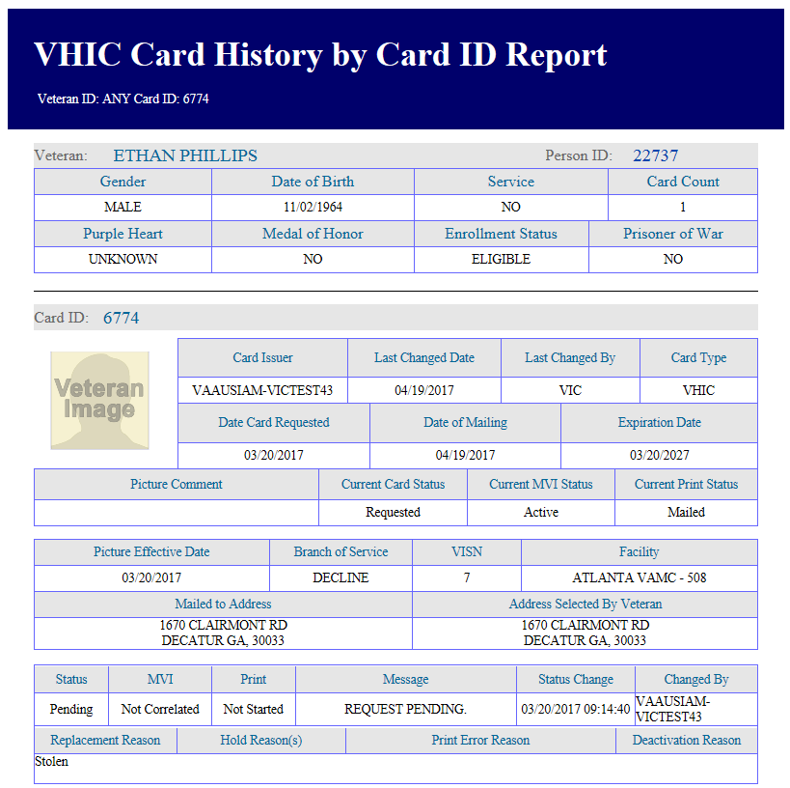

Figure ‑: VHIC Card History by Card ID

The “VHIC Veteran Detail Report” also contains a hyperlink in the “Person ID” area. Clicking this hyperlink takes the user to the “VHIC Card History” by **Person ID** report. This user guide covers Card History Reports in section 7.5.

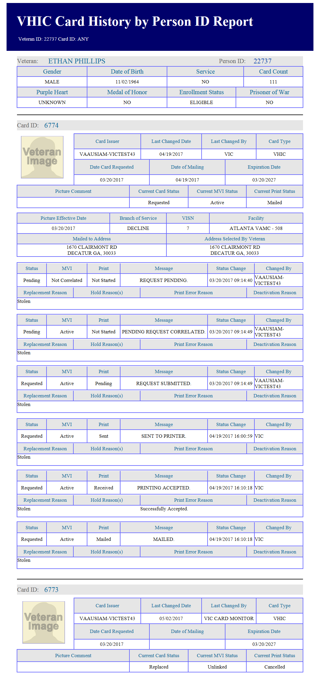

Figure ‑: VHIC Card History by Person ID

## Card Request Totals Report

Table 5: Card Request Totals Report at a Glance

| **At a Glance…** |  |
| --- | --- |
| Who can access this report? | *Administrator, Supervisor, Associate, Tech Admin (Tier 3), Auditor, Read-Only* |
| Who can access National version? | *Administrator, Tech Admin (Tier 3), Auditor* |
| Date Range Allowed | *Admins, Tech Admin (Tier 3), Auditor – unlimited*  *Supervisor, Associate, Read-Only – one (1) year or less from date report is being run* |
| Search Criteria Available (*may vary by role*) | *VISN, Facility, Start Date, End Date* |

The Card Request Totals Report gives the user exactly that – the total card requests by selected VISN and/or Facility, in a tabular format. Selecting the National checkbox, if available, returns results for all VISNs and Facilities. Selecting either the VISN or the Facility radio button will update the list of available options accordingly (based on a user’s role).

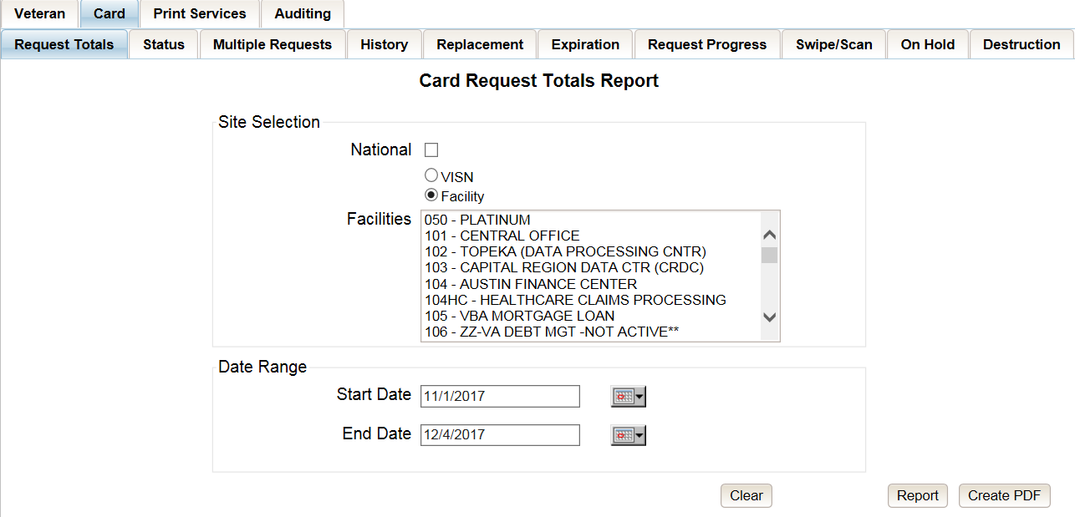

Figure ‑: Card Request Totals Report query screen – Administrators and Tech Admin (Tier 3)

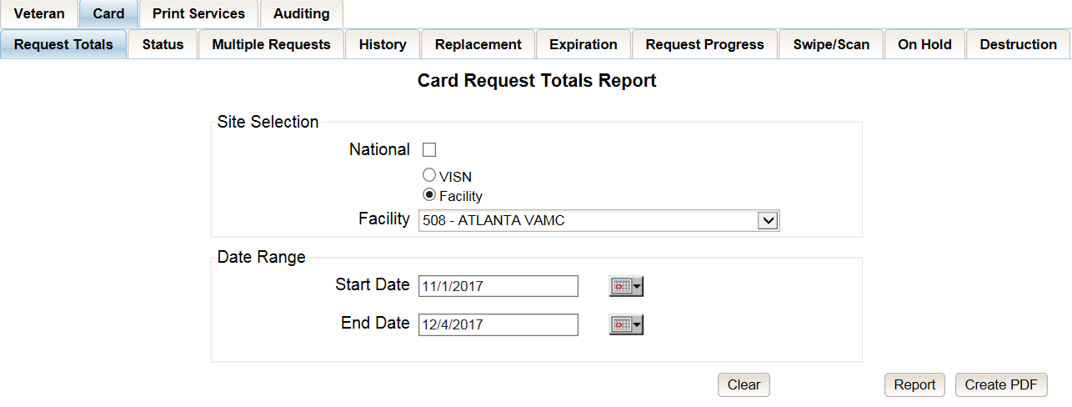

Figure ‑: Card Request Totals Report query screen – Auditor

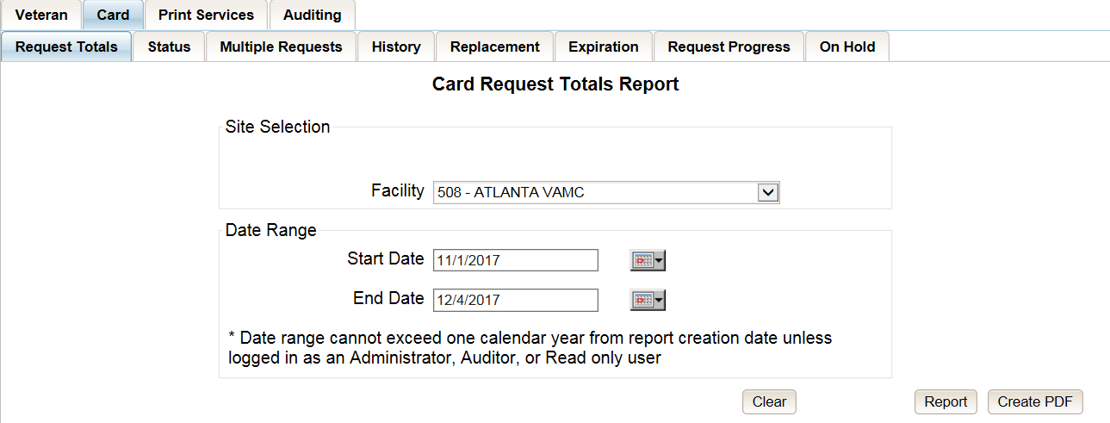

Figure ‑: Card Request Totals Report query screen – Supervisor

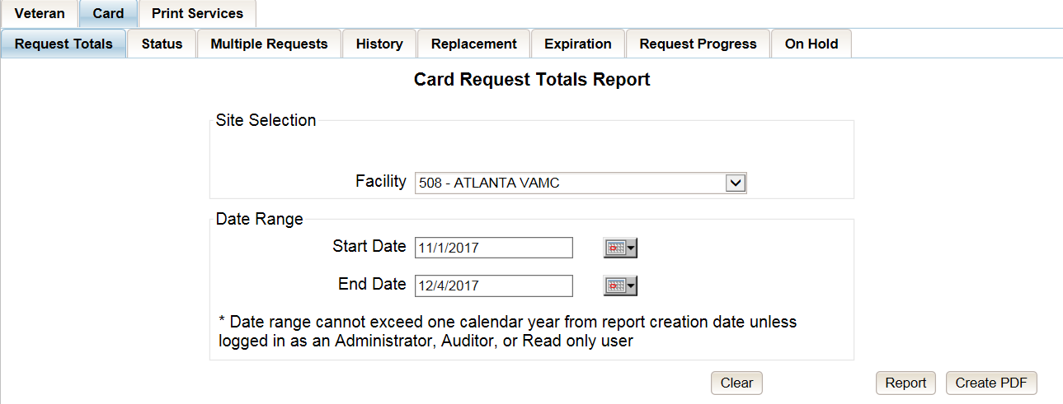

Figure ‑: Card Request Totals Report query screen – Associate

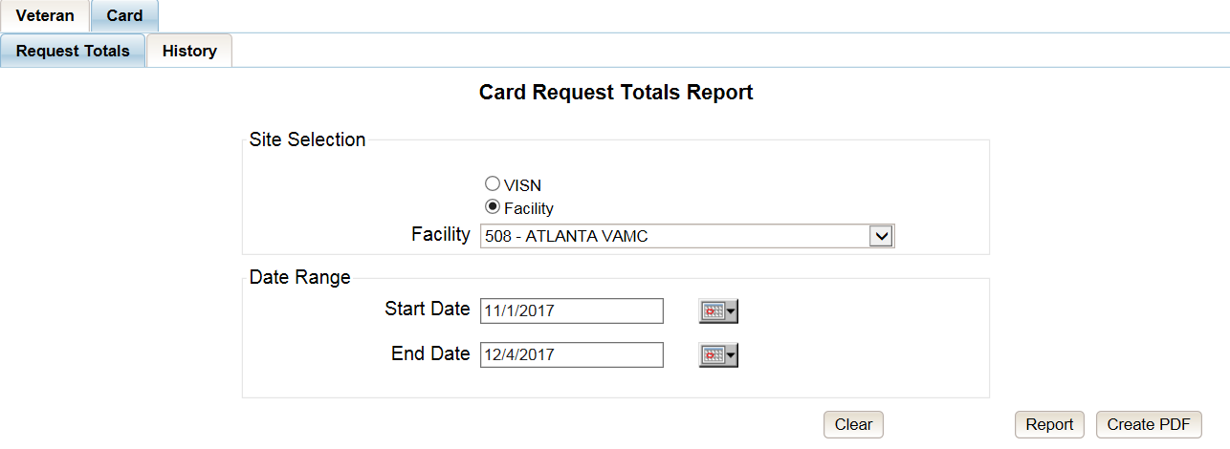

Figure ‑: Card Request Totals Report query screen – Read-Only User

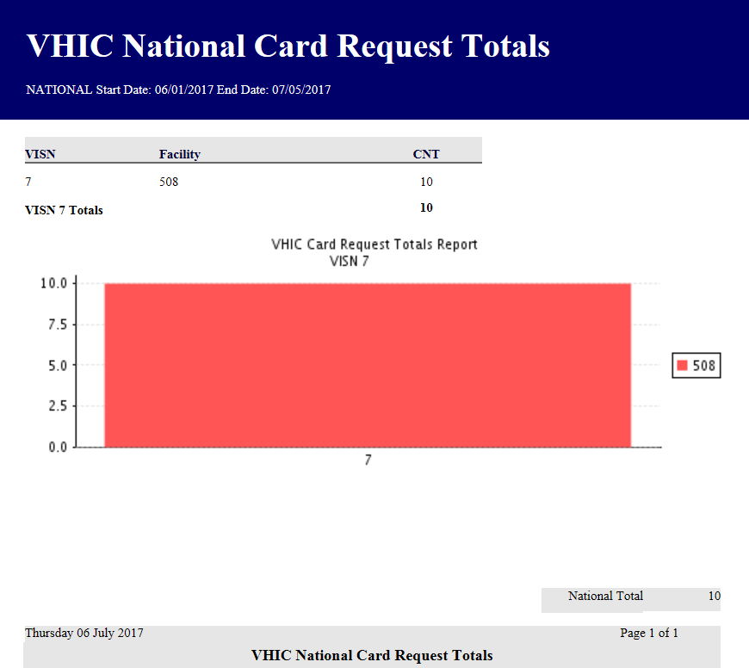

Figure ‑: VHIC Card Request National Report

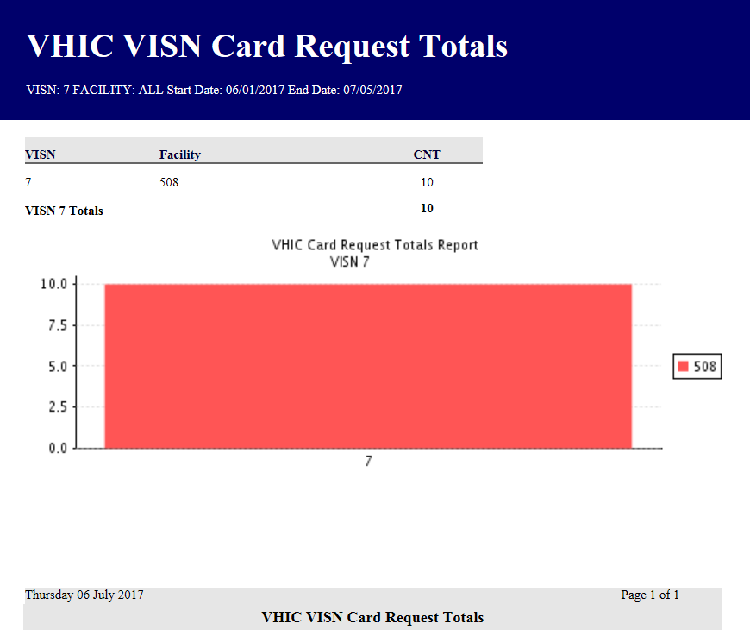

Figure ‑: VHIC Card Request Totals report – VISN

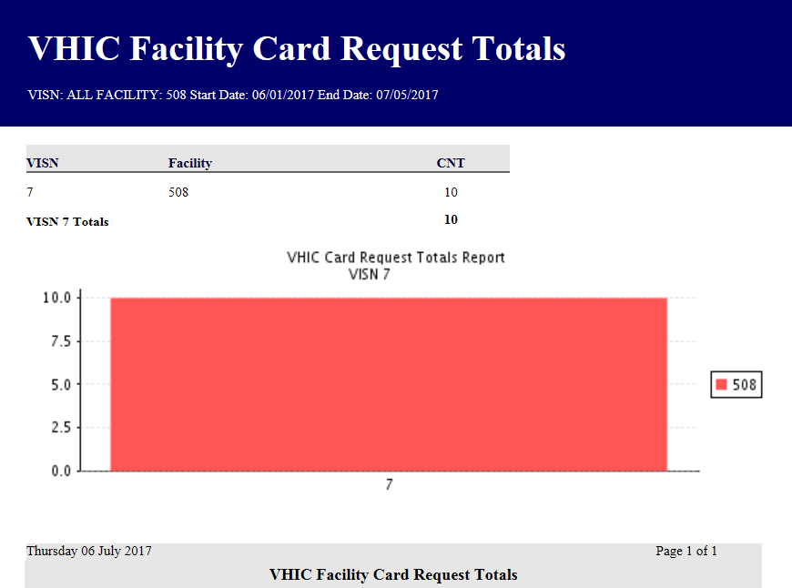

Figure ‑: VHIC Card Request Totals report – Facility

## Card Status Report

Table 6: Card Status Report at a Glance

| **At a Glance…** |  |
| --- | --- |
| Who can access this report? | *Administrator, Supervisor, Associate, Tech Admin (Tier 3), Auditor* |
| Who can access National version? | *Administrator, Tech Admin (Tier 3), Auditor* |
| Date Range Allowed | *Admins, Tech Admin (Tier 3), Auditor – unlimited*  *Supervisor, Associate, Read-Only – one (1) year or less from date report is being run* |
| Search Criteria Available (*may vary by role*) | *VISN, Facility, MVI Status, Card Status, Print Release Status (which includes a drop down list), Start Date, End Date* |

The *Card Status Report* contains three unique categories: MVI Status, Card Status, and Print Release Status. This report has the usual search criterial options such as VISN or Facility, Start Date, and End Date. Along with those, the user must choose one of the three (3) options: *MVI Status*, *Card Status*, or *Print Release Status*. Each one of these options contains their own drop- down-list of items. The user must select one item from the corresponding list prior to running the desired report. The following sections list the options available for each status’ selection.

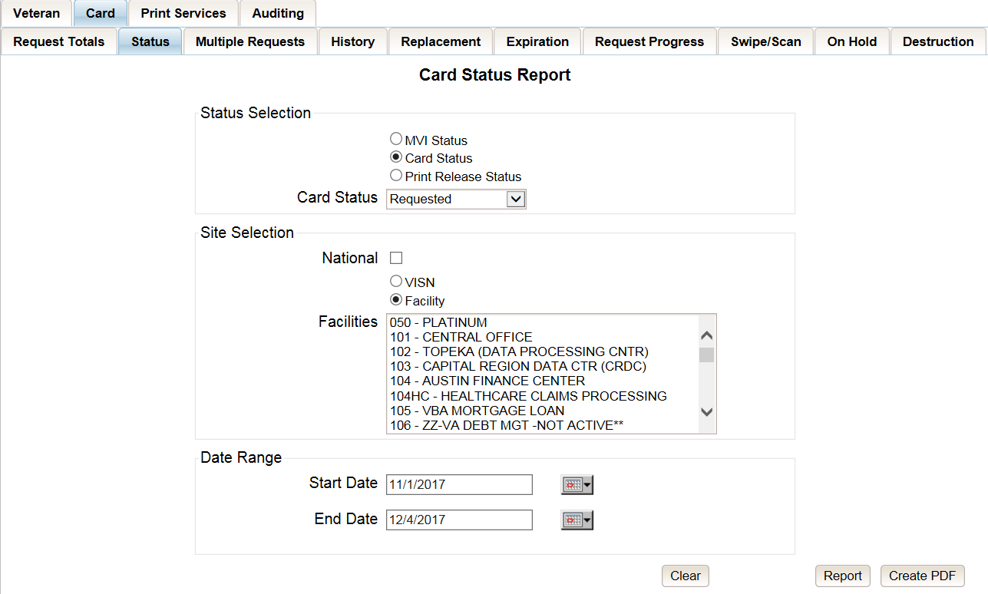

Figure ‑: Card Status Report query screen – Administrator and Tech Admin (Tier 3)

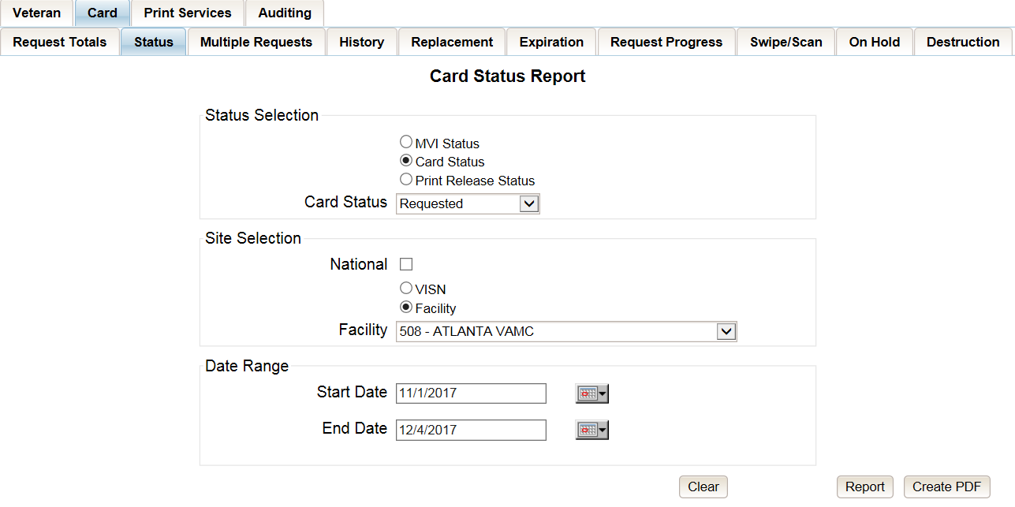

Figure ‑: Card Status Report query screen – Auditor

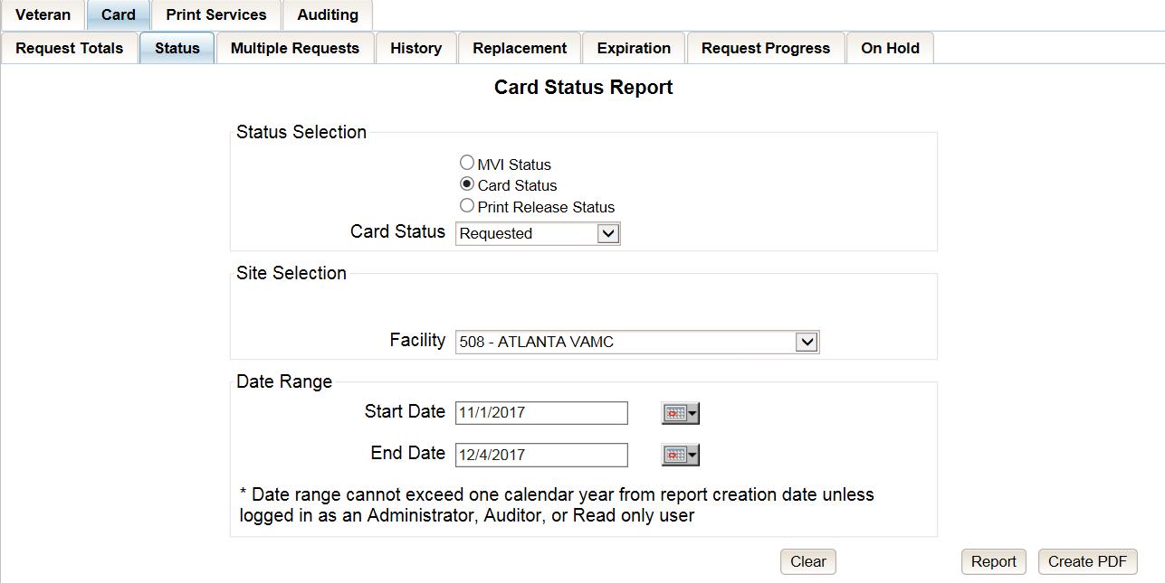

Figure ‑: Card Status Report query screen – Supervisor

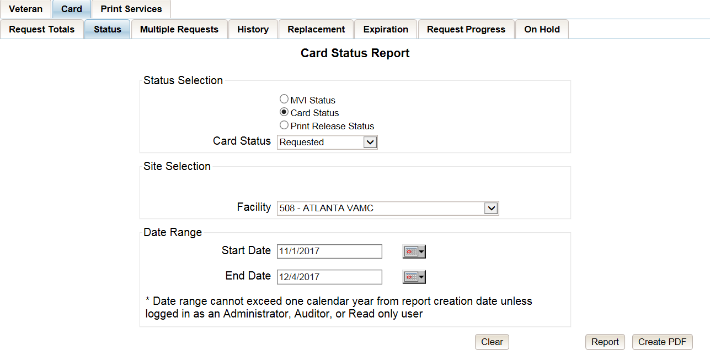

Figure ‑: Card Status Report query screen – Associate

### MVI (Master Veteran Index) Status Option

Clicking the **MVI Status** radio button provides the following report options:

* Active*
* Not Correlated
* Rejected
* Unlinked



***NOTE:*** *The starred (*) item is the default for that status.*

Once the user selects one of the drop-down list options, chooses a site, and inputs a date range, they will click **[Report]**. Clicking **[Report]** will display the “VHIC MVI Status Summary Report.”

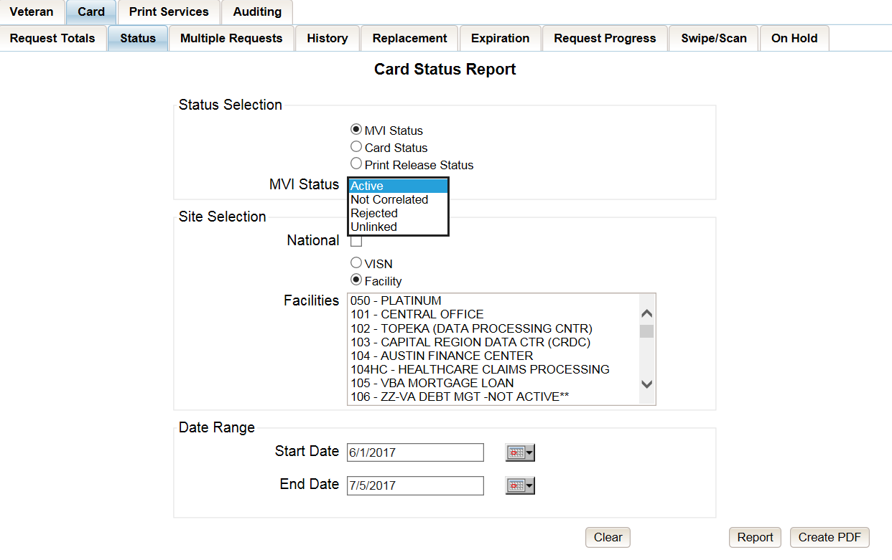

Figure ‑: Card Status Report query screen with MVI Status drop-down options displayed

The “VHIC MVI Status Summary Report” contains hyperlinks (*the number in the column relating to the selection made from the drop down menu*). Clicking a hyperlink will open the next report. The hyperlink in the VHIC MVI Status National Summary Report will take you to the VHIC MVI Status VISN Summary Report.

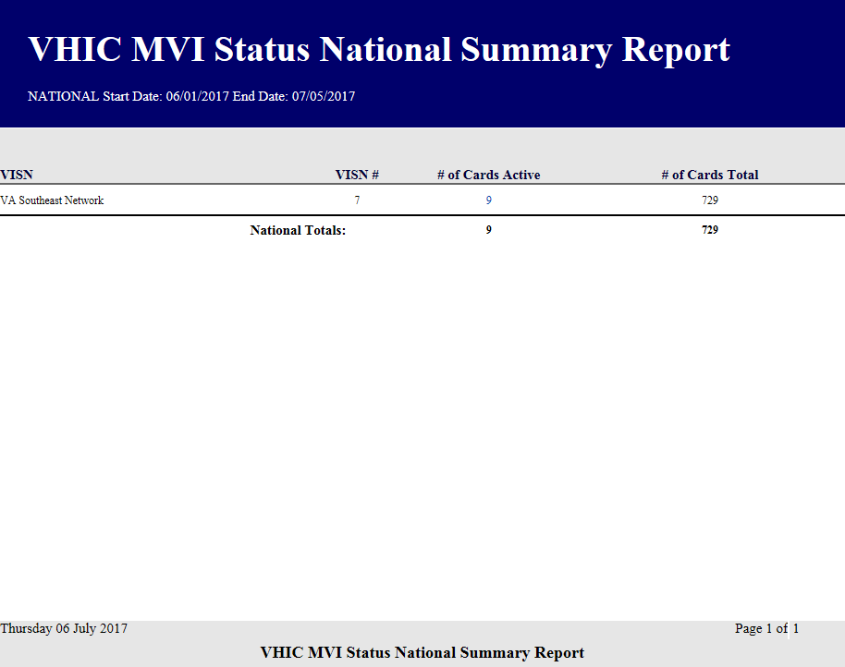

Figure ‑: VHIC MVI Status National Summary Report – Active

Clicking on the hyperlink in the VISN Summary Report will take you to the “VHIC MVI Status Facility Detail Report” with results broken down by Veteran.

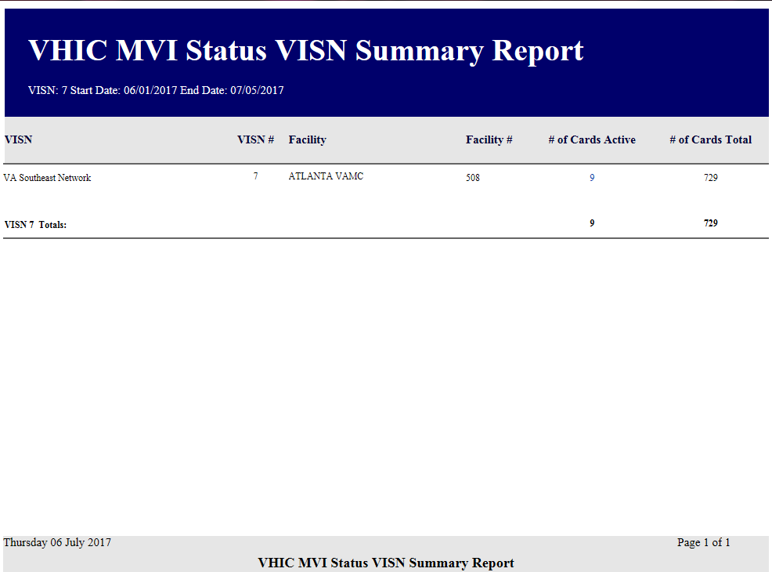

Figure ‑: VHIC MVI Status VISN Summary Report – Active

If you searched by Facility, you would be given the VHIC MVI Status Facility Summary report and would click on the hyperlink to be taken to the VHIC MVI Status Facility Detail Report.

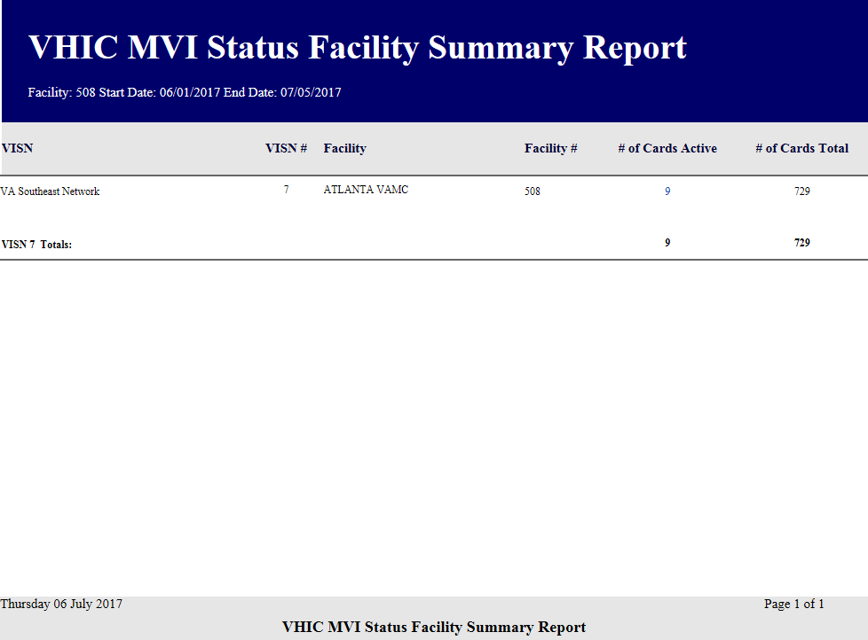

Figure ‑: VHIC MVI Status Facility Summary Report – Active

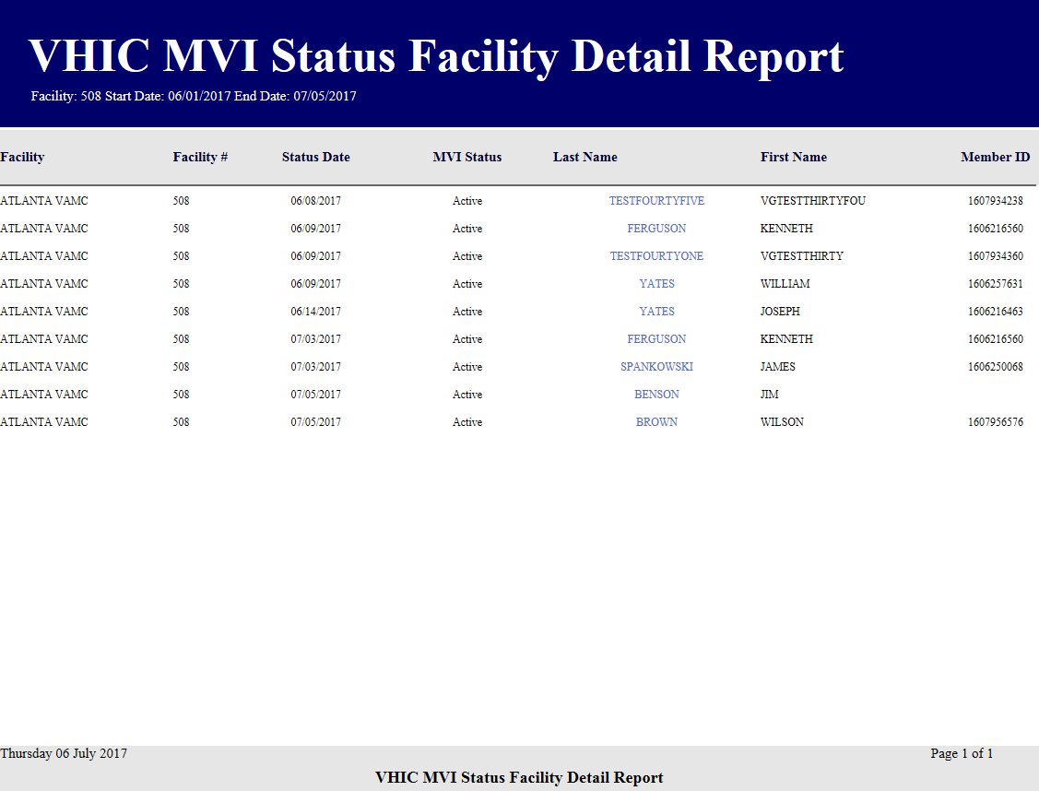

Figure ‑: VHIC MVI Status Facility Detail Report – Active

### Card Status Option

Clicking the **Card Status** radio button provides the following report options:

* Replaced
* Deactivated
* Expired
* On Hold
* Pending
* Requested*
* Defunct



***NOTE:*** *The starred (*) item is the default for that status.*

Once the user selects one of the drop-down list options, chooses a site, and inputs a date range, they will click the **[Report]** button. Clicking **[Report]** will display the “VHIC Card Status Report.”

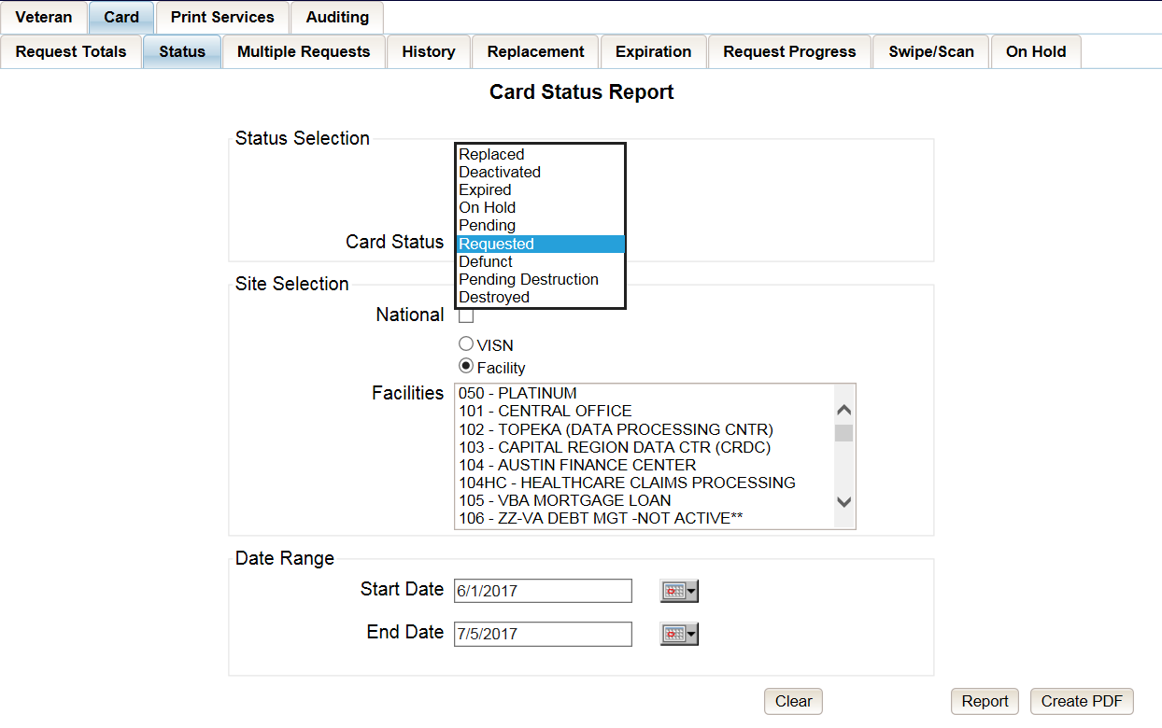

Figure ‑: Card Status Report query screen with Card Status drop-down menu options displayed

The “VHIC Card Status Report” contains hyperlinks (*the number in the column relating to the selection made from the drop down menu*). Clicking a hyperlink will open the next report. The hyperlink in the VHIC Card Status National Report will take you to the VHIC Card Status VISN Report.

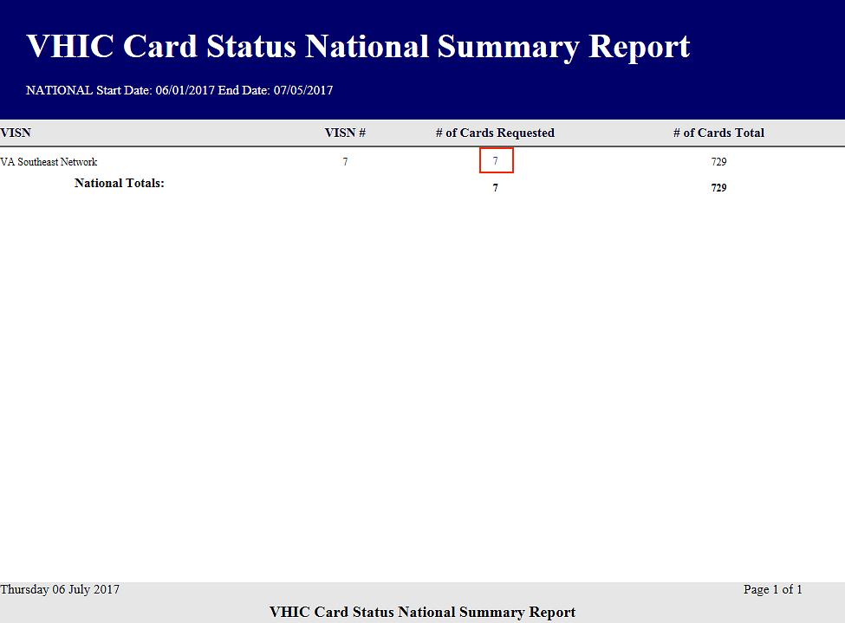

Figure ‑: VHIC Card Status National Summary Report – Requested

Clicking on the hyperlink in the VISN Summary Report will take you to the “VHIC Card Status Detail Report” with results broken down by Veteran.

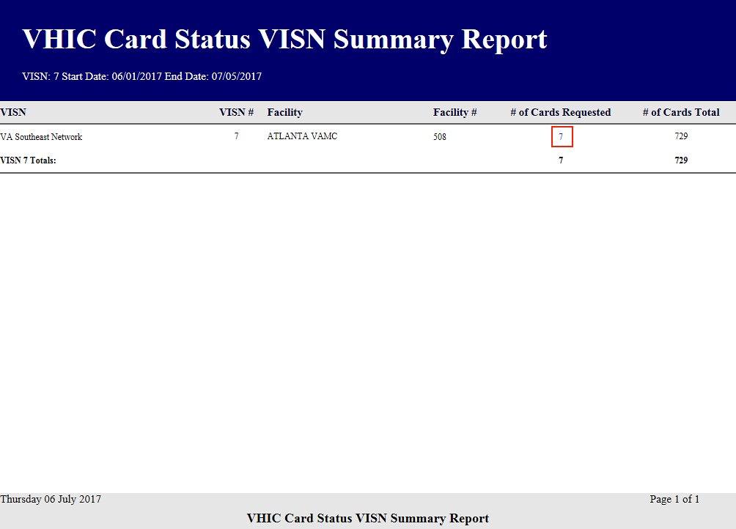

Figure ‑: VHIC Card Status VISN Summary Report – Requested

If you searched by Facility, you would be given the VHIC Card Status Facility report and would click on the hyperlink to be taken to the VHIC Card Status Detail Report.

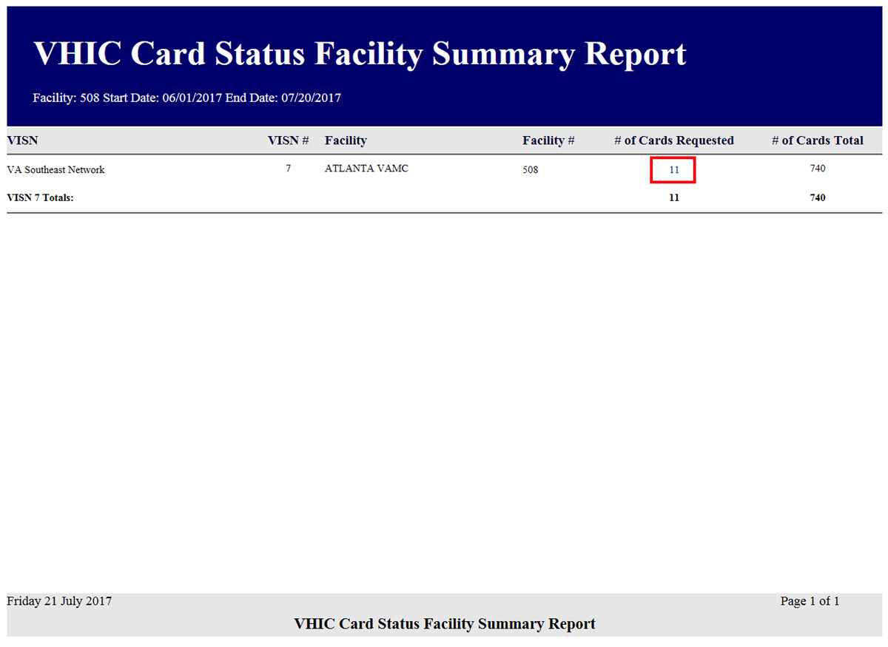

Figure ‑: VHIC Card Status Facility Summary Report– Requested

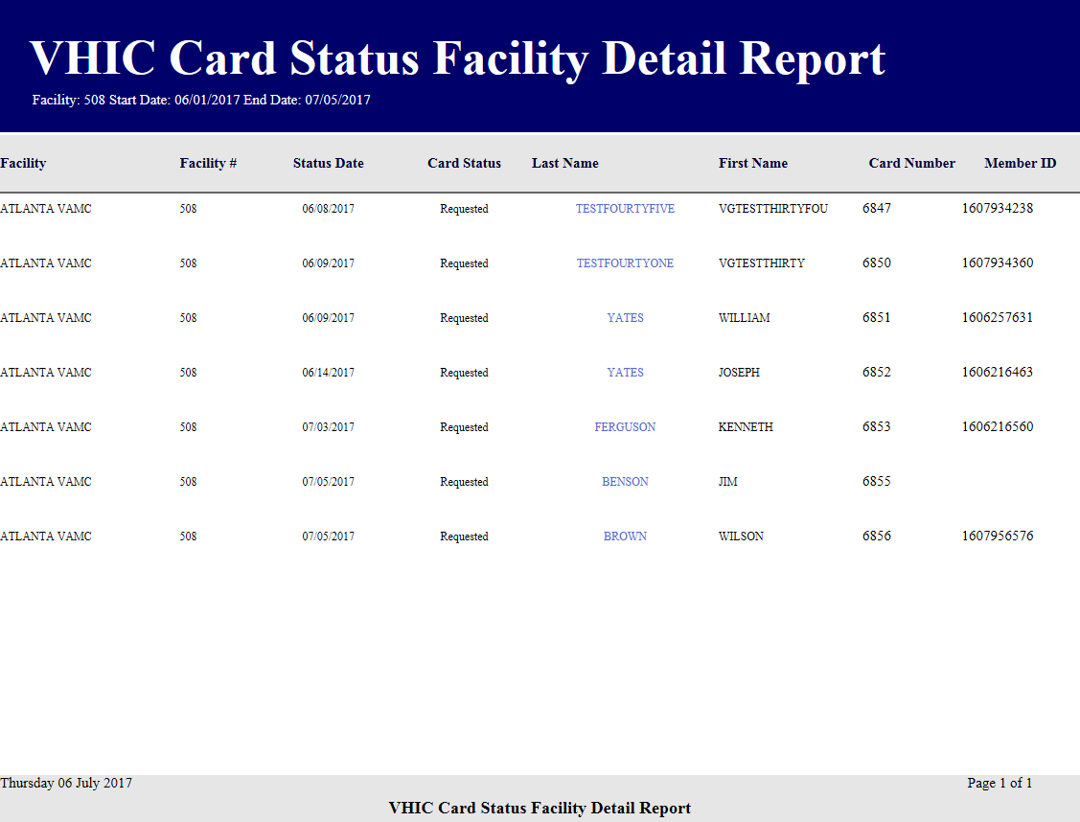

Figure ‑: VHIC Card Status Facility Detail Report – Requested

### Print Release Status Option

Clicking the **Print Release Status** radio button provides the following report options:

* Cancelled
* Error
* Mailed*
* Not Started
* Pending
* Received
* Rejected
* Sent



***NOTE:*** *The starred (*) item is the default for that status.*

Once the user selects one of the drop-down list options, chooses a site, and inputs a date range, they will click the **[Report]** button. Clicking **[Report]** will display the “VHIC Print Status Summary Report.”

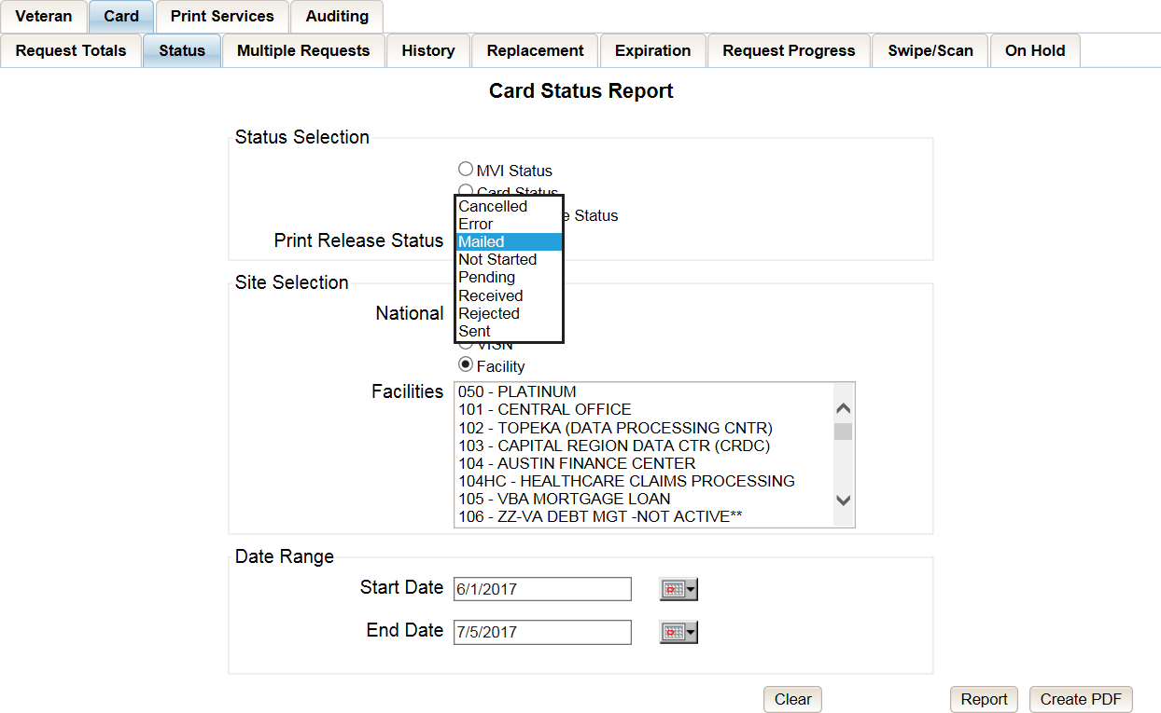

Figure ‑: Card Status Report query screen with Print Release Status drop-down menu options displayed

The “VHIC Print Status Report” contains hyperlinks (*the number in the column relating to the selection made from the drop down menu*). Clicking a hyperlink will open the next report. The hyperlink in the VHIC Print Status National Report will take you to the VHIC Print Status VISN Summary Report.

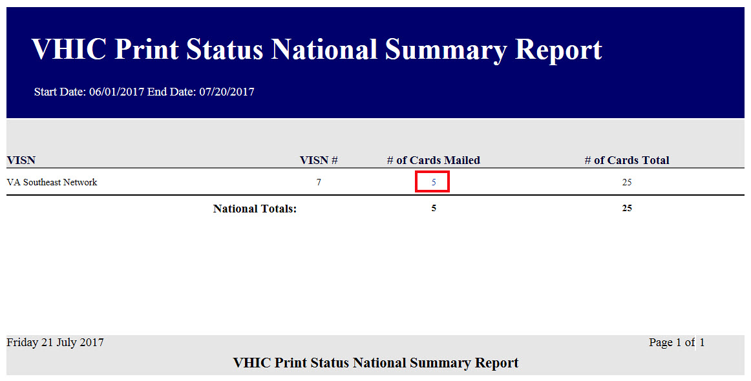

Figure ‑: VHIC Print Status National Summary Report – Mailed

Clicking on the hyperlink in the VISN Summary Report will take you to the “VHIC Print Status Detail Report” with results broken down by Veteran.

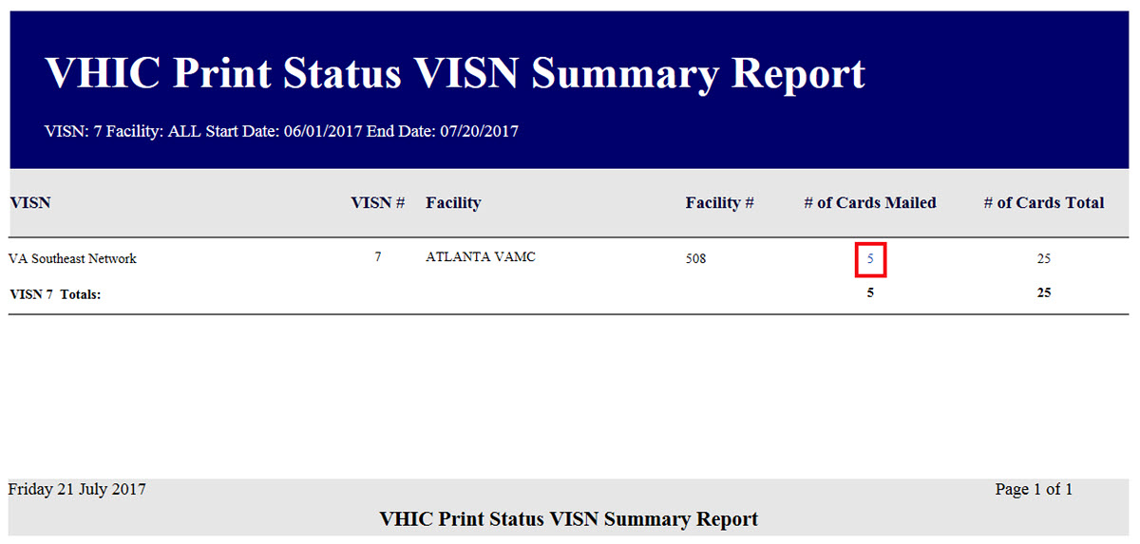

Figure ‑: VHIC Print Release Status Summary Report - VISN – Mailed

If you searched by Facility, you would be given the VHIC Print Status Facility report and would click on the hyperlink to be taken to the VHIC Print Status Detail Report.

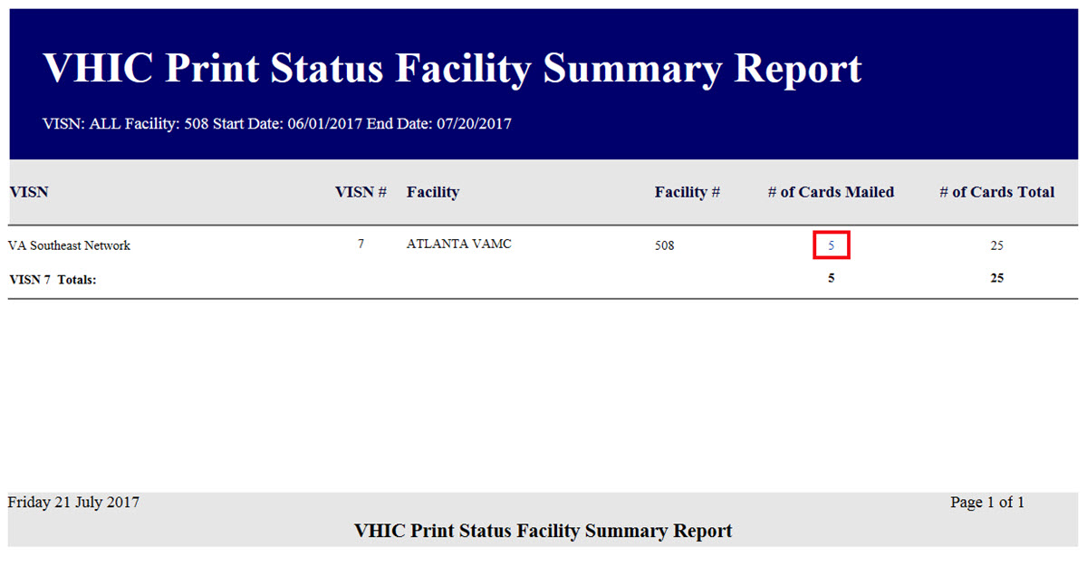

Figure ‑: VHIC Print Release Status Summary Report - Facility – Mailed

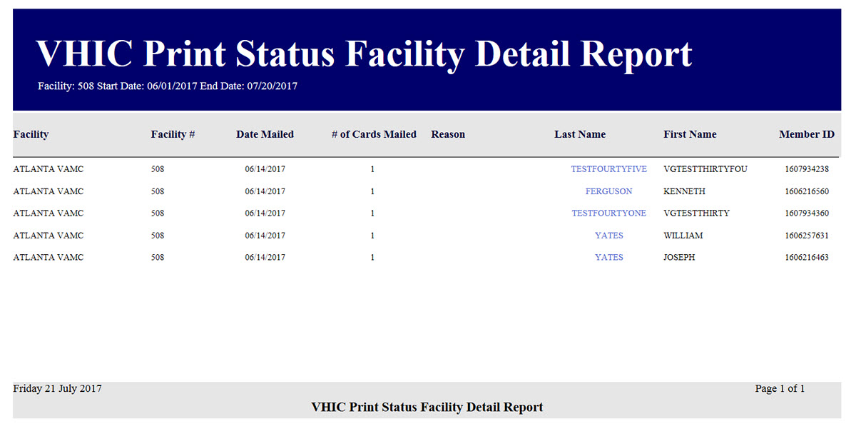

Figure ‑: VHIC Print Status Detail Report - Facility – Mailed

## Multiple Card Requests Report

Table 7: Multiple Request Report at a Glance

| **At a Glance…** |  |
| --- | --- |
| Who can access this report? | *Administrator, Supervisor, Tech Admin (Tier 3), Auditor* |
| Who can access National version? | *Administrator, Tech Admin (Tier 3), Auditor* |
| Date Range Allowed | *Admins, Tech Admin (Tier 3), Auditor – unlimited*  *Supervisor, Associate, Read-Only – one (1) year or less from date report is being run* |
| Search Criteria Available (*may vary by role*) | *Card Requests (#), VISN, Facility, Cards Requested, Cards Mailed, Start Date, End Date* |

The *Multiple Card Requests Report* provides a summary of either multiple cards requested for a Veteran or multiple cards mailed to a Veteran. The user must select the radio button corresponding to the desired report. This report is customizable and will return multiples based on specific numeric criteria entered into the Card Requests field (*the default is two (2)*).

Once the user specifies an amount of cards requested or mailed, chooses a site, and inputs a date range, they will click the **[Report]** button. Clicking **[Report]** will display the “VHIC Detailed Report for Number of Cards Requested/Mailed.”

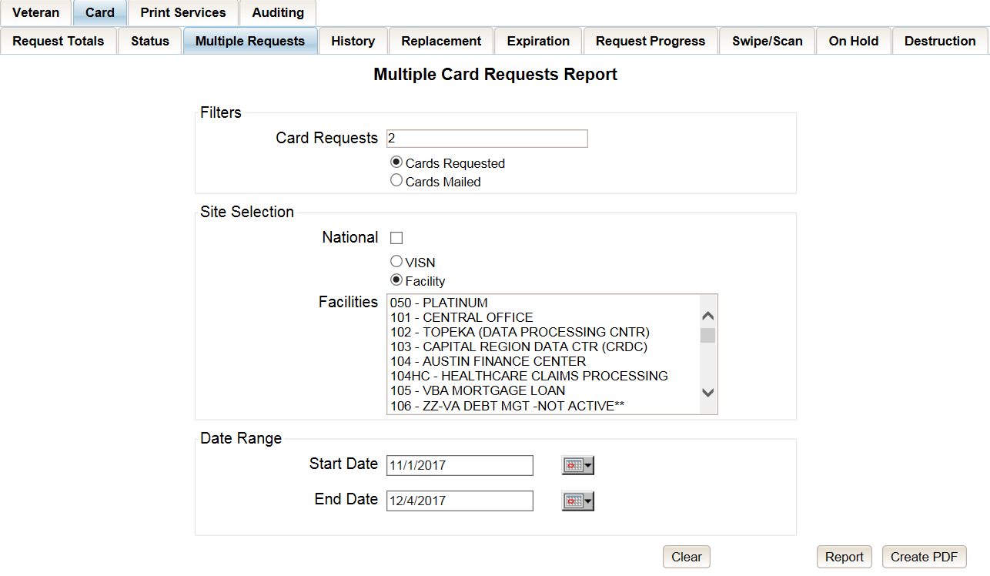

Figure ‑: Multiple Card Requests Report query screen – Administrator and Tech Admin (Tier 3)

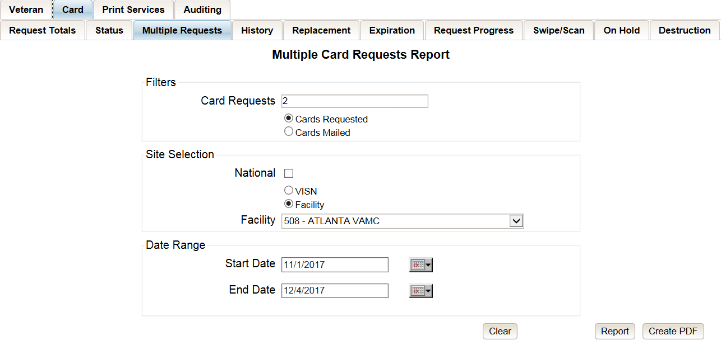

Figure ‑: Multiple Card Requests Report query screen – Auditor

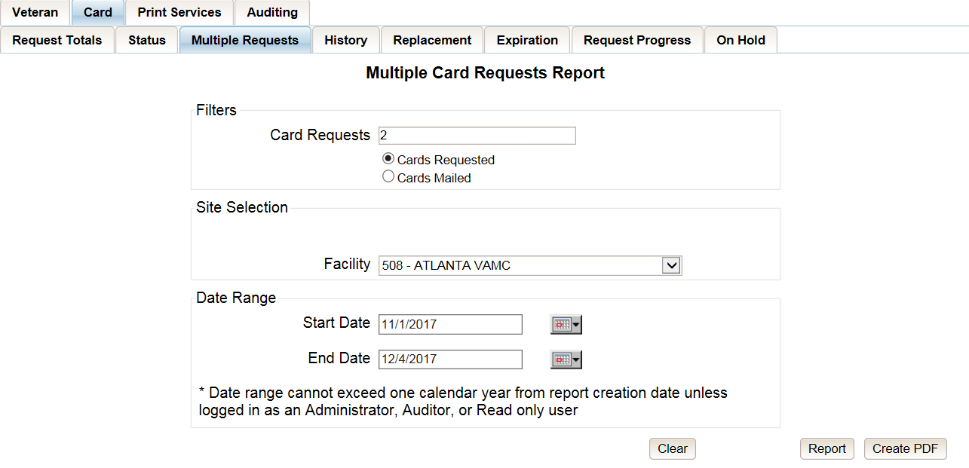

Figure ‑: Multiple Card Requests Report query screen – Supervisors

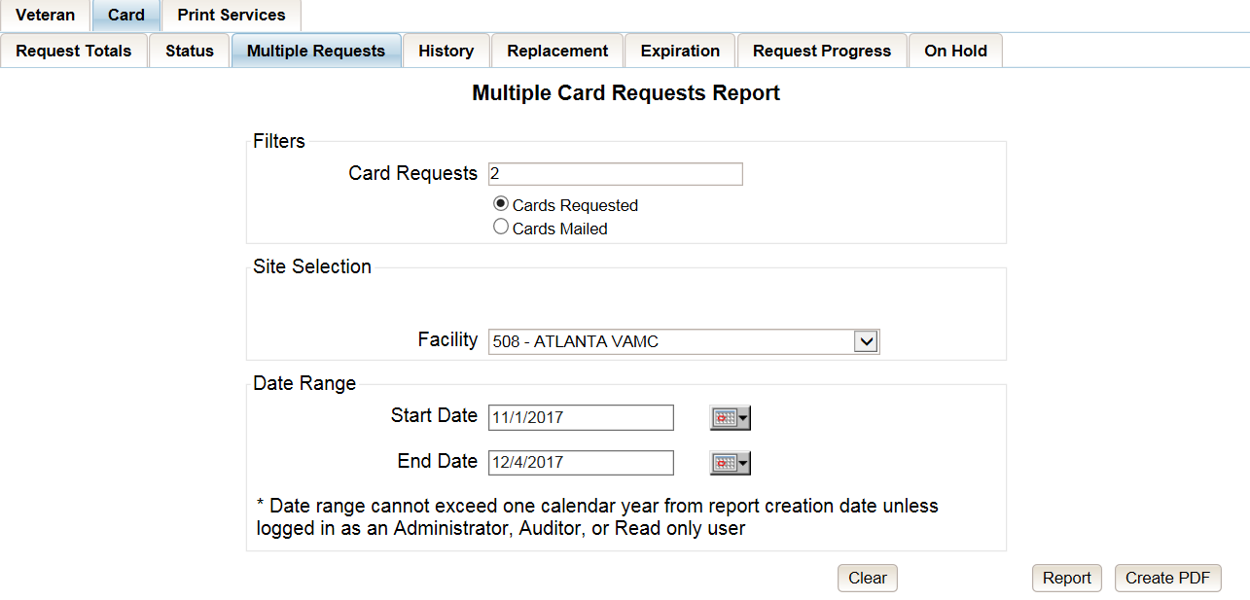

Figure ‑: Multiple Card Requests Report query screen – Associate

The “VHIC Summary Report for Number of Cards Requested/Mailed - National” lists all the VISNs and contains a hyperlink in the “VISN #” column. Clicking the hyperlink takes the user to the “VHIC Detailed Report for Number of Cards Requested/Mailed - VISN” report.

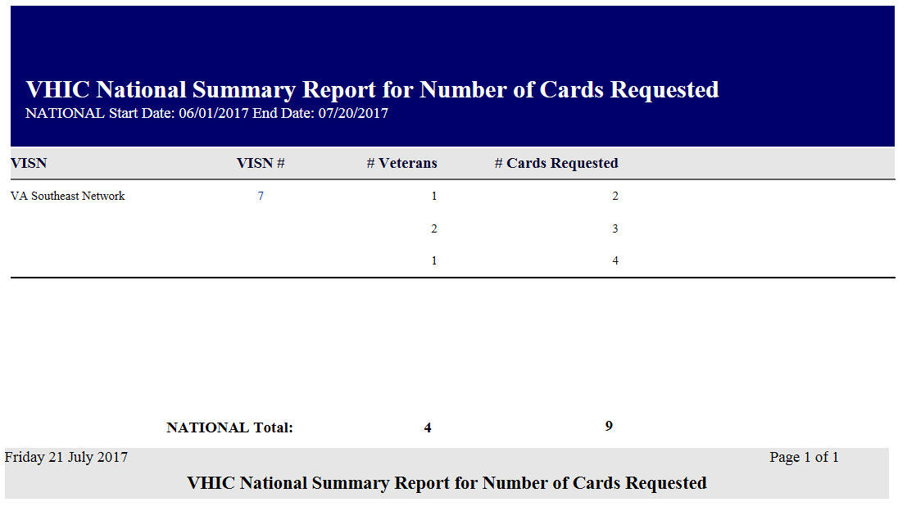

Figure ‑: VHIC National Summary Report for Number of Cards Requested

The “VHIC Detail Report for Number of Cards Requested/Mailed - VISN” lists all the Facilities for the selected VISN and contains a hyperlink in the “Facility #” column. Clicking the hyperlink takes the user to the “VHIC Facility Detailed Report for Number of Cards Requested/Mailed” report.

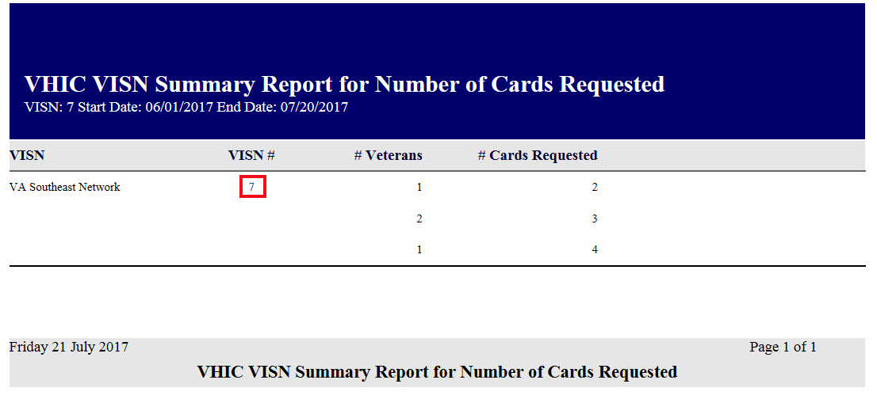

Figure ‑: VHIC VISN Summary Report for Number of Cards Requested

When the user searches by Facility, the “VHIC Detailed Report for Number of Cards Requested/Mailed - Facility” lists all the VISNs and contains a hyperlink in the “Facility #” column. Clicking on the facility number will drill down further to show a breakdown by Veteran.

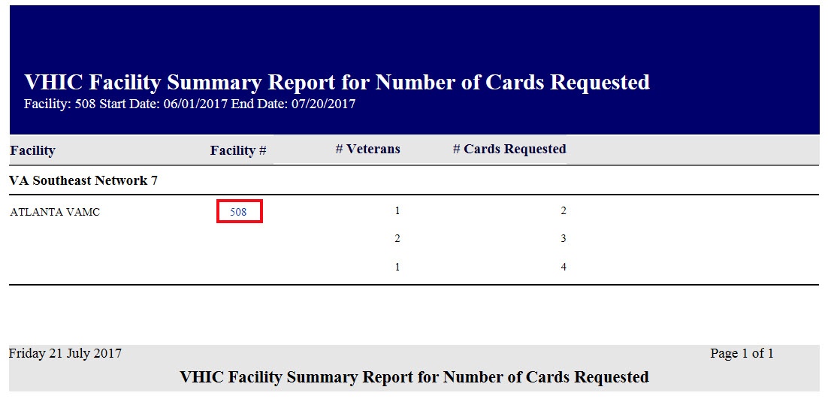

Figure ‑: VHIC Facility Summary Report for Number of Cards Requested

The “VHIC Facility Detailed Report for Number of Cards Requested/Mailed” report includes the Veteran’s Name, Member ID (if available), and number of Cards Requested/Mailed.

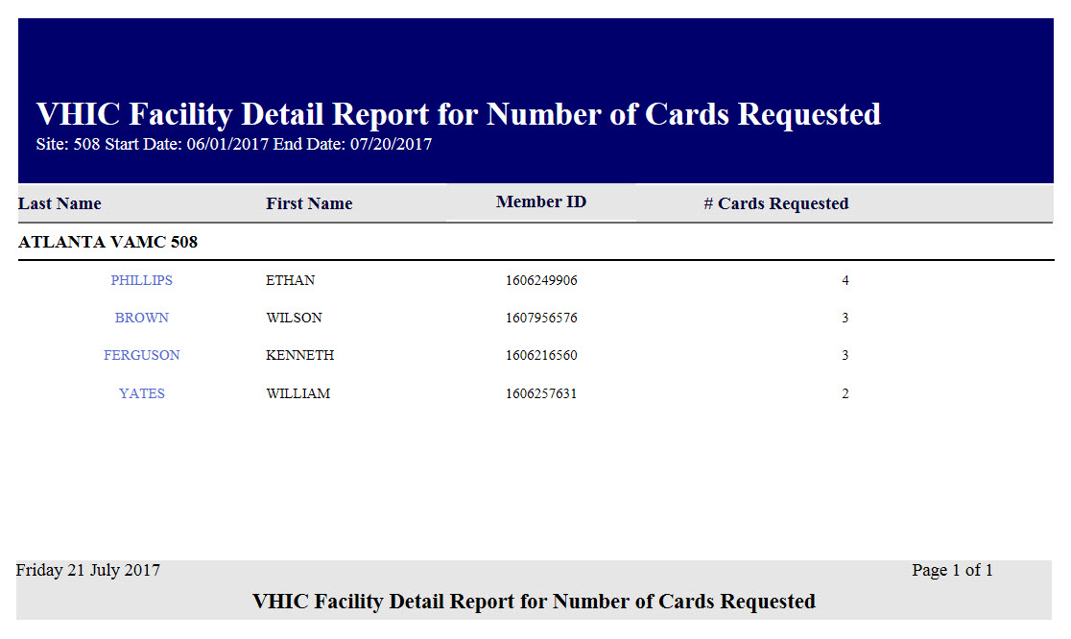

Figure ‑: VHIC Facility Detail Report for Number of Cards Requested

## Card History Report

Table 8: Card History Report at a Glance

| **At a Glance…** |  |
| --- | --- |
| Who can access this report? | *Administrator, Supervisor, Associate, Tech Admin (Tier 3), Auditor, Read-Only* |
| Who can access National version? | *N/A* |
| Date Range Allowed | *N/A* |
| Search Criteria Available | *Card ID, Person ID* |

The *Card History Report* provides the user with a breakdown of requested cards. To access these reports, enter a **Card ID** number or a **Person ID** number of the Veteran.

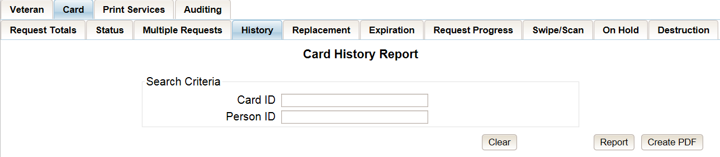

Figure ‑: Card History Report query screen – Administrators, Tech Administrator (Tier 3), and Auditors

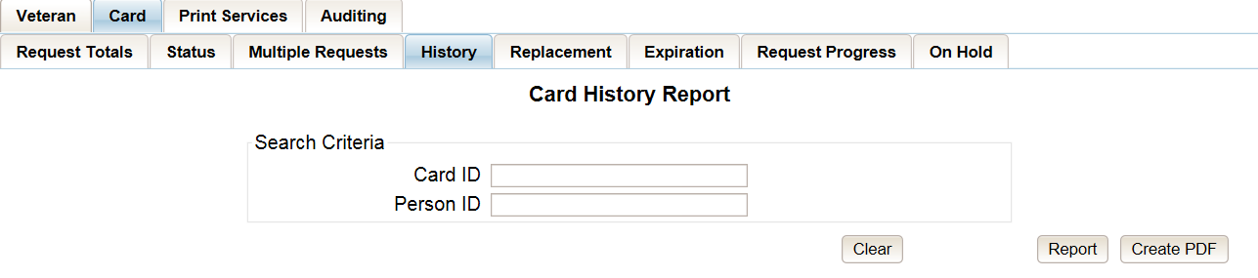

Figure ‑: Card History Report query screen – Supervisor

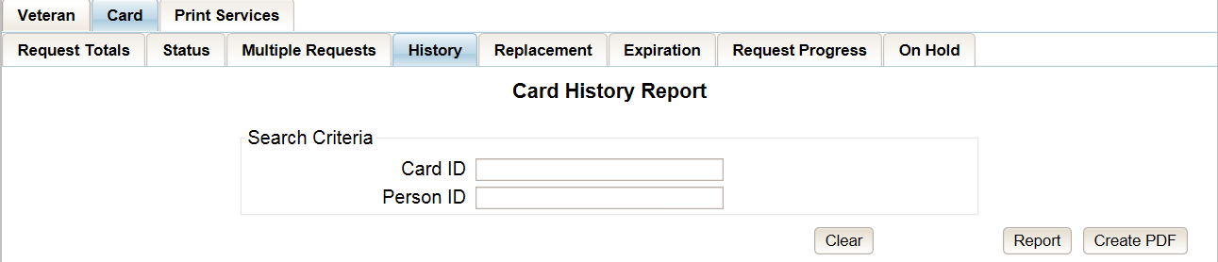

Figure ‑: Card History Report query screen – Associate

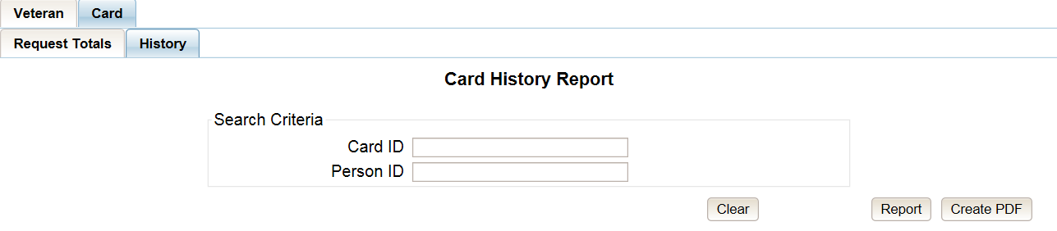

Figure ‑: Card History Report query screen – Read-Only User

Searching by **Card ID** (found in the [Veteran Detail Report](#_Veteran_(Direct_Search))) returns a single result for that specific card number, referred to as the *Card History by Card* ID report.



Figure ‑: VHIC Card History by Card ID Report

Searching by **Person ID** (found in the [Veteran report](#_Veteran_(Direct_Search))) returns all of the cards requested for that Veteran, referred to as the *Card History by Person ID* report.

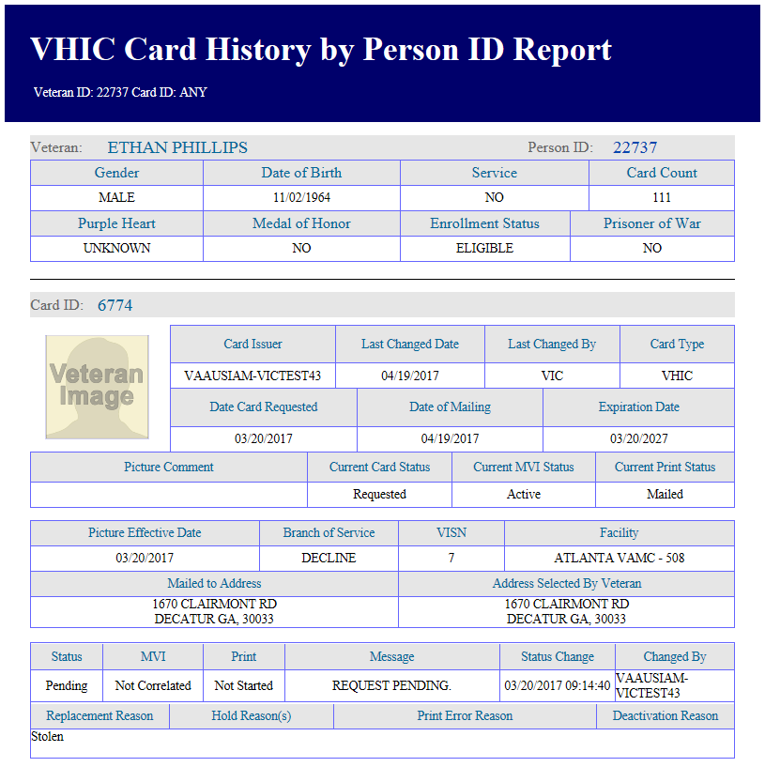

Figure ‑: Card History by Person ID Report

Both reports, *Card History by Card ID* and *Card History by Person ID*, provide the user with the following information tied to that particular card:

* Veteran’s name
* Person ID
* Gender
* Date of Birth
* Service status
* Card Count
* Purple Heart status
* Medal of Honor status
* Enrollment Status
* Prisoner of War status
* Card ID
* Card Issuer
* Last Changed Date
* Last Changed By
* Card Type
* Date Card Requested
* Date of Mailing
* Expiration Date
* Picture Comment
* Current Card Status
* Current MVI Status
* Current Print status
* Picture Effective Date
* Branch of Service
* VISN
* Facility
* Replacement Reason (If any)
* Hold Reason(s) (If any)
* Print Error Reason (If any)
* Deactivation Reason (If any)

A history of the three statuses is also available. This allows reviewers to monitor and verify the various stages the card request has gone through as well as its final status at the time of the report.

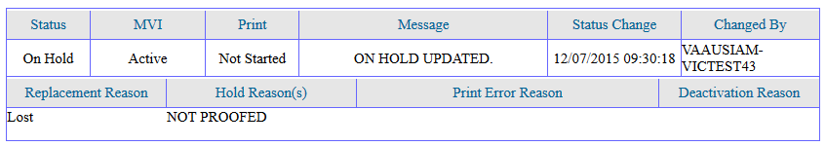

Figure ‑: Card History Report Status History

## Card Replacement Report

Table 9: Card Replacement Report at a Glance

| **At a Glance…** |  |
| --- | --- |
| Who can access this report? | *Administrator, Supervisor, Associate, Tech Admin (Tier 3), Auditor* |
| Who can access National version? | *Administrator, Tech Admin (Tier 3), Auditor* |
| Date Range Allowed | *Administrator, Tech Admin (Tier 3), Auditor – unlimited*  *Supervisor, Associate – one (1) year or less from date report is being run* |
| Search Criteria Available | *VISN, Facility, Start Date, End Date* |

Each *Card Replacement Report* gives the user a breakdown, in a tabular format, of the requested replacement cards. The report, sorted by the replacement reasons and by the selected VISN and/or Facility, displays the “**# of Cards Replaced**” for each specific reason, and provides a hyperlinked number. Clicking a hyperlink takes the user to reports that are more detailed.

Selecting the National checkbox (if available) will return results for all VISNs and Facilities. Selecting either the VISN or the Facility radio button will update the list of available options accordingly (based on a user’s role).

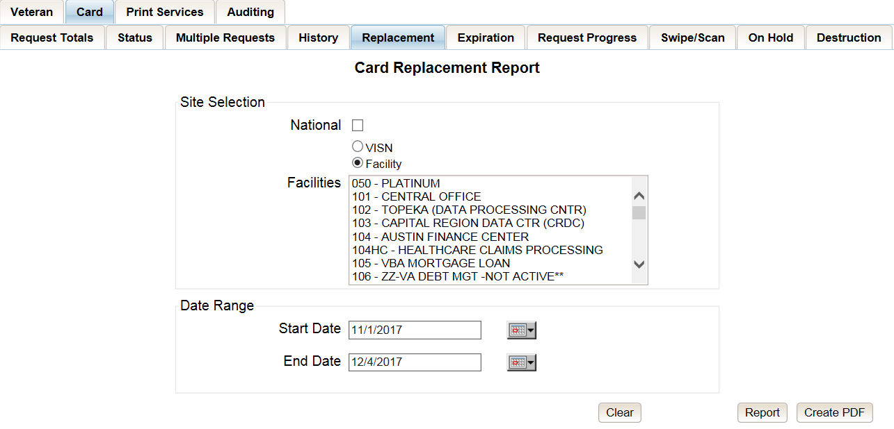

Figure ‑: VHIC Card Replacement Report query screen – Administrators and Tech Administrators (Tier 3)

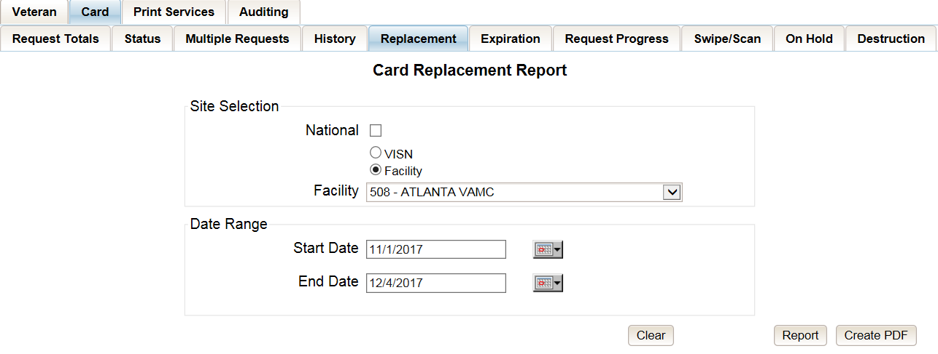

Figure ‑: VHIC Card Replacement Report query screen – Auditors

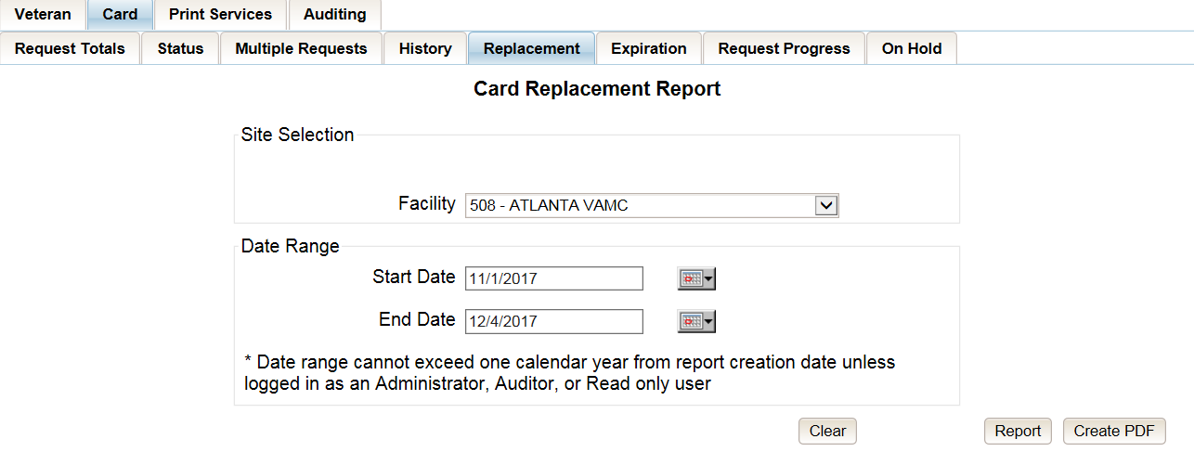

Figure ‑: Card Replacement Report query screen – Supervisors

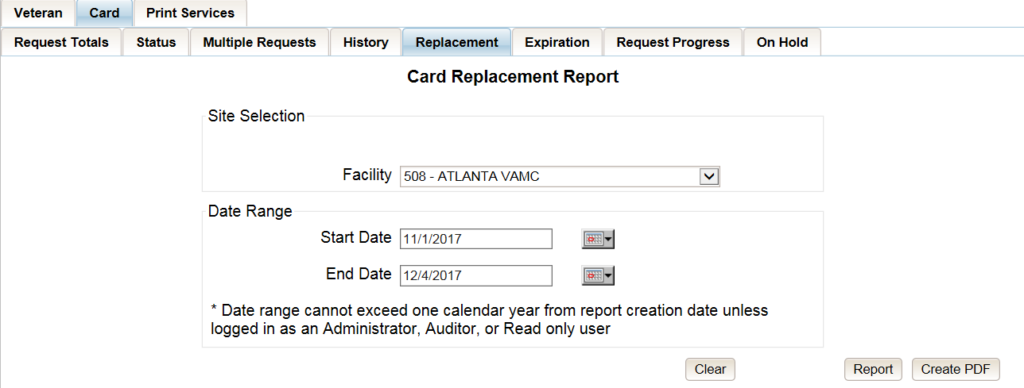

Figure ‑: VHIC Card Replacement Report query screen – Associates

The “VHIC Card Replacement National Report” lists the VISNs and contains a hyperlink in the “VISN #” column. Clicking the hyperlink takes the user to the “VHIC Card Replacement VISN Summary Report.”

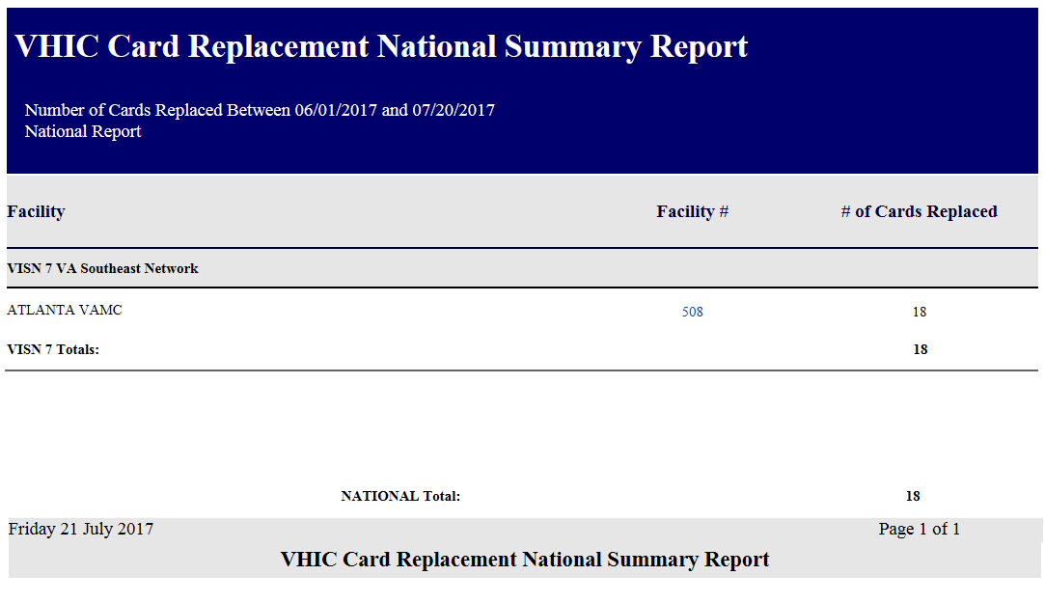

Figure ‑: VHIC Card Replacement Summary Report – National

The “VHIC Card Replacement Facility Report” lists the Replacement Reasons and contains a hyperlink in the “# of Cards Replaced” column. Clicking the hyperlink takes the user to the “VHIC Card Replacement Facility Sub-Reason Report.”

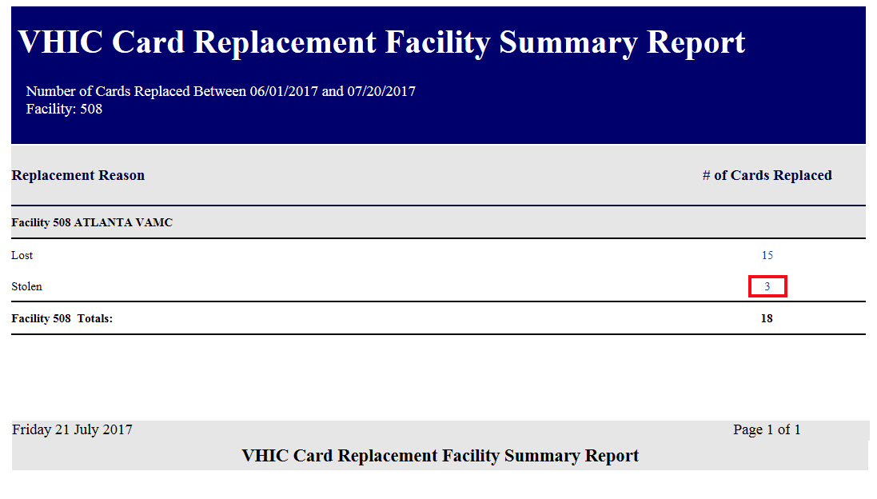

Figure ‑: VHIC Card Replacement Facility Report – Summary

The “VHIC Card Replacement Facility Sub-Reason Report” contains a hyperlink in the “# of Cards Replaced” column. Clicking the hyperlink opens up a detailed breakdown report by Veteran.

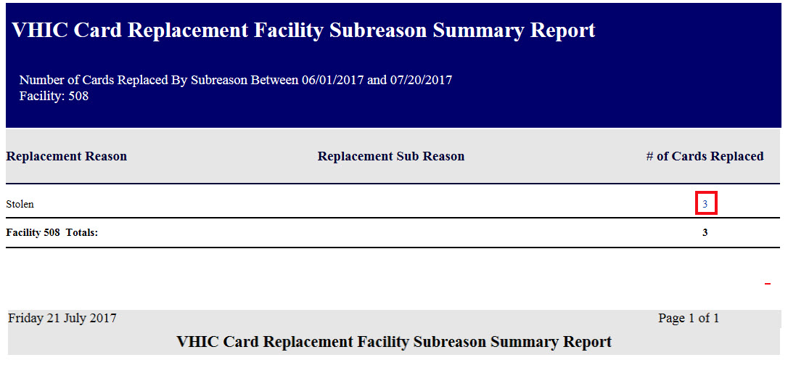

Figure ‑: VHIC Card Replacement Facility Sub Reason Report – Summary

The “VHIC Card Replacement Sub-Reason Detail” contains hyperlinks in both the “Card Number” column and the “Last 4 SSN” column. Clicking the hyperlink under Card Number will take the user to the Card History report for that Card ID, and clicking on the hyperlink under the Last 4 SSN takes the user to the Veteran Detail Report for the Veteran selected.

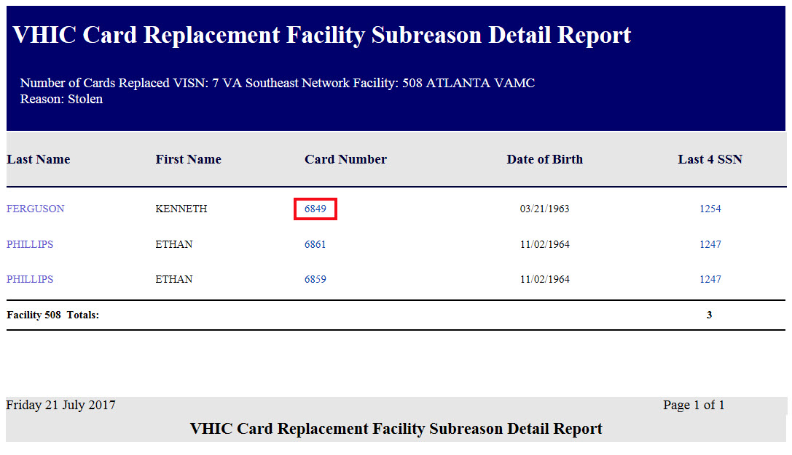

Figure ‑: VHIC Card Replacement Facility Sub Reason Detail report

## Card Expiration Report

Table 10: Card Expiration Report at a Glance

| **At a Glance…** |  |
| --- | --- |
| Who can access this report? | *Administrator, Supervisor, Associate, Tech Admin (Tier 3), Auditor* |
| Who can access National version? | *Administrator, Tech Admin (Tier 3), Auditor* |
| Date Range Allowed | *Administrator, Tech Admin (Tier 3), Auditor – unlimited*  *Supervisor, Associate – one (1) year or less from date report is being run* |
| Search Criteria Available | *VISN, Facility, Start Date, End Date* |

The *Card Expiration Report* allows the user to view information pertaining to VHICs that have expired. From the Card Expiration Report screen, the user can query expired cards by National, VISN, or Facility, depending on their role.

***NOTE:*** *The user can also find VHICs set to expire by selecting future start and end dates.*

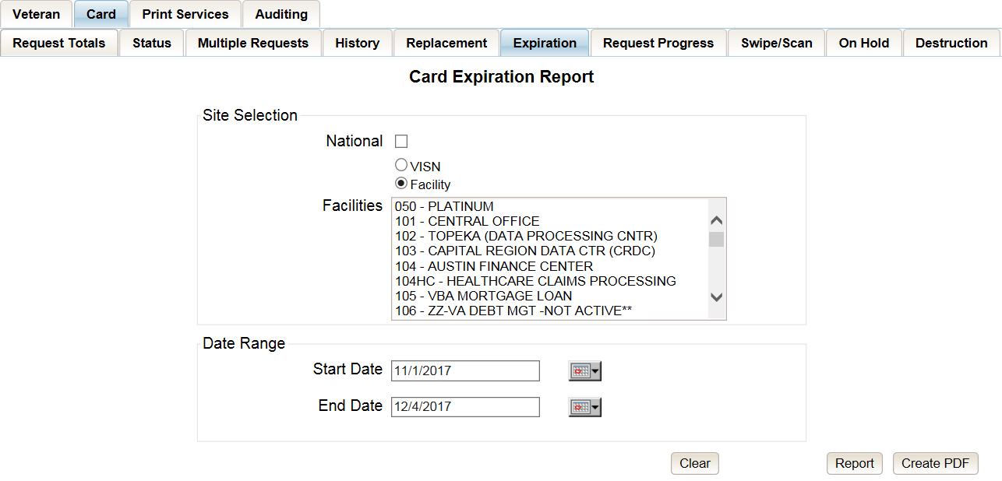

Figure ‑: Card Expiration Report query screen – Administrators and Tech Administrators (Tier 3)

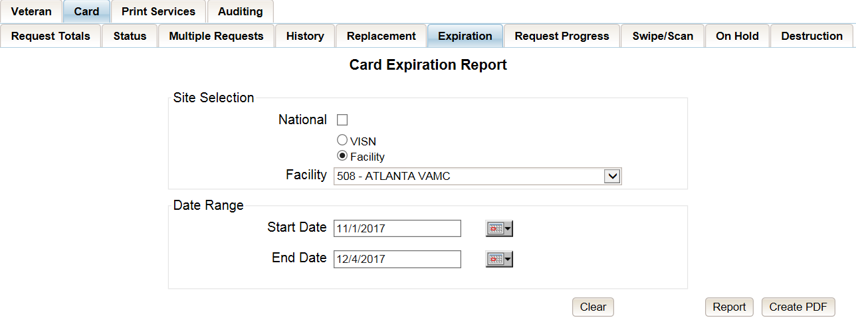

Figure ‑: Card Expiration Report query screen – Auditors

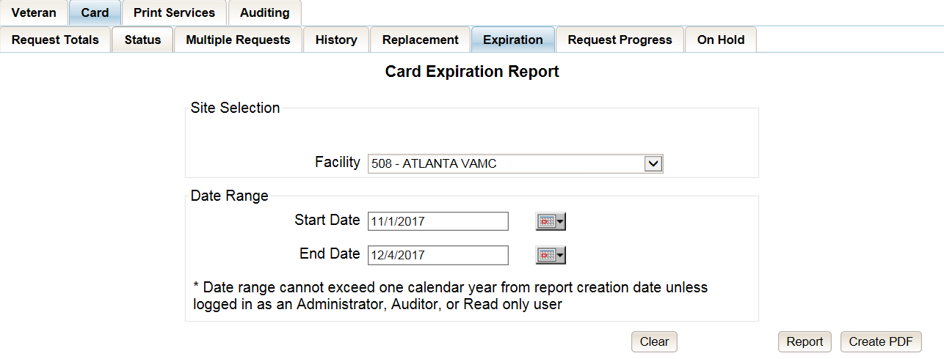

Figure ‑: Card Expiration Report query screen – Supervisors

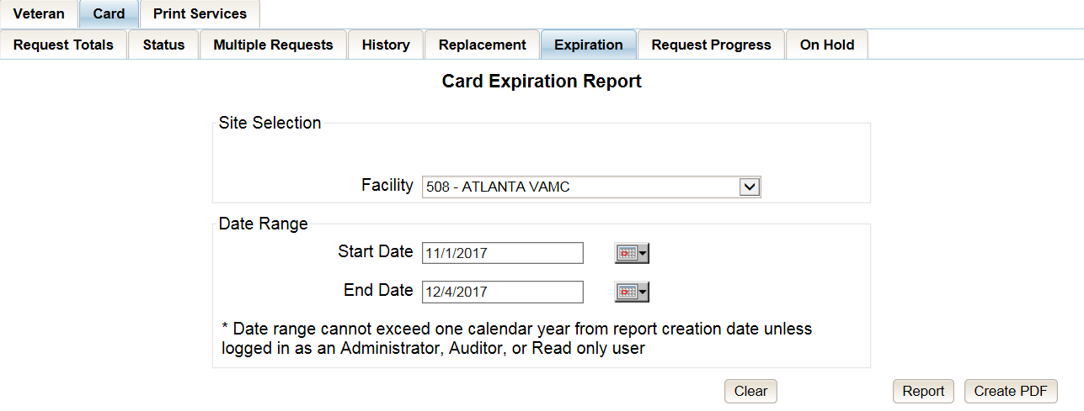

Figure ‑: Card Expiration Report query screen – Associates

The “VHIC Card Expiration Summary Report - National” lists the VISNs and Facilities and contains a hyperlink in the “VISN Number” column. Clicking the hyperlink takes the user to the “VHIC Card Replacement Site Report – VISN.”

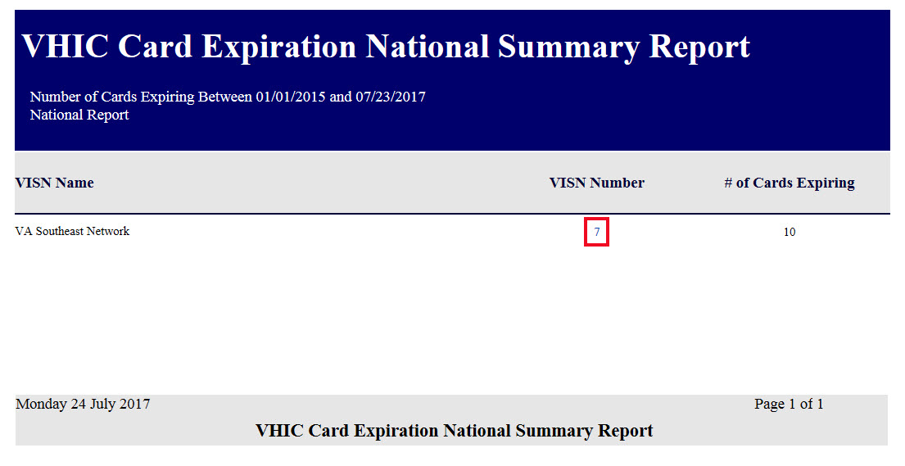

Figure ‑: VHIC Card Expiration National Summary Report

The “VHIC Card Expiration Site Report - VISN” contains a hyperlink in the “Facility Number” column. Clicking the hyperlink opens up a detailed breakdown report by Veteran.

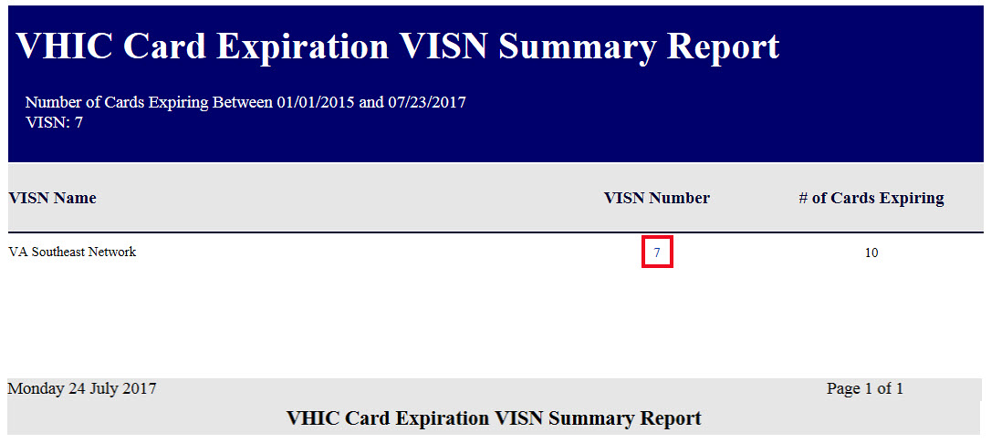

Figure ‑: VHIC Card Expiration VISN Summary Report

In addition, when searching my Facility on the query screen, the VHIC user will be taken to “VHIC Card Expiration Site Report – Facility.” The “VHIC Card Expiration Site Report - Facility” contains a hyperlink in the “Facility Number” column. Clicking the hyperlink opens up a detailed breakdown report by Veteran.

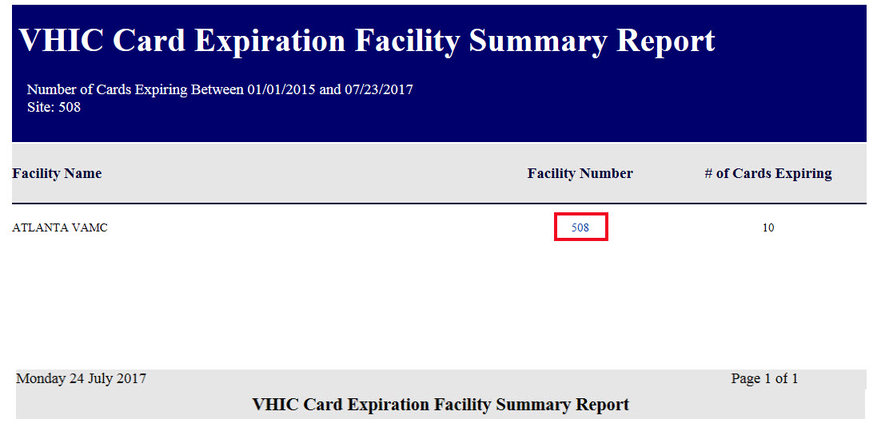

Figure ‑: VHIC Card Expiration Facility Summary Report

The “VHIC Card Expiration Detail Report” contains hyperlinks in both the “Card Number” column and the “Last 4 SSN” column. Clicking the hyperlink under Card Number will take the user to the Card History report for that Card ID, and clicking on the hyperlink under the Last 4 SSN takes the user to the Veteran Detail Report for the Veteran selected.

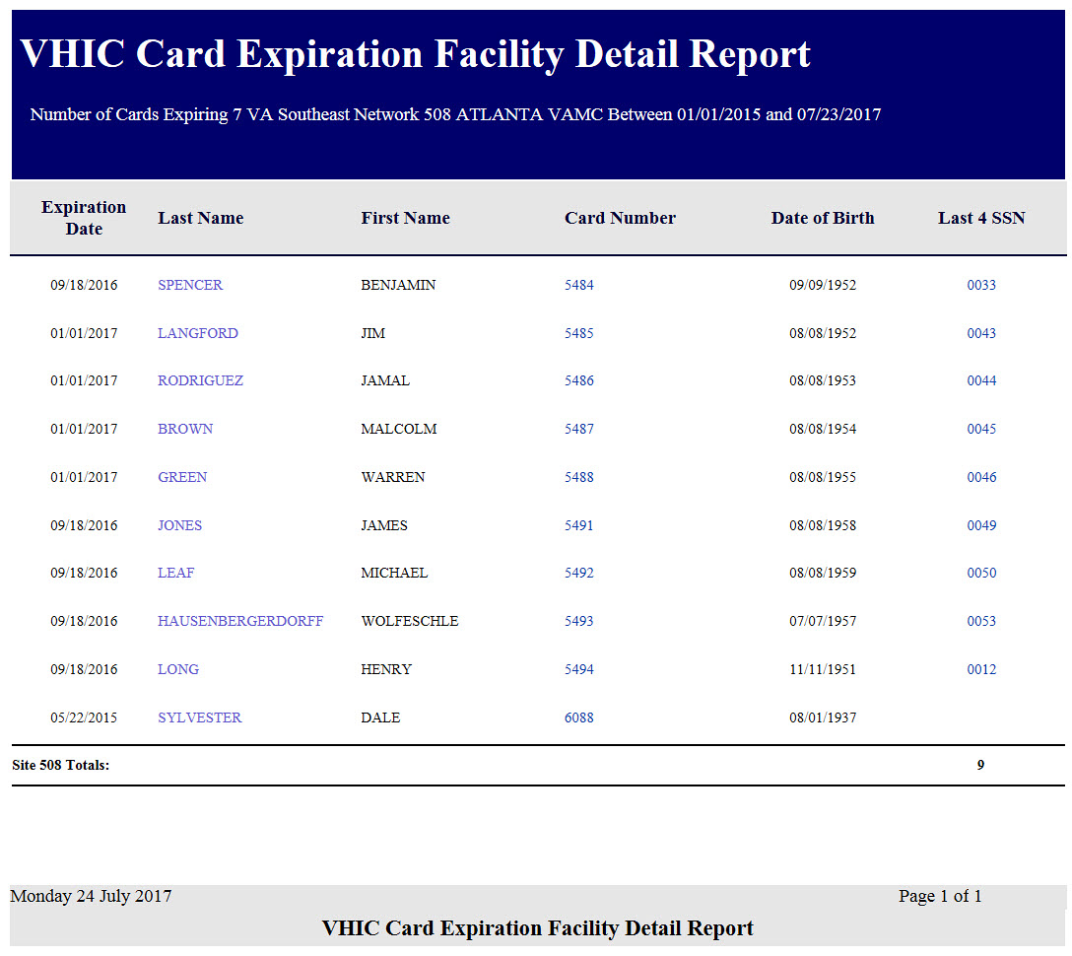

Figure ‑: VHIC Card Expiration Facility Detail Report

## Card Request Progress Report

Table 11: Card Request Progress Report at a Glance

| **At a Glance…** |  |
| --- | --- |
| Who can access this report? | *Administrator, Supervisor, Associate, Tech Admin (Tier 3), Auditor* |
| Who can access National version? | *Administrator, Tech Admin (Tier 3), Auditor* |
| Date Range Allowed | *Administrator, Tech Admin (Tier 3), Auditor – unlimited*  *Supervisor, Associate – one (1) year or less from date report is being run* |
| Search Criteria Available | *VISN, Facility, Start Date, End Date* |

There are many stages that a VHIC (card) goes through once the user clicks either the Submit button or the Hold button.

The *Card Request Progress* report allows the user to see how many cards are currently at each step of the Card Request lifecycle starting from the time the VHIC user clicks on either the Submit button or the Hold button, all the way through the mailed confirmation for a given VISN, Facility and Nationally, during a set time period.

The card request stages that are displayed on this report are: Pending, Request Submitted, On Hold, Defunct, Sent to Printer, Acknowledged, Rejected, and Confirmed Mailed.

This would allow the user to keep an eye on potential areas of trouble (i.e. Cards On-Hold or timing out and becoming Defunct) and be able to track down what is happening at each stage much easier.

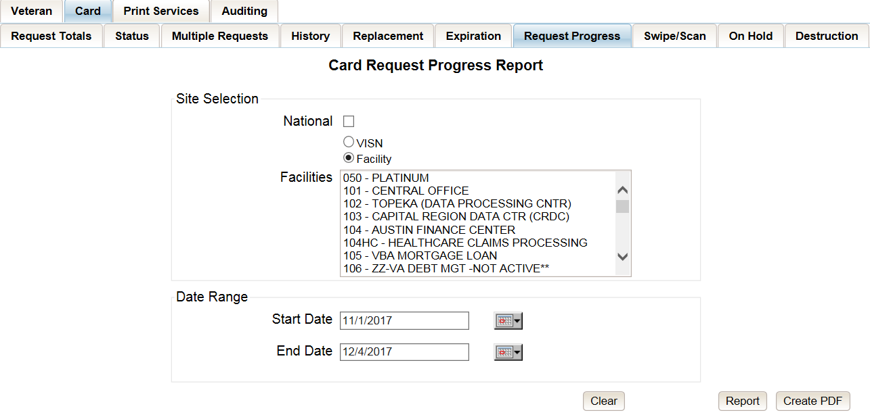

Figure ‑: Card Request Progress Report query screen - Administrators and Tech Administrators (Tier 3)

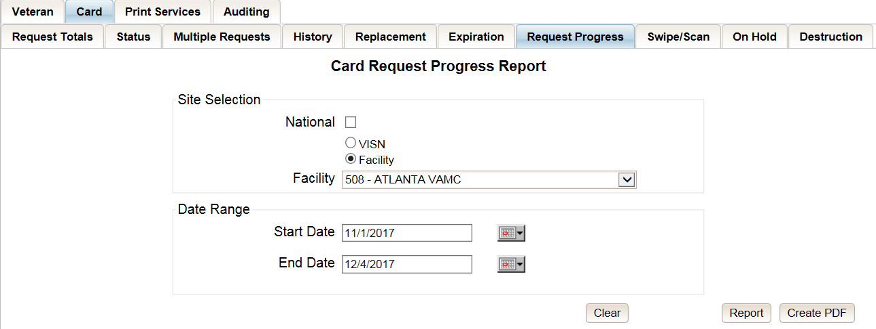

Figure ‑: Card Request Progress Report query screen – Auditors

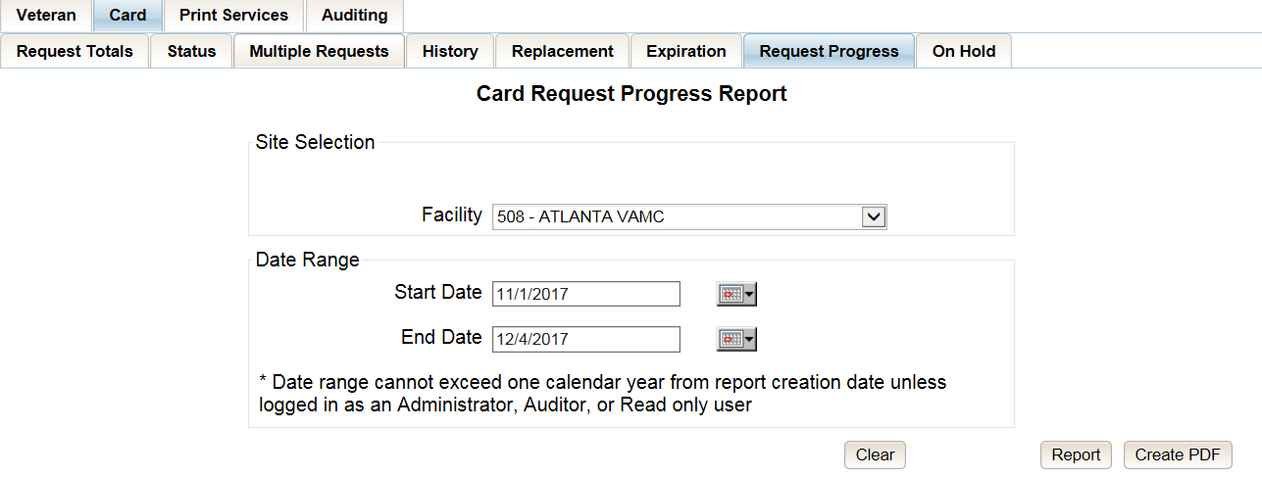

Figure ‑: Card Request Progress Report query screen – Supervisors

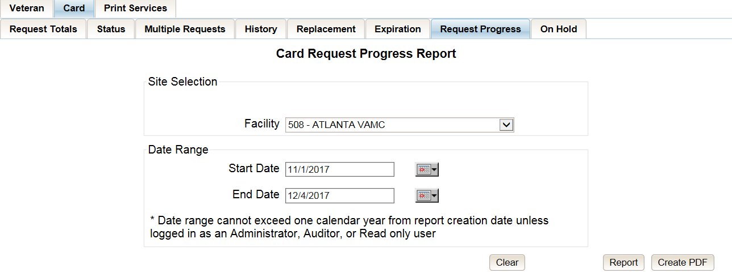

Figure ‑: Card Request Progress Report query screen – Associates

The “VHIC Card Request Progress National Summary Report” lists all of the VISNs and contains a hyperlink in the “VISN #” column. Clicking the hyperlink takes the user to the “VHIC Card Request Progress VISN Summary Report.”

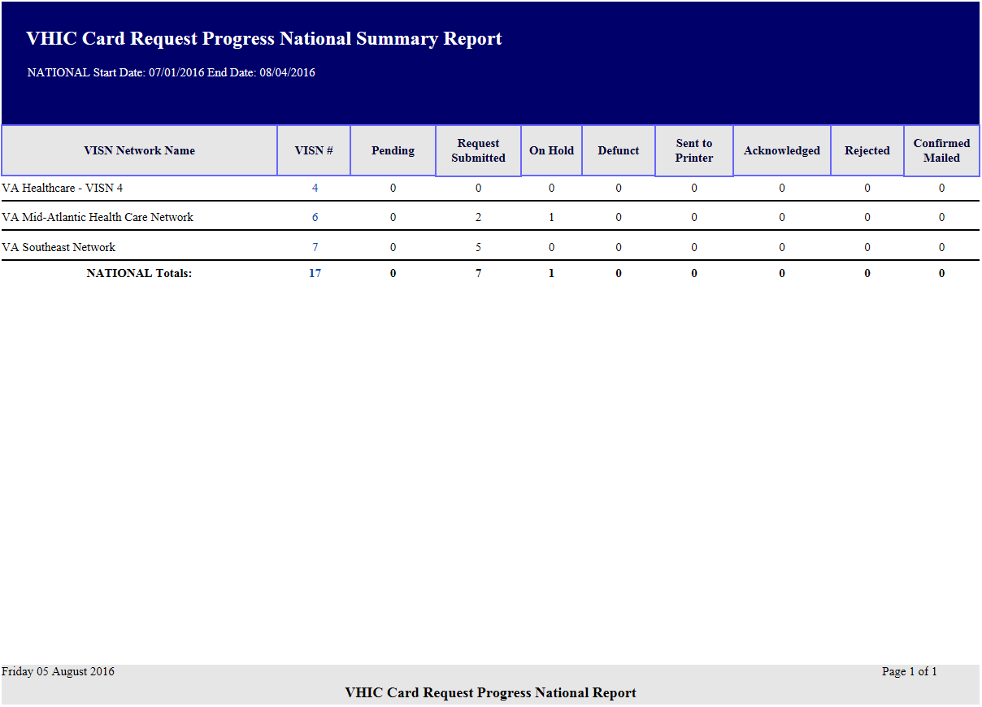

Figure ‑: VHIC Card Request Progress National Summary Report

The “VHIC Card Request Progress VISN Summary Report” lists all of the Facilities included in the selected VISN and contains a hyperlink in the “Facility #” column. Clicking the hyperlink takes the user to the “VHIC Card Request Progress Facility Summary Report.”

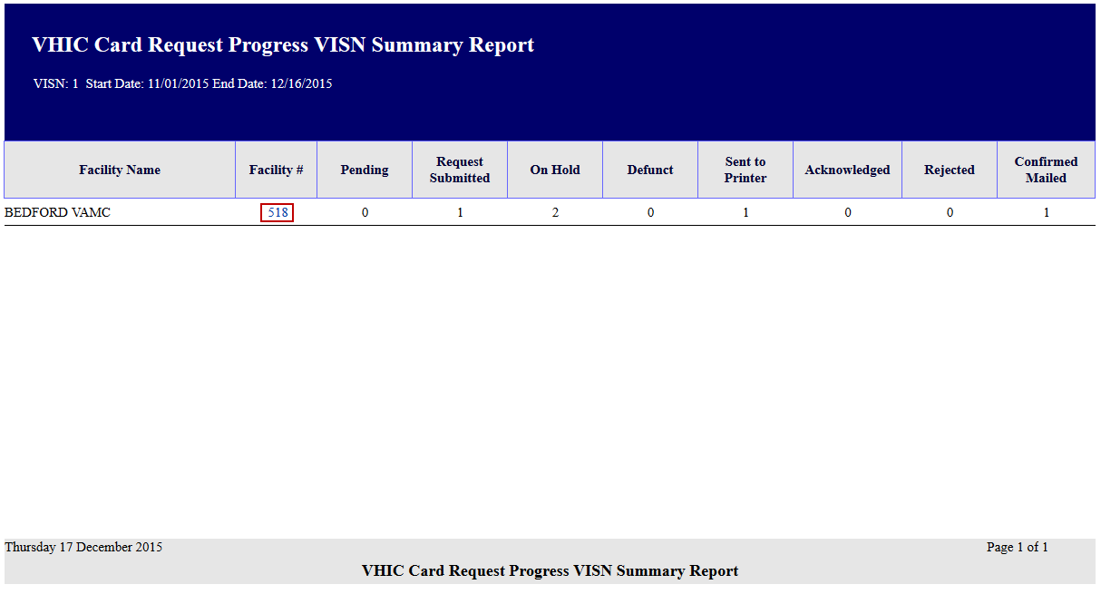

Figure ‑: VHIC Card Request Progress VISN Summary Report

The “VHIC Card Request Progress Facility Summary Report” contains a hyperlink on the number displayed for each progress status column. Clicking the hyperlink takes the user to the “VHIC Card Request Progress Facility Detail Report” for the selected progress status.

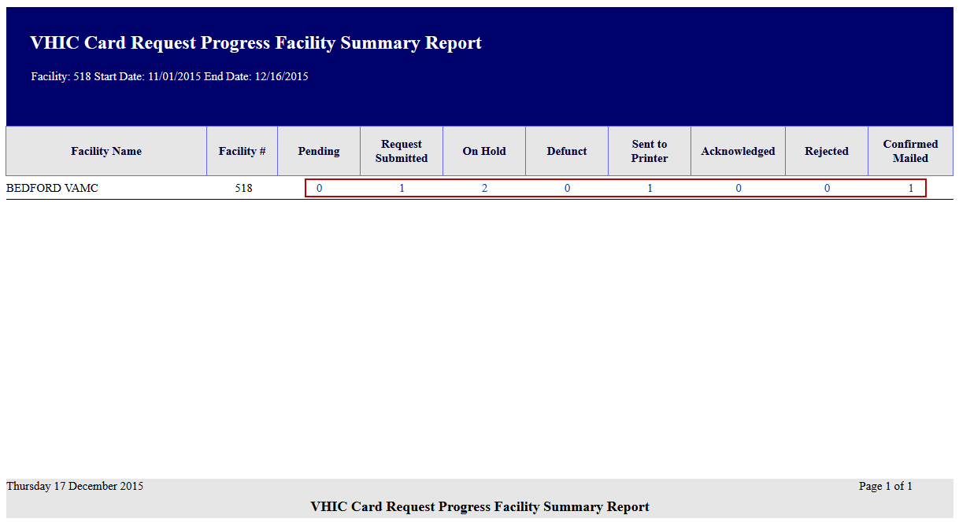

Figure ‑: VHIC Card Request Progress Facility Summary Report

The “VHIC Card Request Progress Facility Detail Report” will provide a detailed list of all the cards that have the selected status. The user will be able to see the Status Date, Veteran’s Name, Card ID and Member ID (if available).

The “VHIC Card Request Progress Facility Detail Report” contains hyperlinks in both the “Card Number” column and the “Last Name” column. Clicking the hyperlink under Card Number will take the user to the Card History report for that Card ID, and clicking on the hyperlink under the Last Name takes the user to the Veteran Detail Report for the Veteran selected.

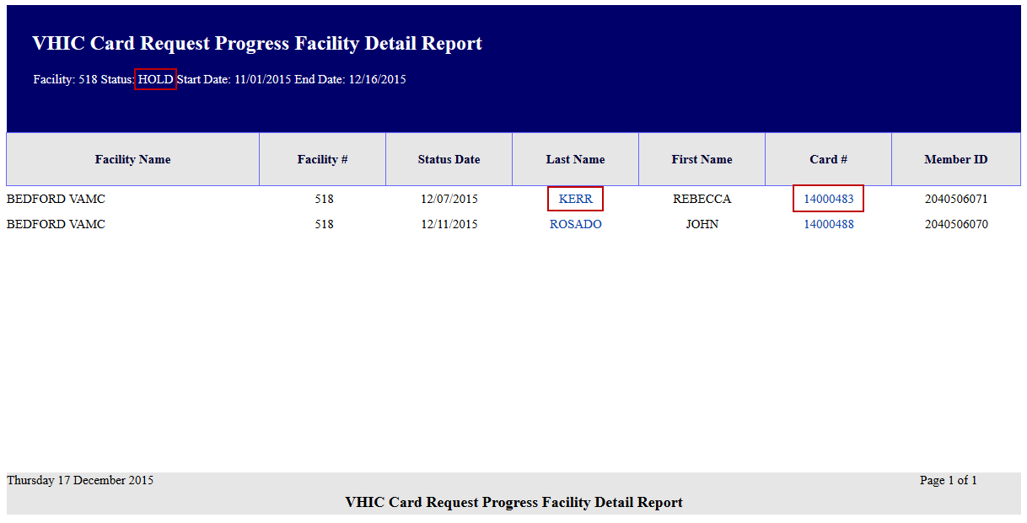

Figure ‑: VHIC Card Request Progress Facility Detail Report

## Card Swipe/Scan Report

Table 12: Card Swipe/Scan Report at a Glance

| **At a Glance…** |  |
| --- | --- |
| Who can access this report? | *Administrator, Tech Admin (Tier 3), Auditor* |
| Who can access National version? | *N/A* |
| Date Range Allowed | *N/A* |
| Search Criteria Available | *Card ID* |

The Card Swipe/Scan Report will allow the Administrator, Tech Admin (Tier 3) and the Auditor to look up all of the swipe scan information for a given card ID.

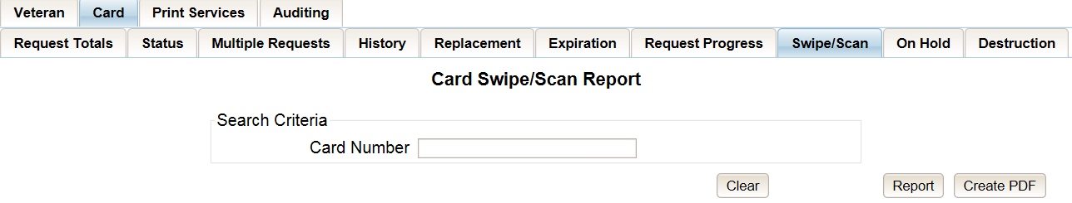

Figure ‑: VHIC Card Swipe/Scan Report query screen - Administrators, Tech Administrators (Tier 3), and Auditors

For now, the expected result will be that no swipe scan data has been found until the service that will pass VHIC the information has been promoted into Production.

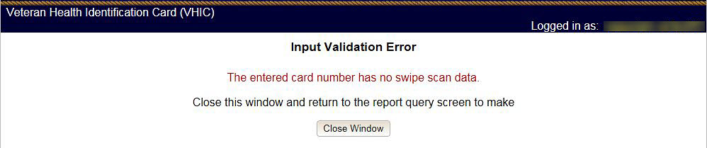

Figure ‑: No Swipe/Scan data for the card ID entered message

The expected report, once we are able to receive data, will look like this. It will include the Veteran’s Name, Card ID, Member ID (if available), Facility Name, Facility #, where the card was either scanned or swiped and the Date/Time.

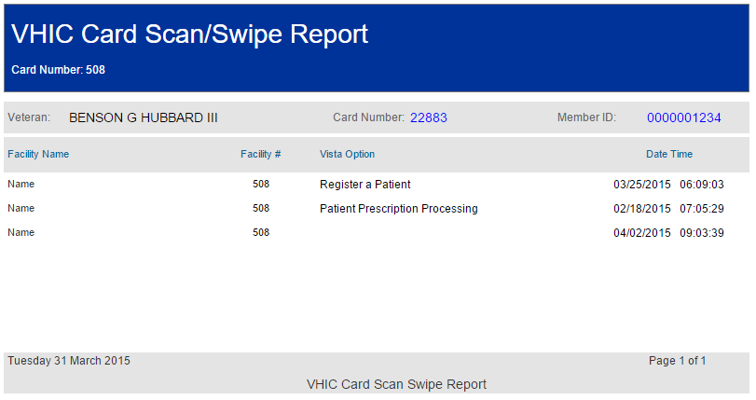

Figure ‑: VHIC Card Swipe/Scan Report

## Card On Hold Report

Table 13: On Hold Status Report at a Glance

| **At a Glance…** |  |
| --- | --- |
| Who can access this report? | *Administrator, Tech Admin (Tier 3), Supervisor, Associate, Auditor* |
| Who can access National version? | *Administrator, Tech Admin (Tier 3), Auditor* |
| Date Range Allowed | *Admins, Tech Admin (Tier 3), Auditor – unlimited*  *Supervisor, Associate – one (1) year or less from date report is being run* |
| Search Criteria Available | *VISN, Facility, Start Date, End Date* |

The *On Hold Status Report* contains one category: On Hold Status. This report has the usual search criterial options such as National, VISN or Facility, Start Date, and End Date. Along with those, the user must select one of seven On Hold Status options: All, *Not Proofed, Eligibility Pending, Enrollment Services Unavailable, Not Correlated, No Photo and Bad Data*.

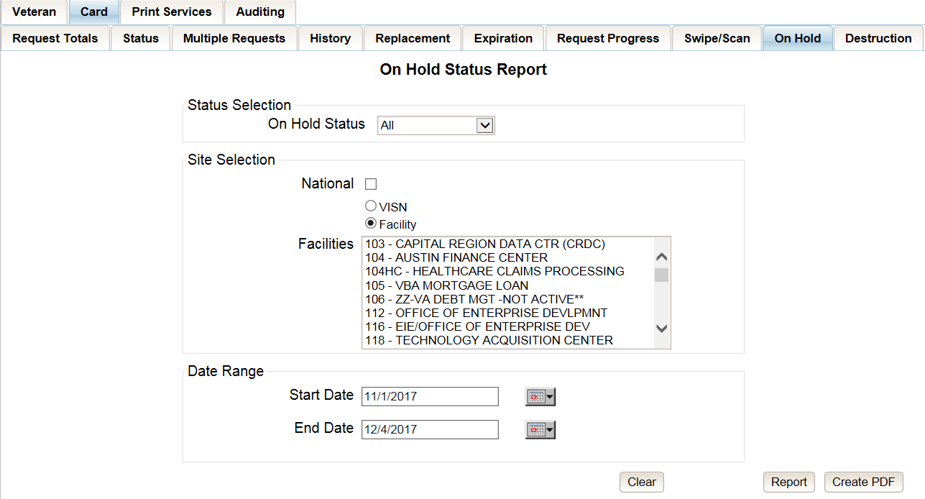

Figure ‑: On Hold Status Report query screen – Administrator and Tech Administrator (Tier 3)

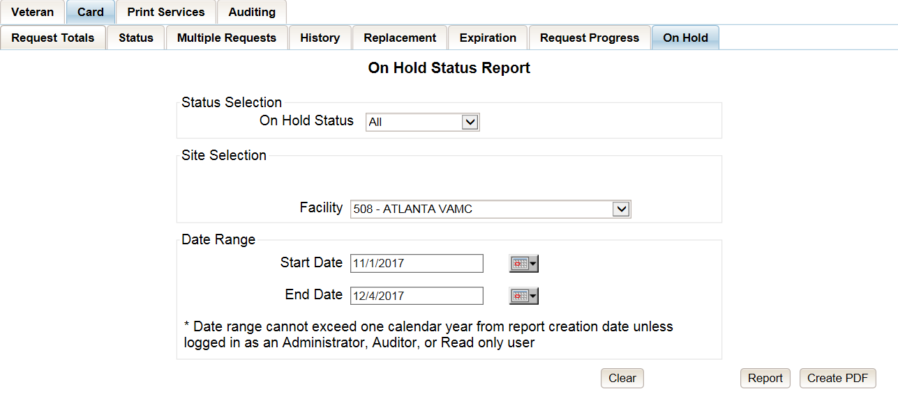

Figure ‑: On Hold Status Report query screen – Supervisor

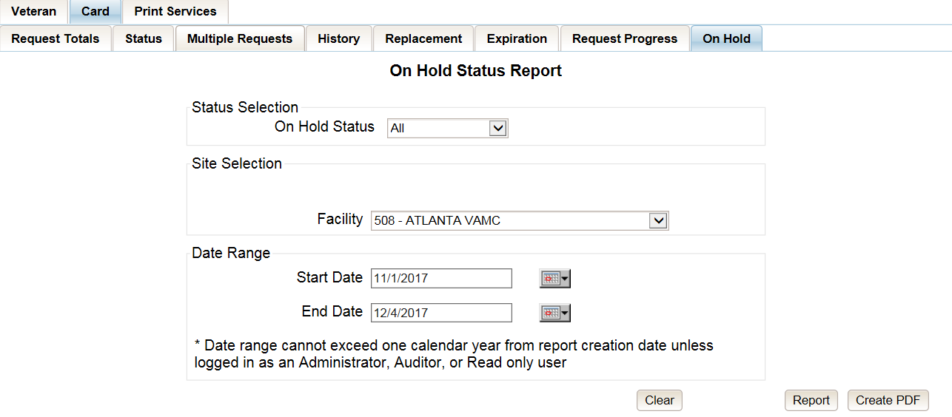

Figure ‑: On Hold Status Report query screen – Associate

The “VHIC On Hold Card Status National Summary Report” lists all of the VISNs and contains a hyperlink in the “VISN #” column. Clicking the hyperlink takes the user to the “VHIC On Hold Card Status VISN Summary Report.”

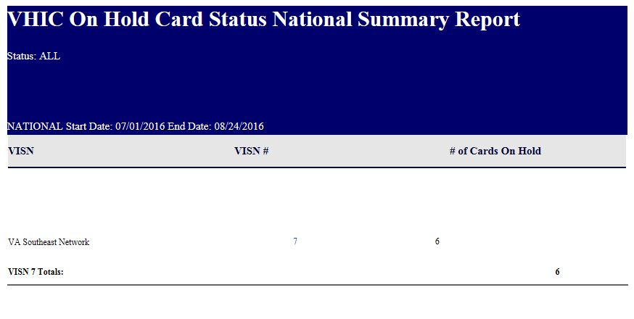

Figure ‑: VHIC On Hold Card Status National Summary Report

The “VHIC On Hold Card Status VISN Summary Report” lists all of the Facilities pertaining to the selected VISN and contains a hyperlink in the “Facility #” column. Clicking the hyperlink takes the user to the “VHIC On Hold Card Status Facility Summary Report.”

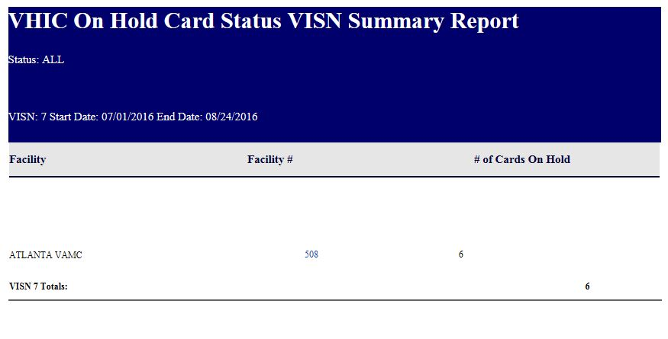

Figure ‑: VHIC On Hold Card Status VISN Summary Report

The “VHIC On Hold Card Status Facility Summary Report” displays the total number of cards On Hold for the selected Facility VISN and contains a hyperlink in the “Facility #” column. Clicking the hyperlink takes the user to the “VHIC On Hold Card Status Facility Detail Report.”

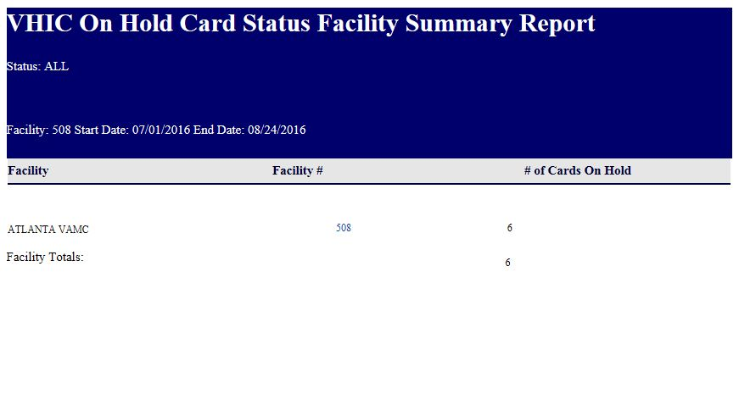

Figure ‑: VHIC On Hold Card Status Facility Summary Report

The “VHIC On Hold Card Status Facility Detail Report” contains several columns: *Facility Name, Facility #, On Hold Date, On Hold Reason, Card Issuer, Last Name, and Card Id.* The purpose of this report is to provide detailed information in regards to cards that are, or have been, placed on hold. There are hyperlinks in the *Last Name and Card ID* columns.

* Clicking on the hyperlinked Last Name will take the user to the VHIC Veteran Detail Report
* Clicking the hyperlinked Card ID will take the user to the VHIC Card History Report

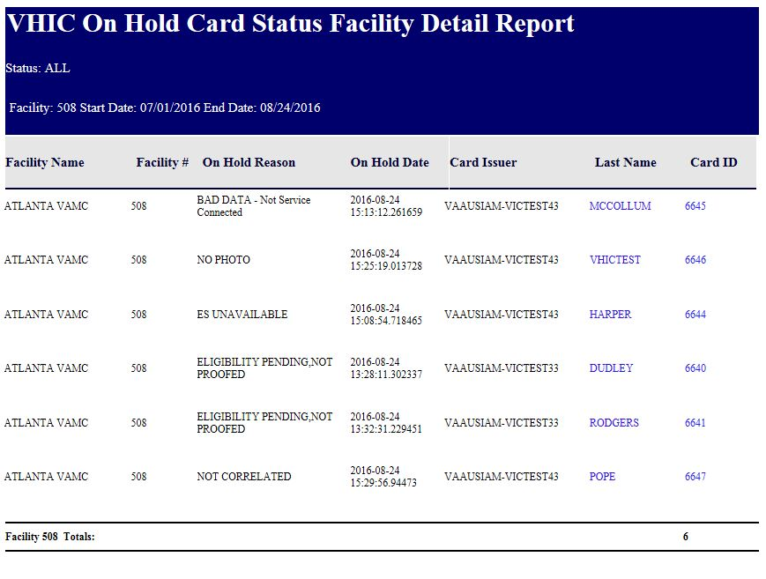

Figure ‑: VHIC On Hold Card Status Facility Detail Report

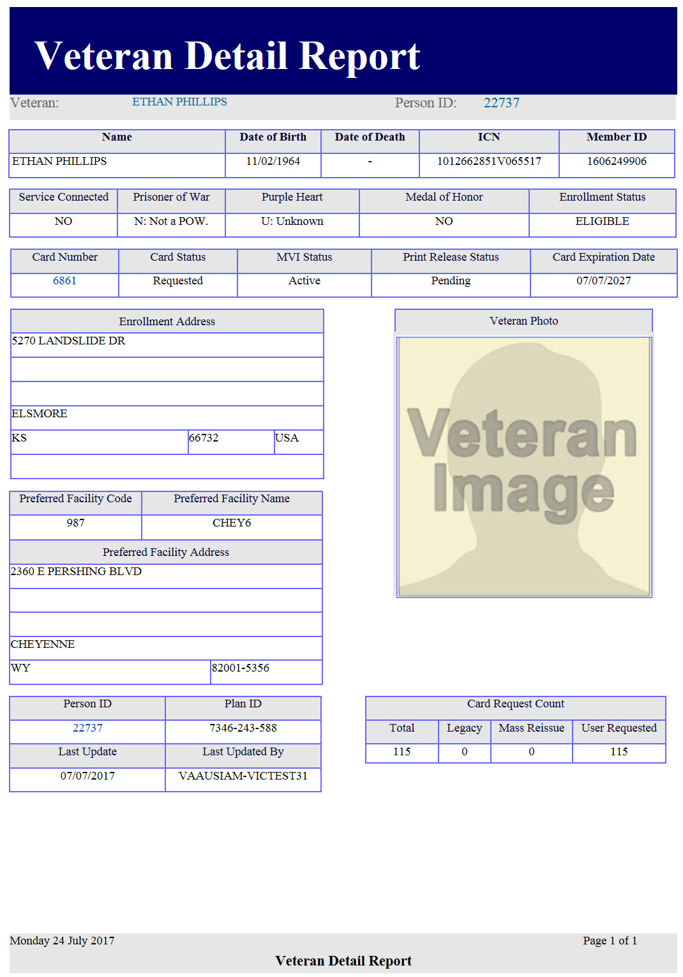

Figure ‑: VHIC Veteran Detail Report

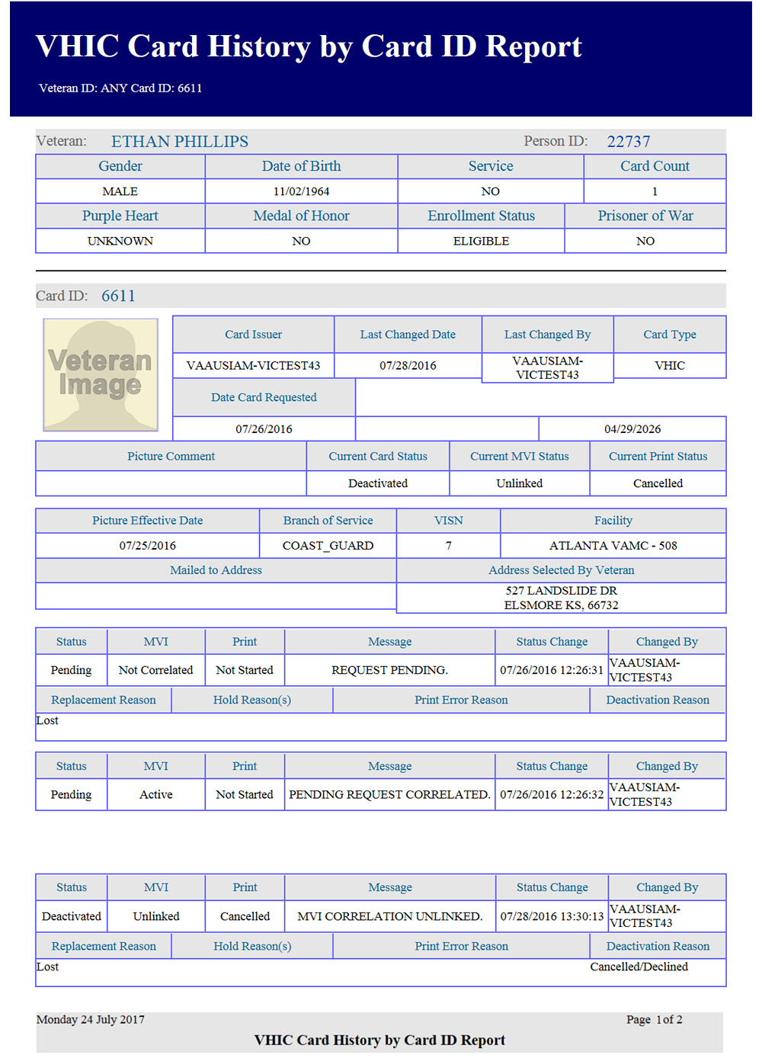

Figure ‑: VHIC Card History by Card ID

## Card Destruction Report

Table 13: Card Destruction Report at a Glance

| **At a Glance…** |  |
| --- | --- |
| Who can access this report? | *Administrator, Tech Admin (Tier 3), Supervisor, Associate, Auditor* |
| Who can access National version? | *Administrator, Tech Admin (Tier 3), Auditor* |
| Date Range Allowed | *Admins, Tech Admin (Tier 3), Auditor – unlimited*  *Supervisor, Associate – one (1) year or less from date report is being run* |
| Search Criteria Available | *VISN, Facility, Start Date, End Date* |

The *Card Destruction Report* contains two categories: Pending Destruction and Destroyed. The user must also a select one of four Card Type options: *All*, *Legacy, Mass Reissuance, and VHIC.* As with other searches, the user must specify a Start Date and End Date range for the search.

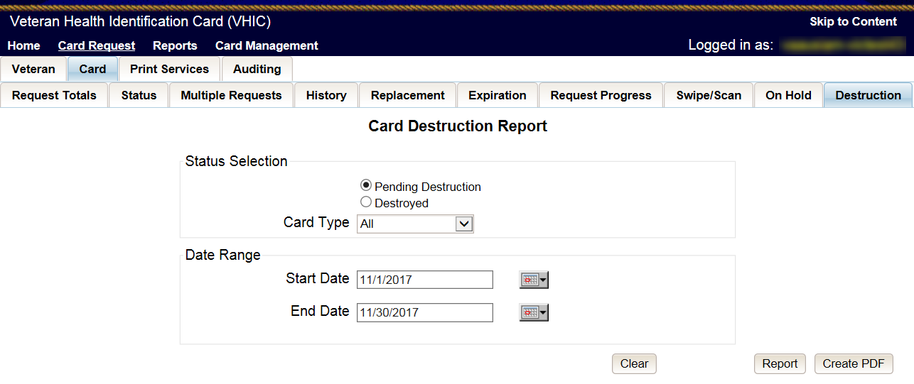

Figure ‑: Card Destruction Report – Administrators and Tech Administrators (Tier 3)

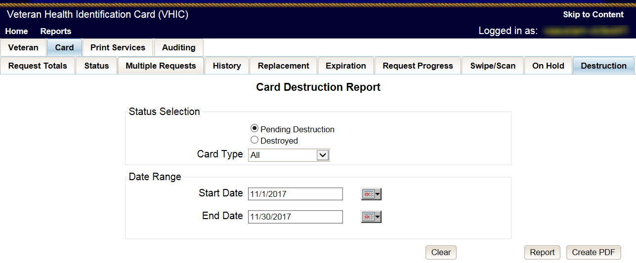

Figure ‑: Card Destruction Report – Auditors

Choosing Pending Destruction and Card Type All, users receive the “VHIC Card Destruction Report – Pending Destruction” report. Click the Last Name hyperlink highlighted below.

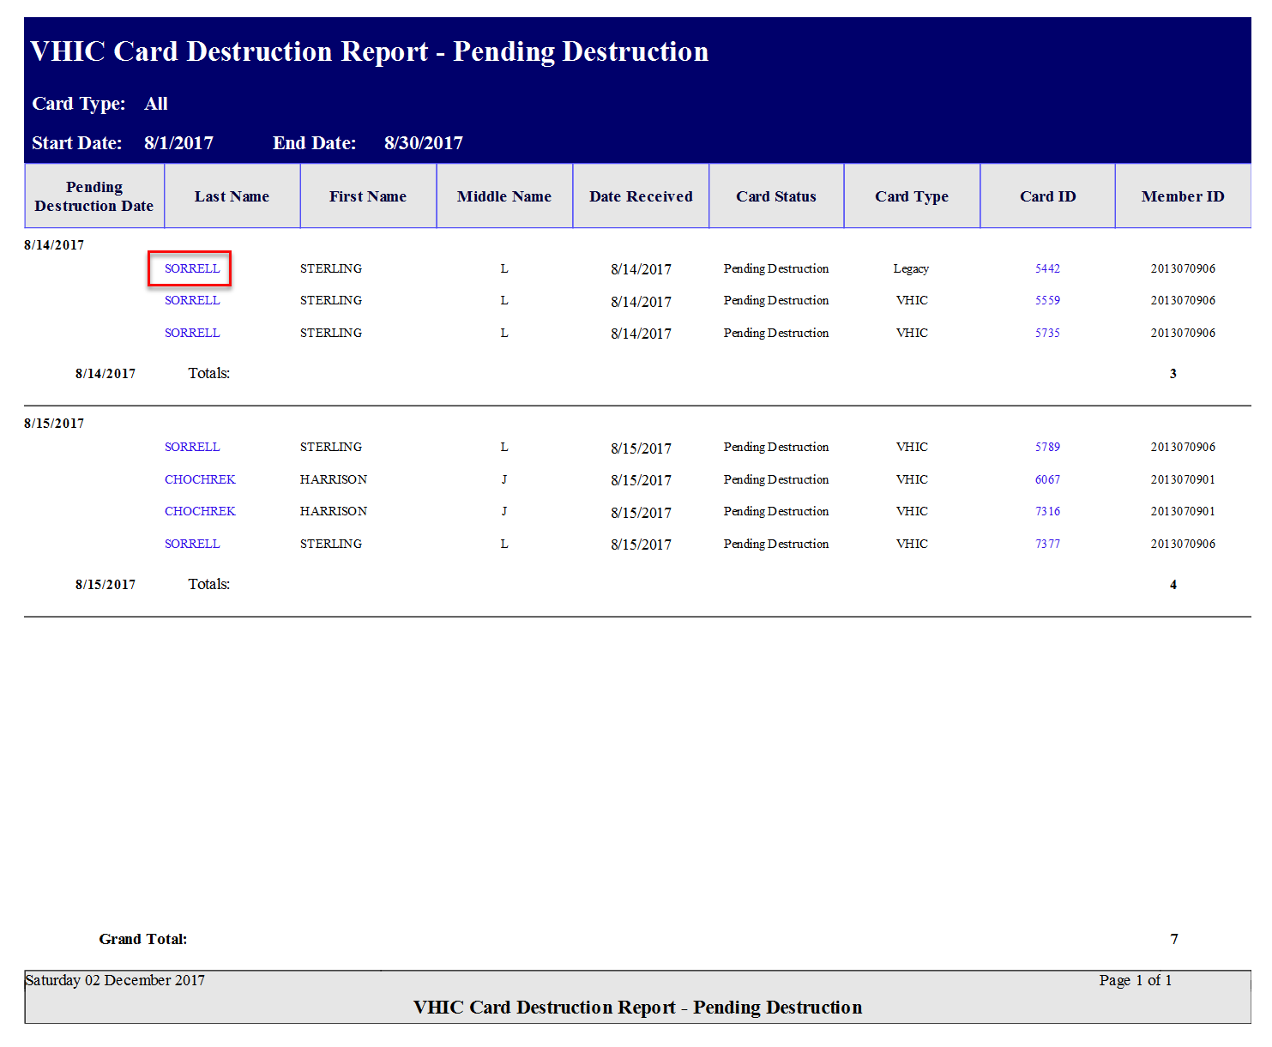

Figure ‑: Card Destruction Report – Pending Destruction – Last Name Hyperlink

This returns the Veteran Detail Report.

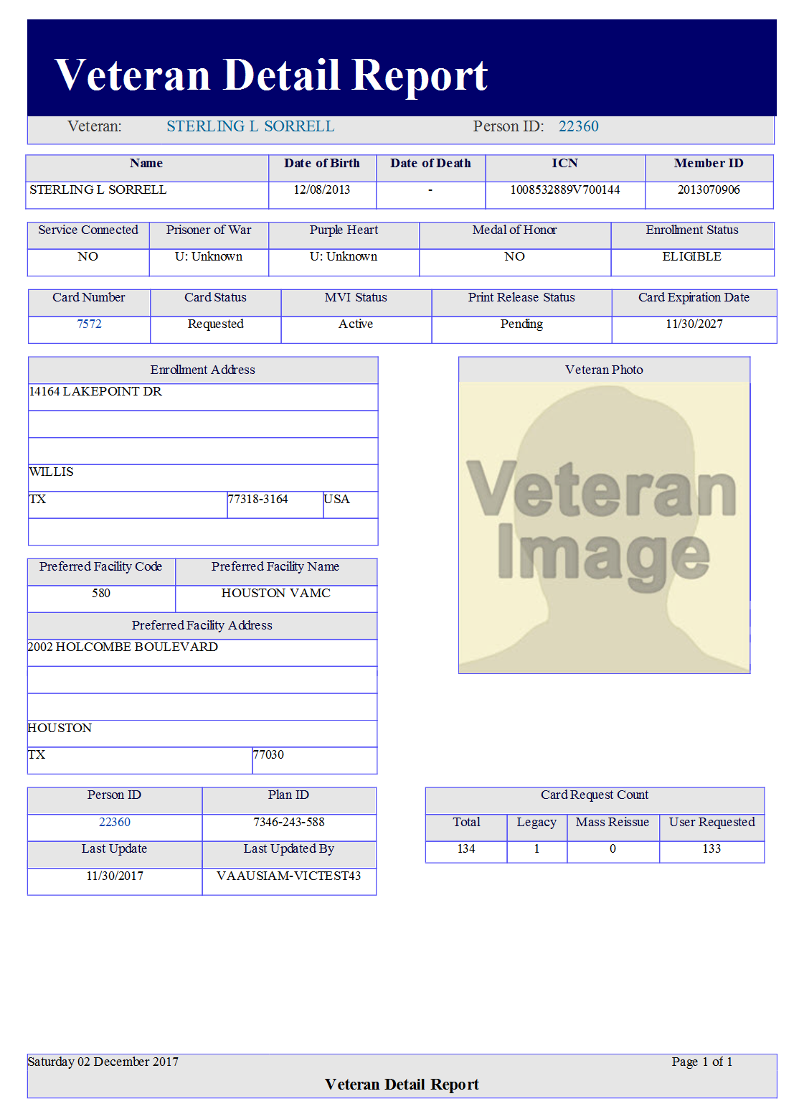

Figure ‑: Veteran Detail Report

Click the Card ID hyperlink highlighted below.

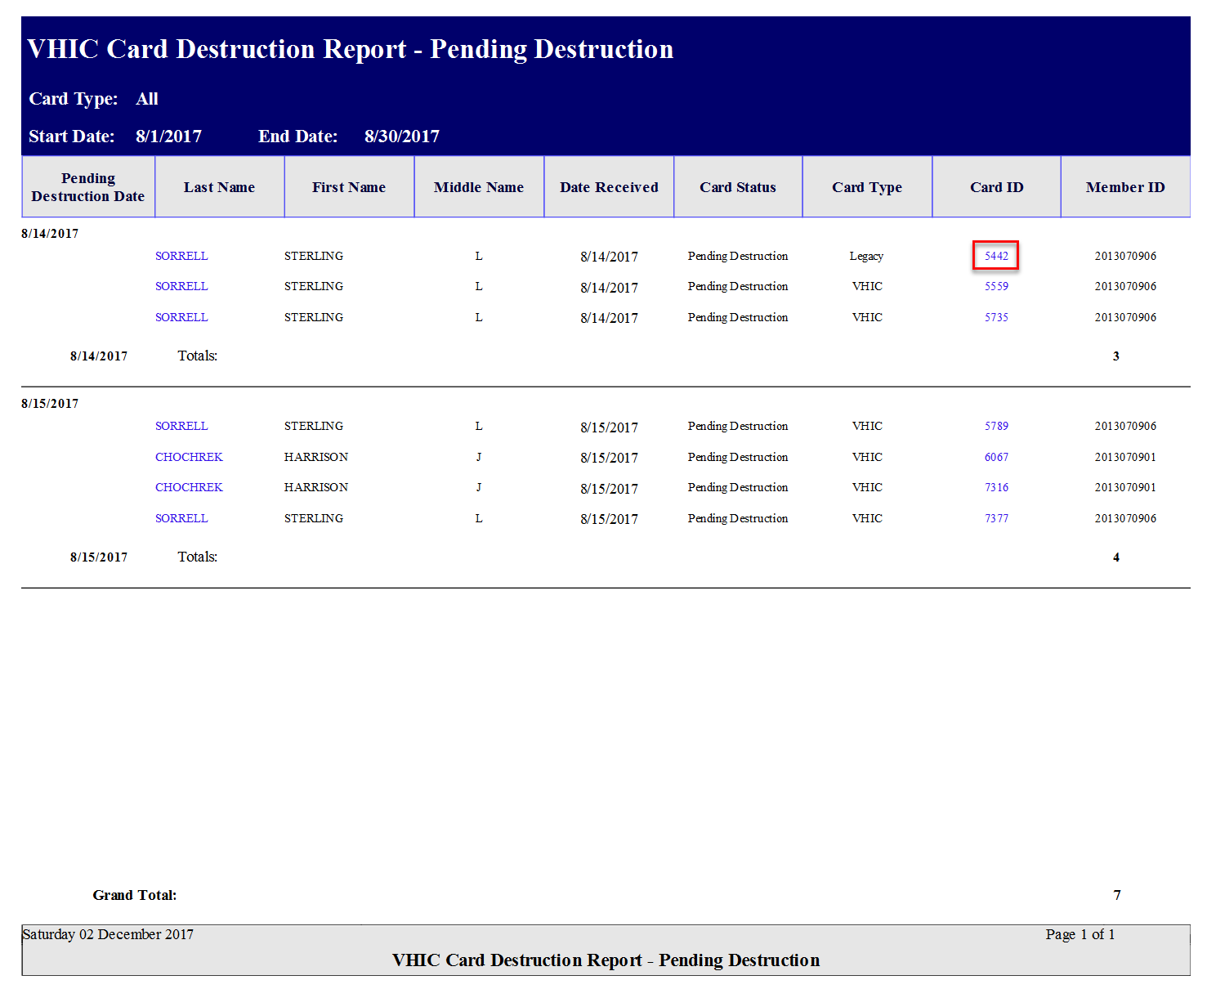

Figure ‑: Card Destruction Report – Pending Destruction – Last Name Hyperlink

The Card ID hyperlink opens the VHIC Card History by Card ID Report.

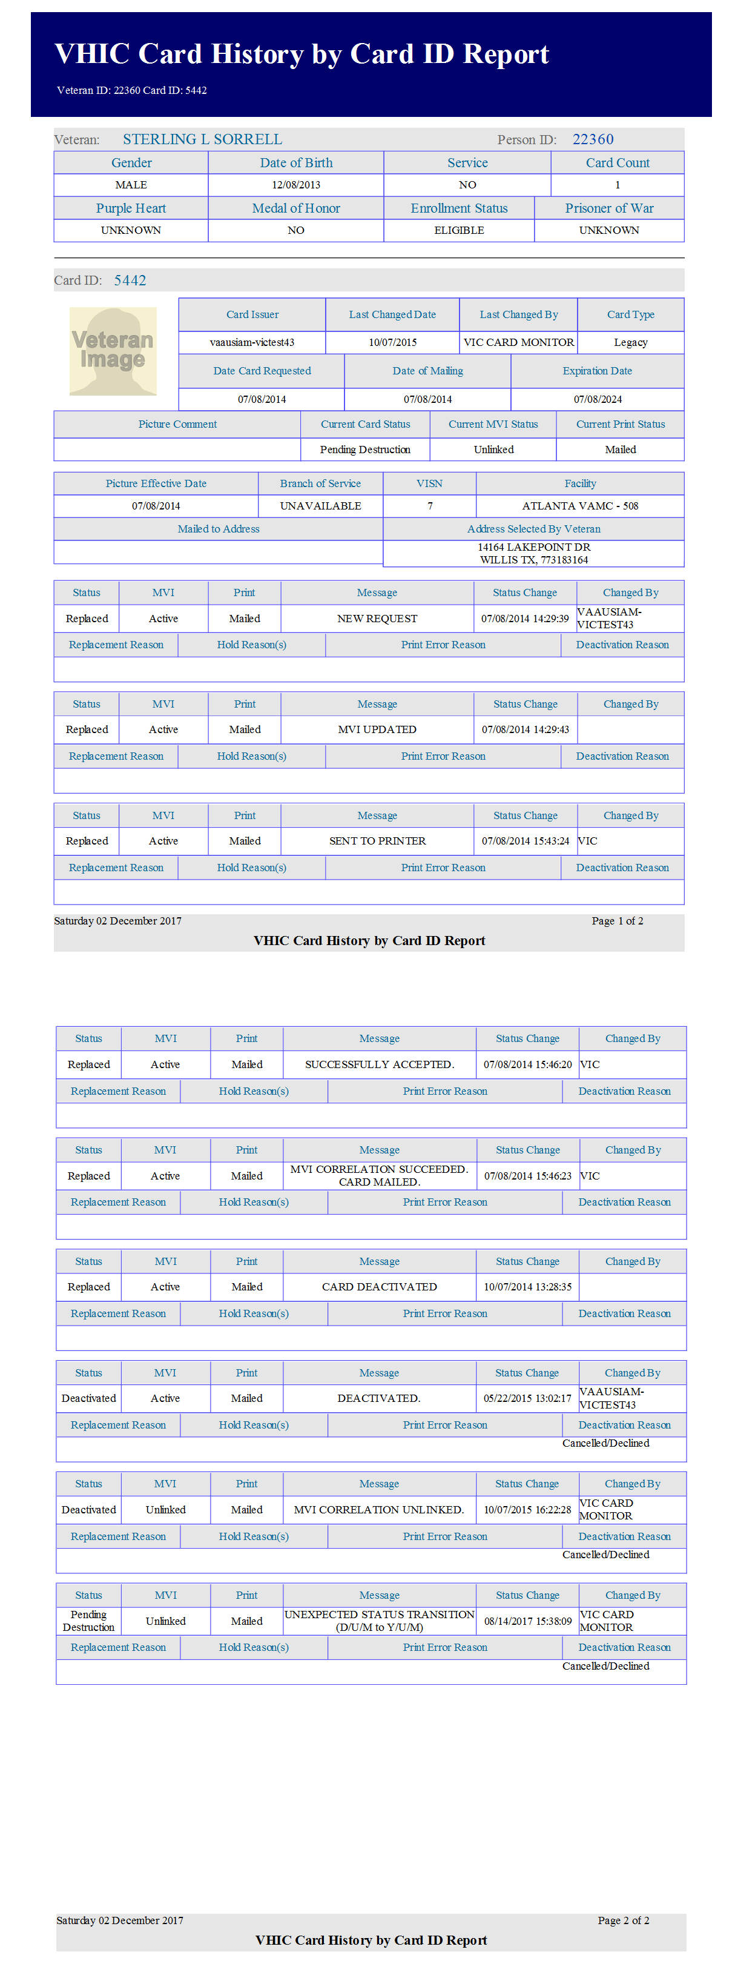

Figure ‑: VHIC Card History by Card ID Report

**NOTE:** Clicking the Person ID hyperlink, in the upper right-hand corner of the VHIC Card History by Card ID Report, opens the Veteran Detail Report.

Choosing Destroyed and Card Type All, the user receives the “VHIC Card Destruction Report – Destroyed” report. Click the Last Name hyperlink highlighted below.

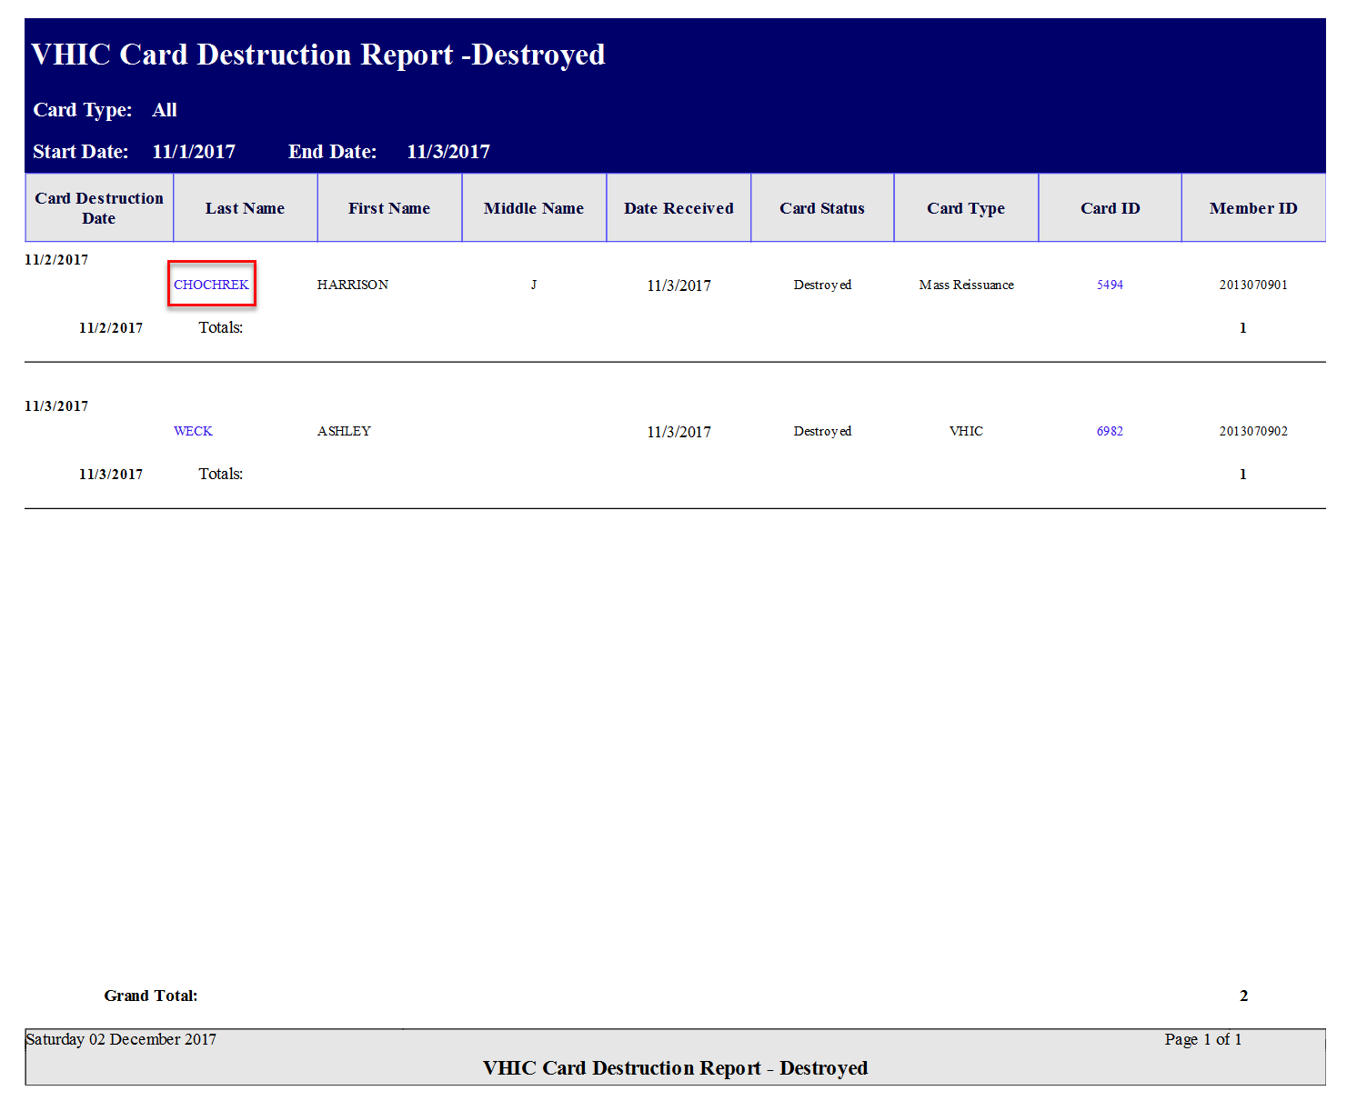

Figure ‑: VHIC Card History by Card ID Report

The Last Name hyperlink opens the Veteran Detail Report.

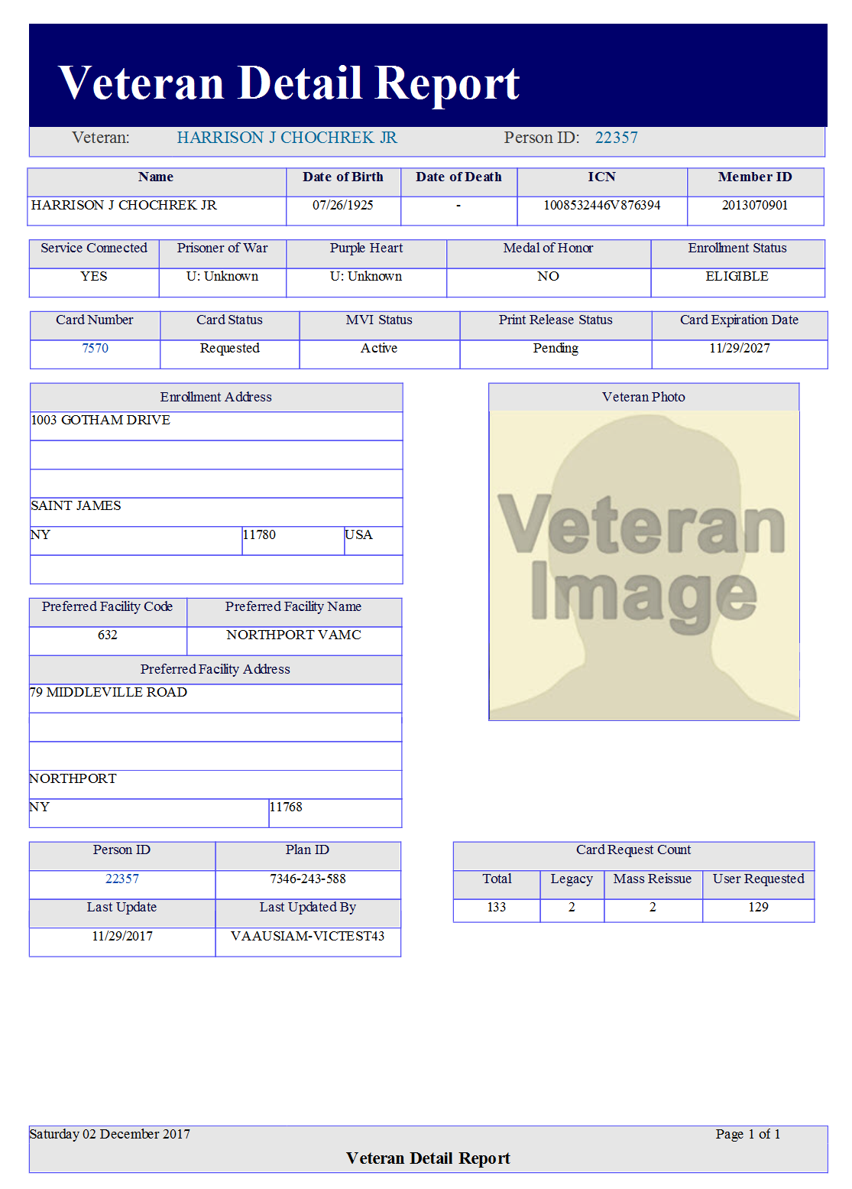

Figure ‑: Veteran Detail Report

Click the Card ID hyperlink highlighted below.

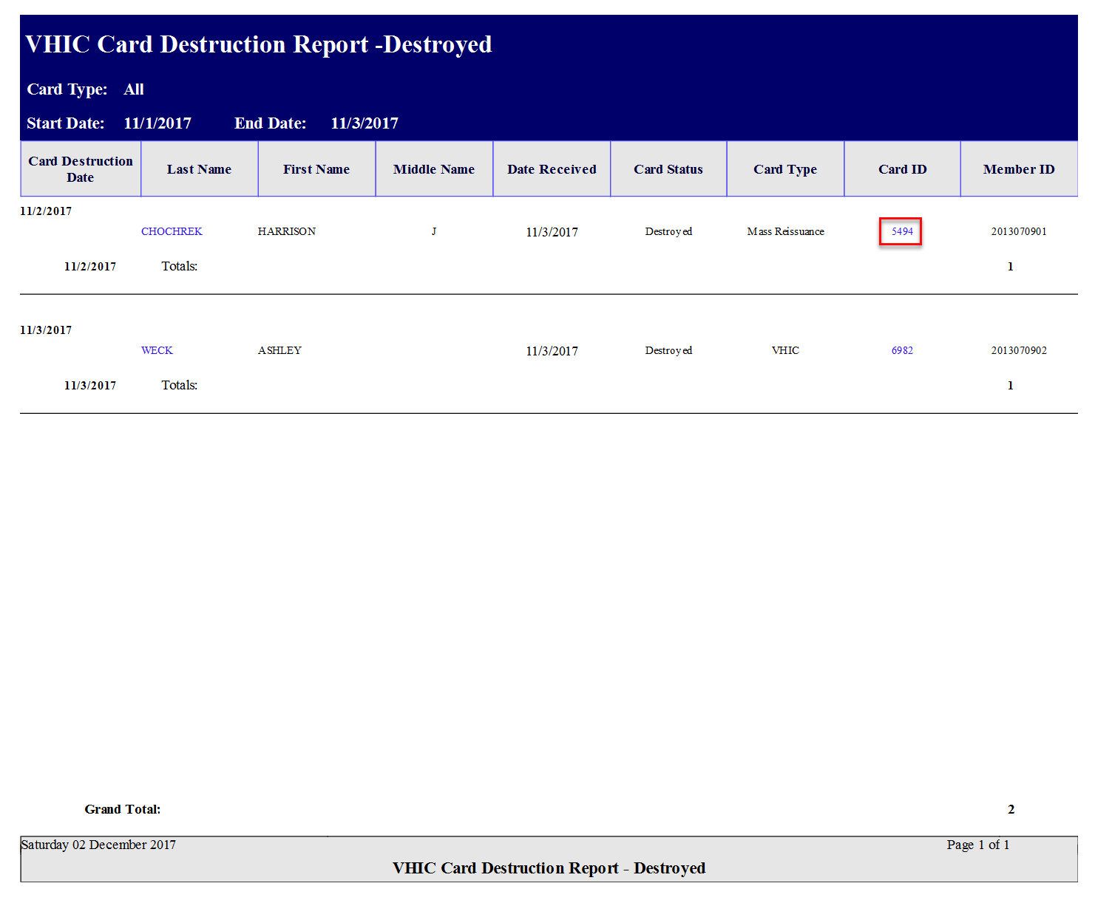

Figure ‑: VHIC Card Destruction Report - Destroyed - Card ID Hyperlink

The Card ID hyperlink opens the VHIC Card History by Card ID Report.

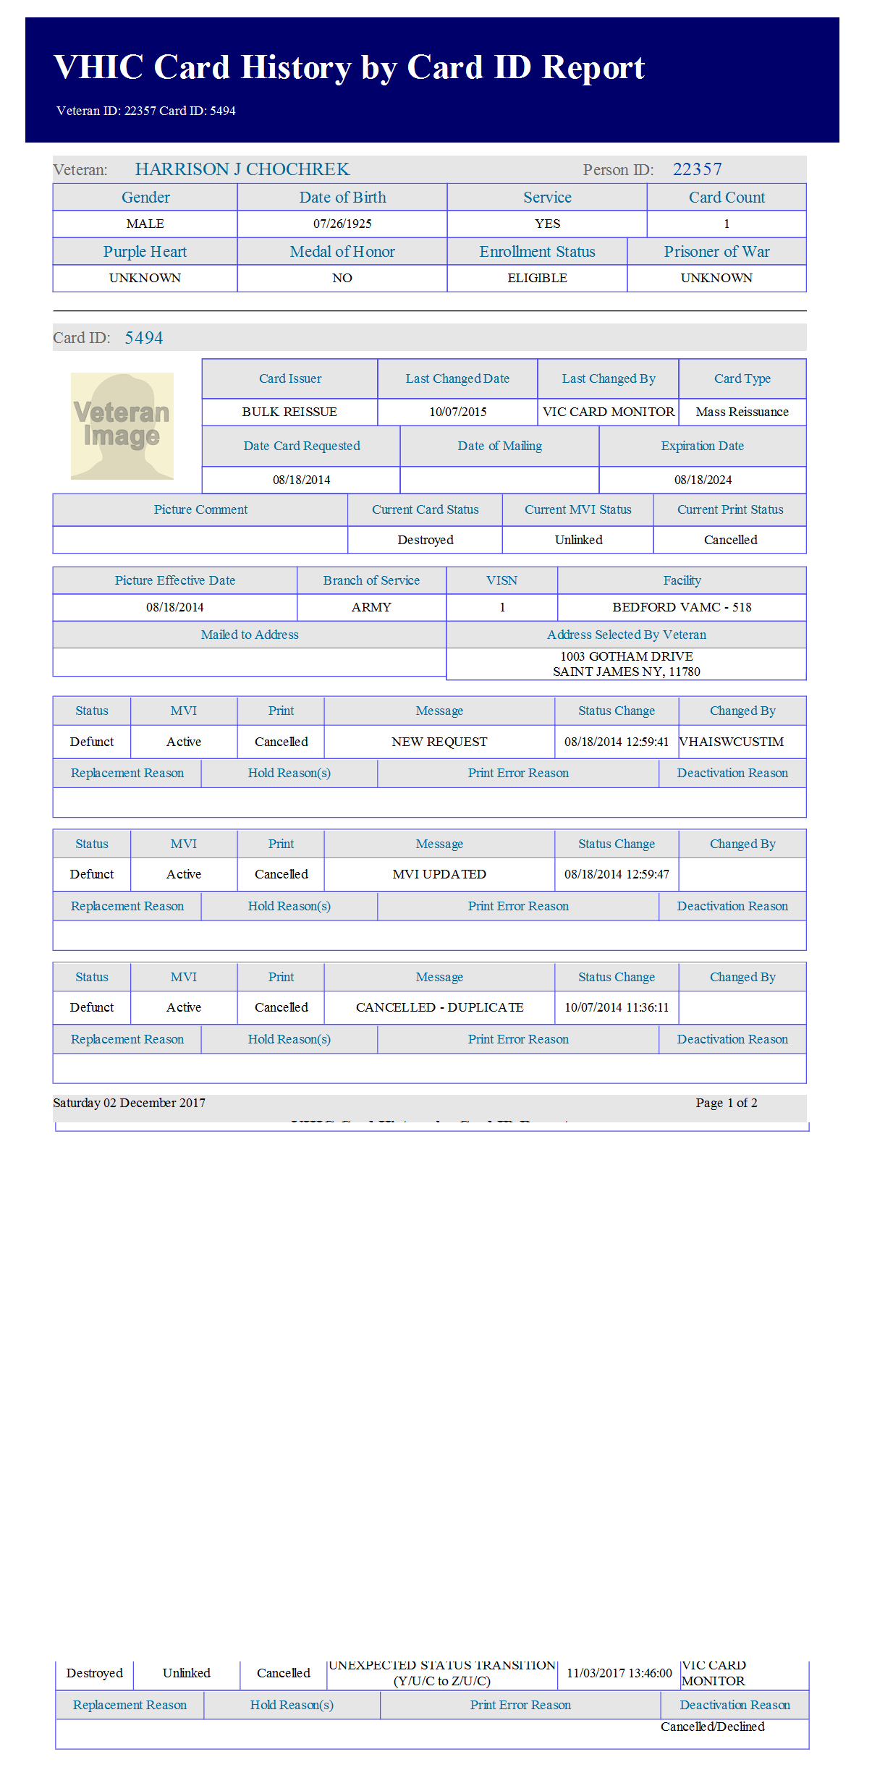

Figure ‑: VHIC Card History by Card ID Report

**NOTE:** Clicking the Person ID hyperlink, in the upper right-hand corner of the VHIC Card History by Card ID Report, opens the Veteran Detail Report.

## Print Services – Processing Report

Table 14: Batch Summary Report at a Glance

| **At a Glance…** |  |
| --- | --- |
| Who can access this report? | *Administrator, Supervisor, Tech Admin (Tier 3), Auditor* |
| Who can access National version? | *Administrator, Tech Admin (Tier 3), Auditor* |
| Date Range Allowed | *Admins, Tech Admin (Tier 3), Auditor – unlimited*  *Supervisor, Associate – one (1) year or less from date report is being run* |
| Search Criteria Available | *VISN, Facility, Start Date, End Date* |

Clicking **[Submit]** on step 6 of the Card Request process does not immediately transmit a card request to the print vendor. The card requests from all sites are stored throughout the day, then bundled and transmitted to the print vendor in one batch file. When the print vendor receives the batch file, they send back a confirmation message. The Print Services reports provide the user with information received from the Print Vendor after sending the batch files.

After processing the card requests in a batch file, the print vendor sends back to VHIC an acknowledgement file for every request specifying success or failure in card printing. The numbers in the report comes from the data updated by the confirmation and acknowledgement files received from the print vendor.

The *Print Services Processing Status Summary Report* date fields are not auto-populated like most of the other reports. The user must populate them prior to running the report.

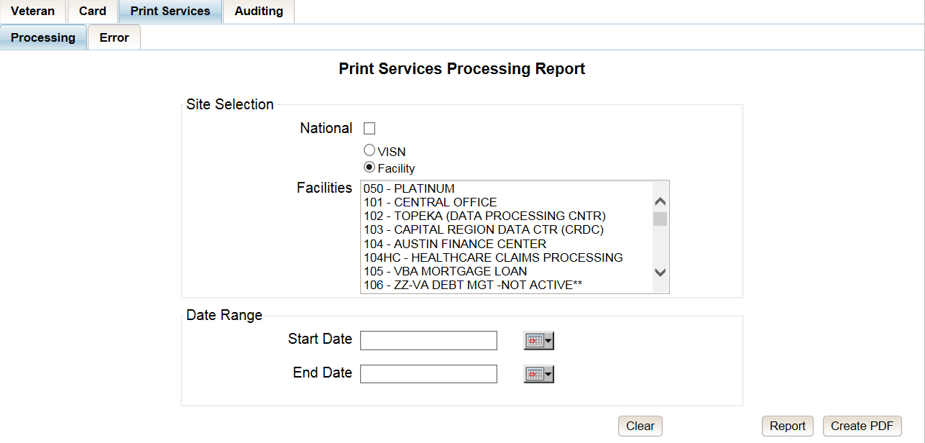

Figure ‑: VHIC Print Services Processing Status Summary Report – Administrators and Tech Administrators (Tier 3)

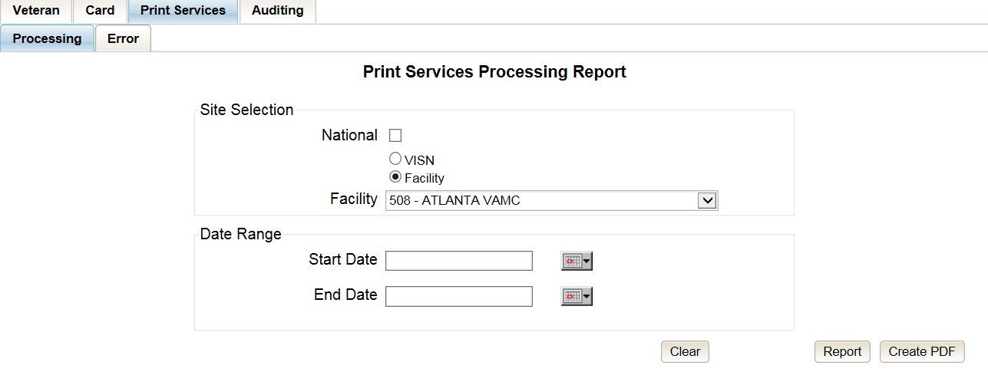

Figure ‑: VHIC Print Services Processing Status Summary Report – Auditors

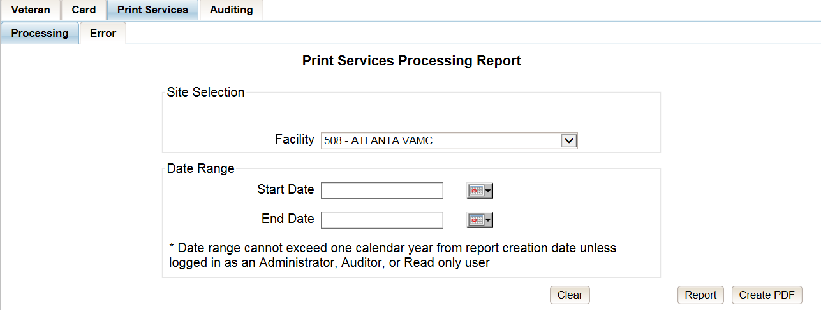

Figure ‑: VHIC Print Services Processing Status Summary Report – Supervisors

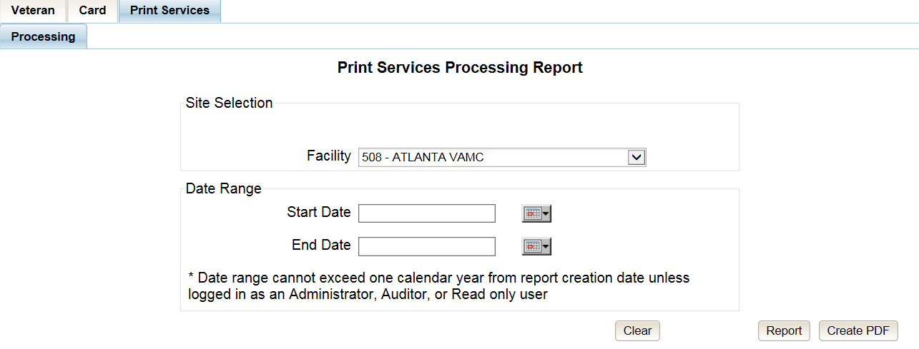

Figure ‑: VHIC Print Services Processing Status Summary Report query screen – Associates

The “VHIC Batch File Processing Status Summary Report” provides a high-level count of Accepted, Error, Sent, Mailed, and Rejected card requests. The “VHIC Batch File Processing Status National Summary Report” has a hyperlink in the VISN number column that will take you to the “VHIC Batch File Processing Status Summary Report – VISN.”

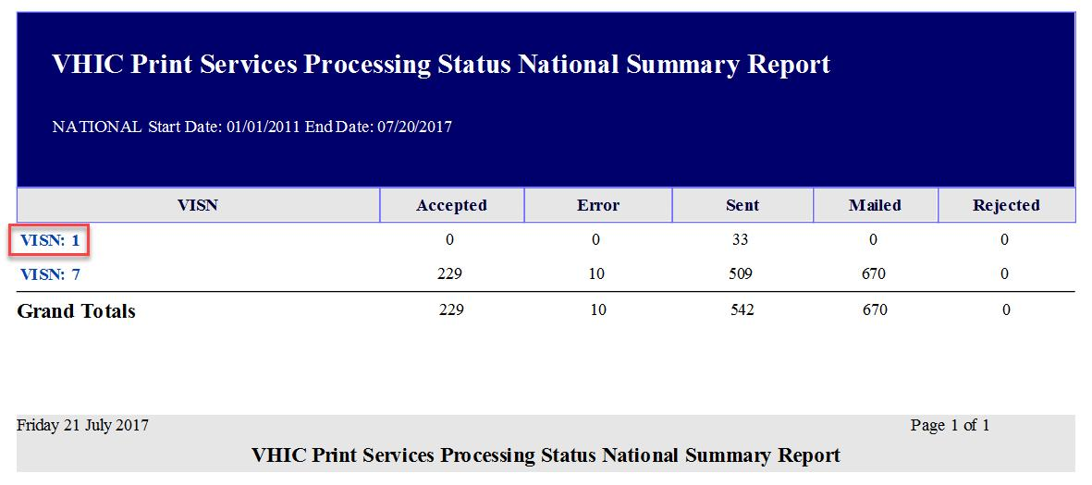

Figure ‑: VHIC Print Services Processing Status Summary Report

The “VHIC Batch File Processing Status Summary Report – VISN” has a hyperlink in the Facility Code column that will take you to the “VHIC Batch File Processing Status Summary Report – Facility.”

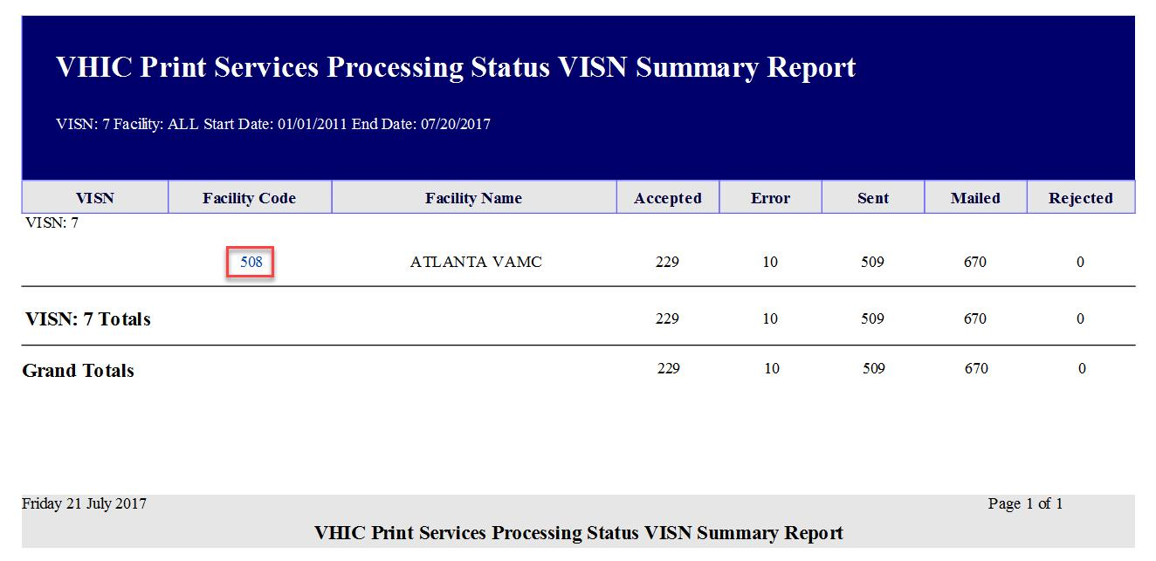

Figure ‑: VHIC Print Services Processing Status VISN Summary Report

The “VHIC Batch File Processing Status Summary Report – Facility” has a hyperlink in the Facility Code column that will take you to the “VHIC Batch File Processing Status Detail Report.”

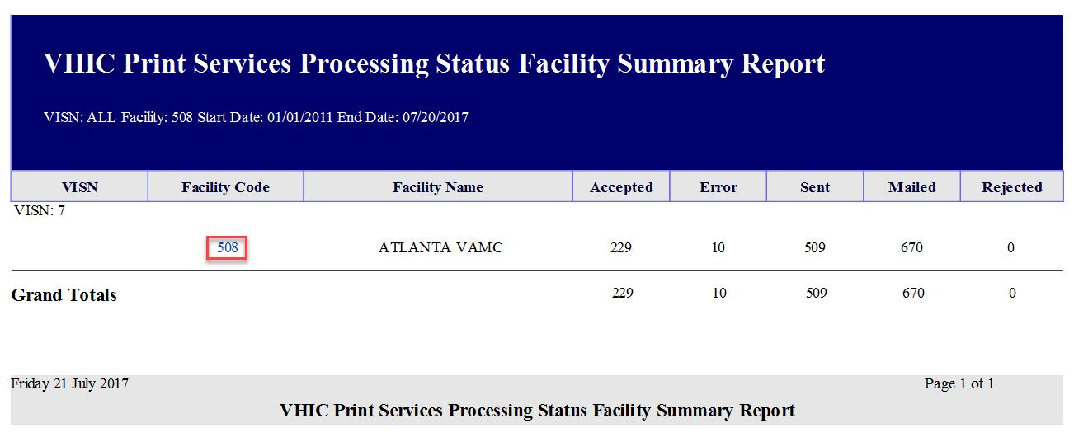

Figure ‑: VHIC Print Services Processing Status Facility Summary Report

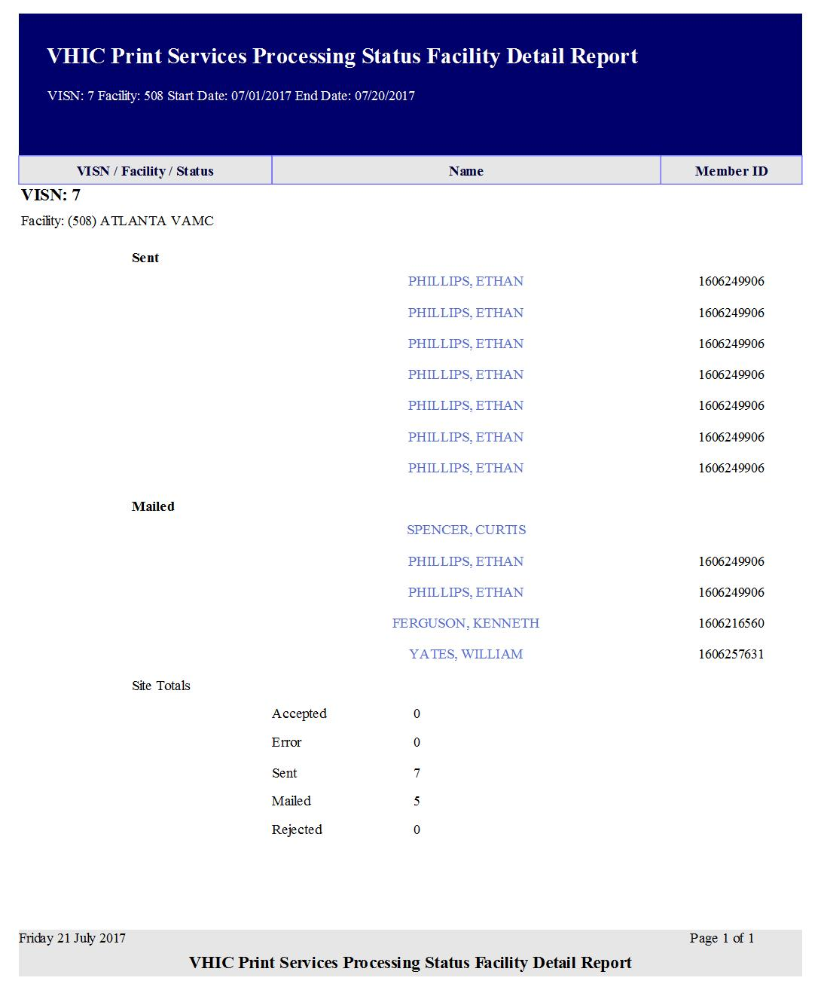

Figure ‑: VHIC Print Services Processing Status Facility Detail Report

## Print Services – Batch Error Report

Table 15: Batch Error Report at a Glance

| **At a Glance…** |  |
| --- | --- |
| Who can access this report? | *Administrator, Supervisor, Tech Admin (Tier 3), Auditor* |
| Who can access National version? | *Administrator, Tech Admin (Tier 3), Auditor* |
| Date Range Allowed | *Admins, Tech Admin (Tier 3), Auditor – unlimited*  *Supervisor – one (1) year or less from date report is being run* |
| Search Criteria Available | *VISN, Facility, Not Acknowledged, Acknowledged Not Confirmed, Pending Not Sent (which includes configurable Number of Days field), Start Date, End Date* |

The *VHIC Print Error Status Summary Report – Sent Not Acknowledged* allows the user to find out how many cards have not been acknowledged with an acknowledgement file or cards that have been acknowledged but have received no confirmation of being mailed within a given date range. The user will also be able to see how many cards are still sitting in a Pending state and have not been sent to the print vendor.

The user would be able to select the number of days to configure the query. How many days after being sent to the printer before looking for an Acknowledgement file, how many days after getting the Acknowledgement file before receiving Confirmation of it being mailed, or how many days has the card been sitting at a Pending status but has not been sent to the print vendor.

The user would be able to select between National, VISN, and Facility depending on their role.

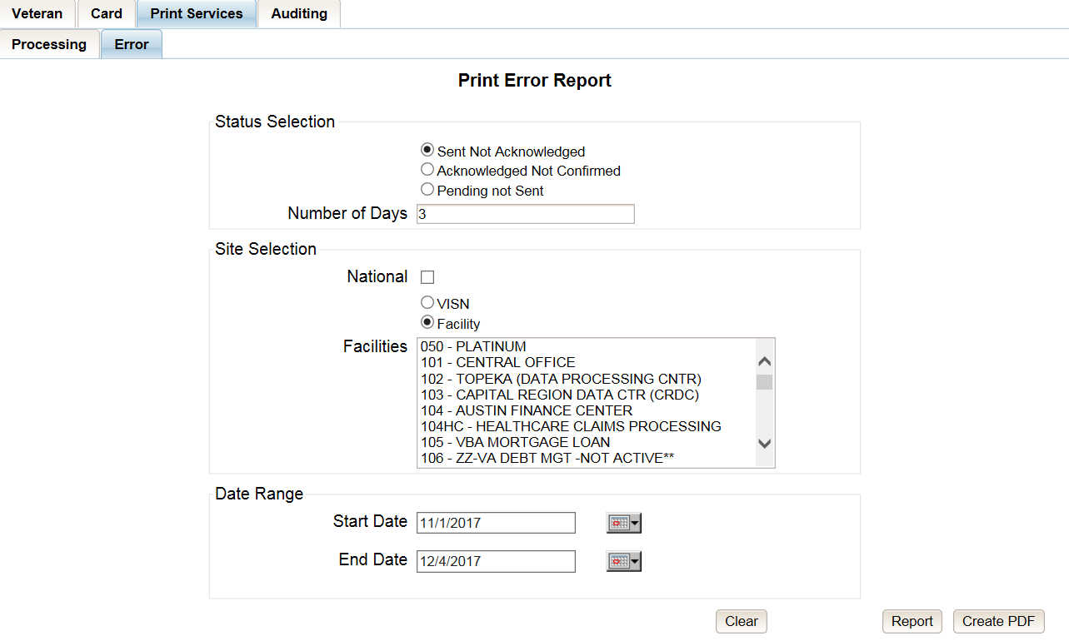

Figure ‑: Print Services – Print Error Status Report query screen – Administrators and Tech Administrators (Tier 3)

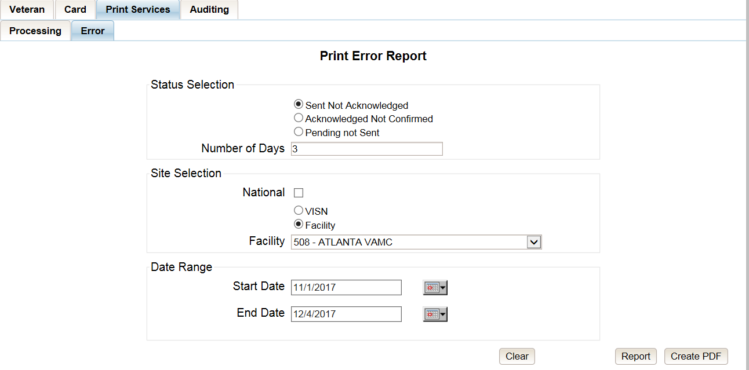

Figure ‑: Print Services - Print Error Status Report query screen – Auditors

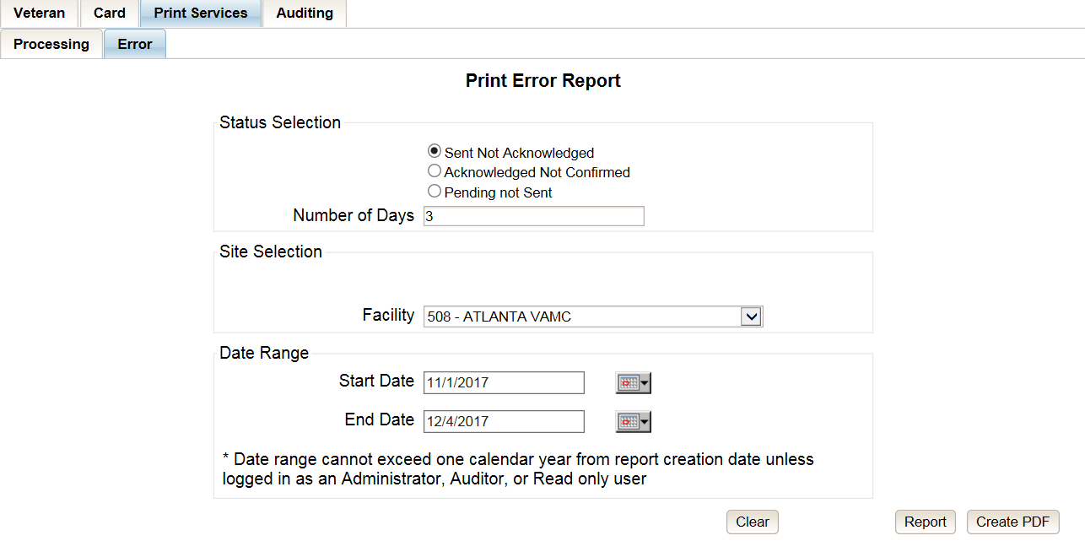

Figure ‑: Print Services - Print Error Status Report query screen – Supervisors

### Sent Not Acknowledged

By selecting the Not Acknowledged radio button, the VHIC user will be able to see how many cards have not been acknowledged as received within the entered Number of Days (the default is three (3) days) after being sent to the print vendor during the selected Date Range.

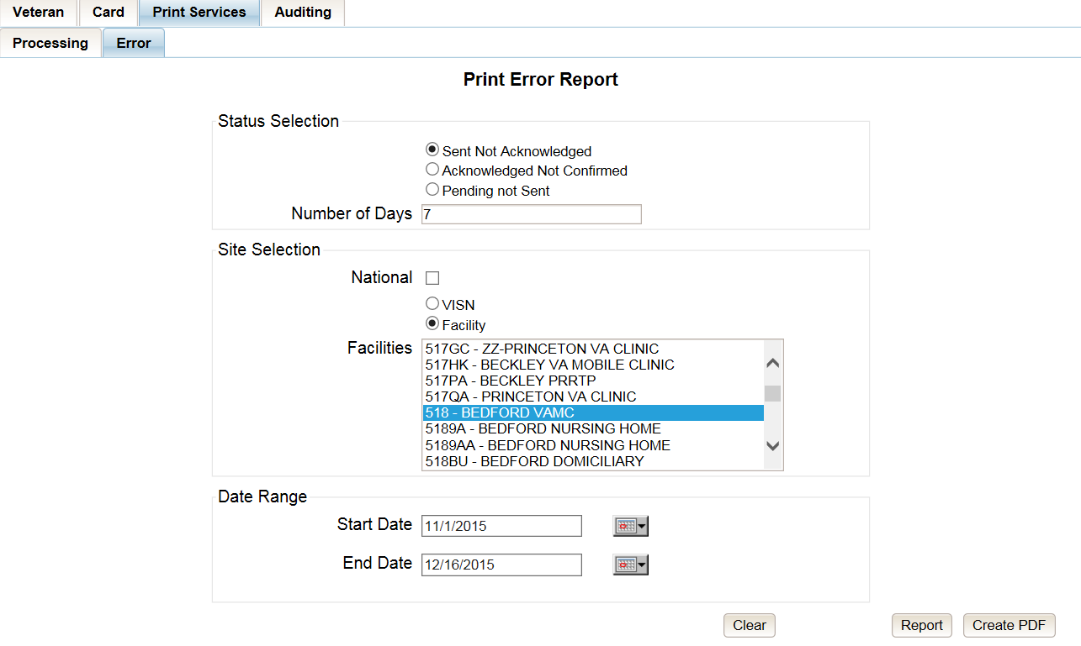

Figure ‑: VHIC Print Error Status Facility Summary Report – Sent Not Acknowledged

The National Error Summary report lists all of the VISNs and the VISN # is a hyperlink to the VISN Error Summary Report.

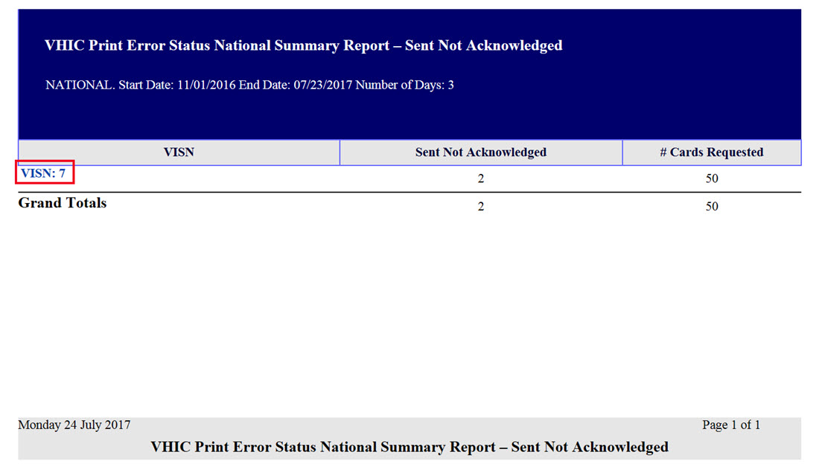

Figure ‑: VHIC Print Error Status National Summary Report – Sent Not Acknowledged

The VISN Error Summary Report lists all of the Facilities for the selected VISN. The Facility # is a hyperlink to the Facility Error Summary Report.

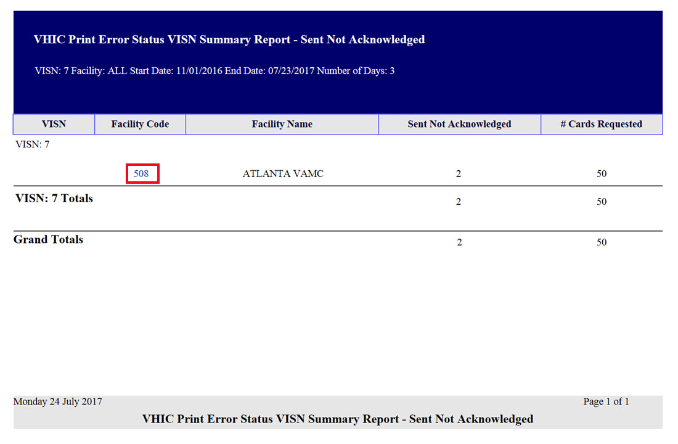

Figure ‑: VHIC Print Error Status VISN Summary Report – Sent Not Acknowledged

The Facility Error Summary report shows the totals for the selected Facility. The Facility # is a hyperlink to the Facility Error Detail Report.

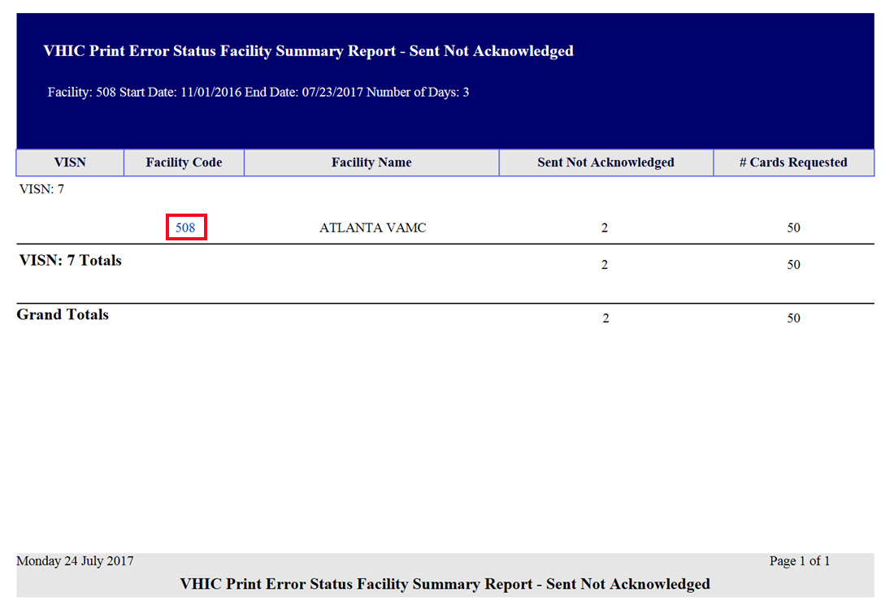

Figure ‑: VHIC Print Error Status Facility Summary Report – Sent Not Acknowledged

The Facility Error Detail Report would give a list of all of the cards that have NOT been Acknowled by the print vendor and will display the Veteran’s Name, Card ID, and the Card Request File name.

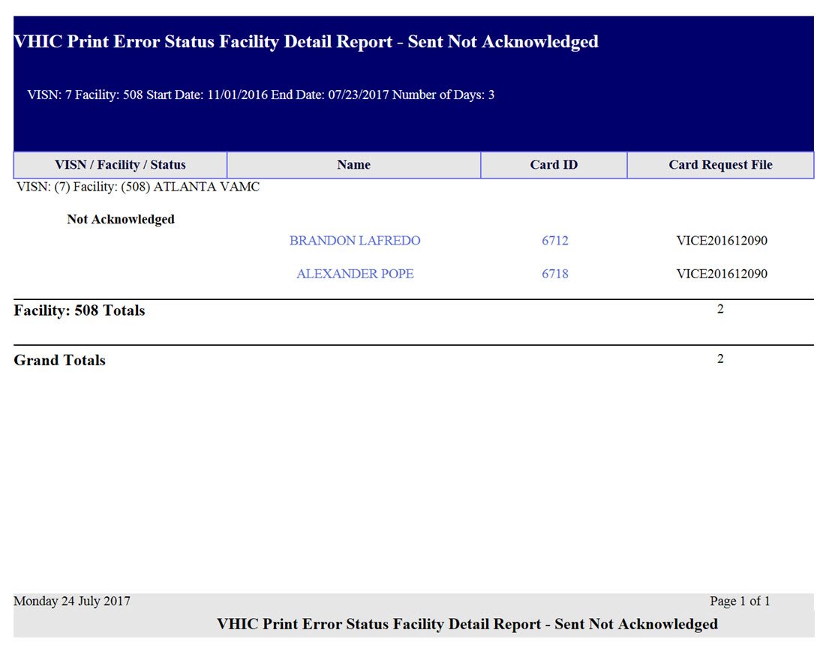

Figure ‑: VHIC Batch File Processing Error Status Detail Report - Not Acknowledged

### Acknowledged Not Confirmed

By selecting the Acknowledged Not Confirmed radio button, the VHIC user will be able to see how many cards have been acknowledged as received but have NOT been confirmed as mailed within the entered Number of Days (the default is seven (7) days) after receiving the acknowledgement file from the print vendor during the selected Date Range.

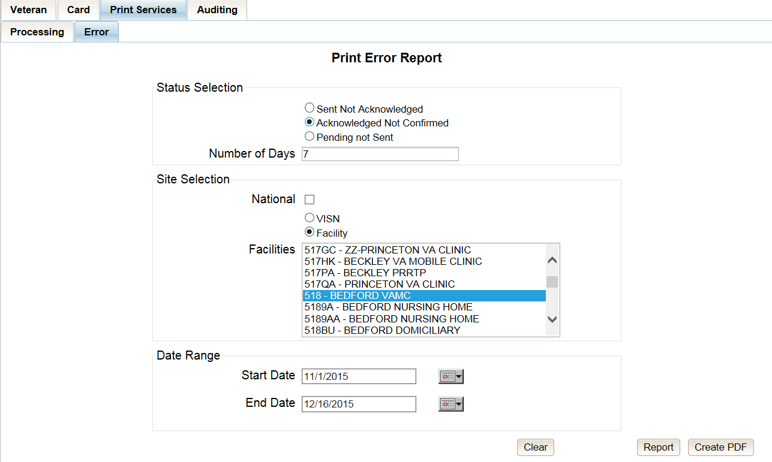

Figure ‑: VHIC Print Error Status Facility Detail Report – Acknowledged Not Confirmed

The National Error Summary report lists all of the VISNs and the VISN # is a hyperlink to the VISN Error Summary Report.

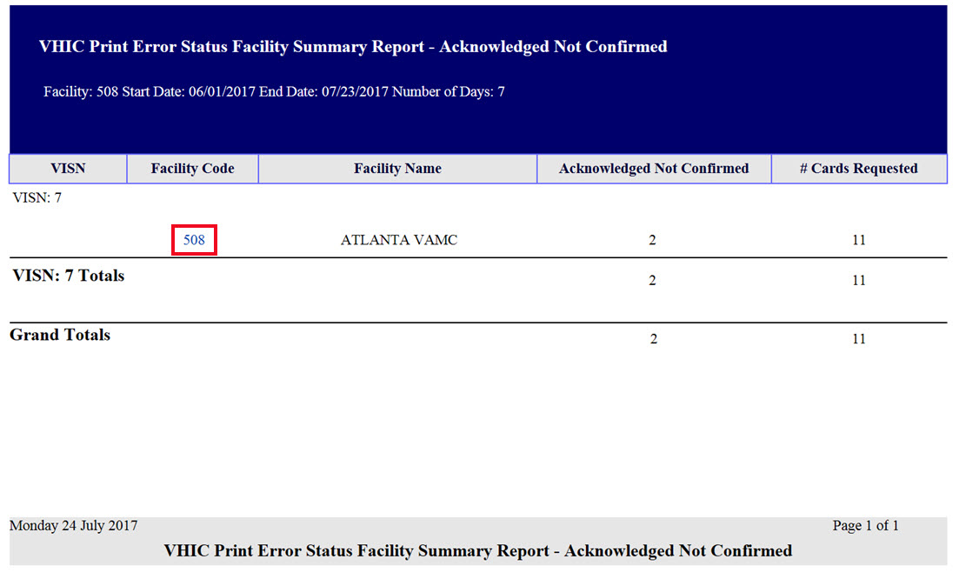

Figure ‑: VHIC Print Error Status National Summary Report – Acknowledged Not Confirmed

The VISN Error Summary Report lists all of the Facilities for the selected VISN. The Facility # is a hyperlink to the Facility Error Summary Report.

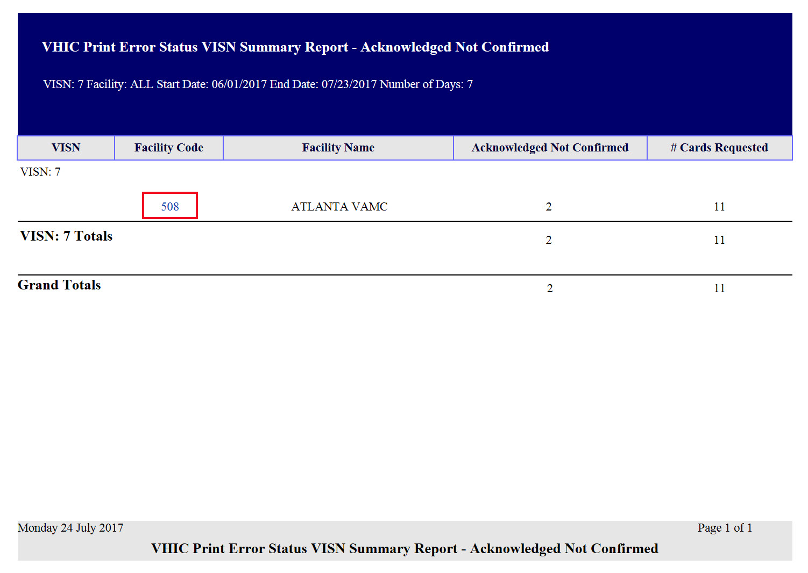

Figure ‑: VHIC Print Error Status VISN Summary Report – Acknowledged Not Confirmed

The Facility Error Summary report shows the totals for the selected Facility. The Facility # is a hyperlink to the Facility Error Detail Report.

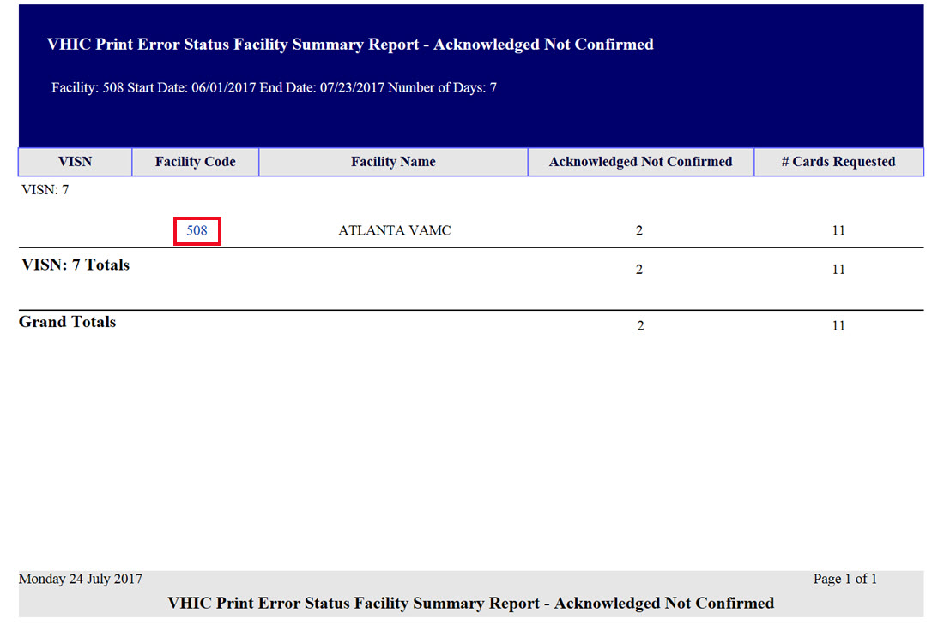

Figure ‑: VHIC Print Error Status Facility Detail Report – Acknowledged Not Confirmed

The Facility Error Detail Report would give a list of all of the cards that have NOT been confirmed as Mailed by the print vendor and will display the Veteran’s Name, Card ID, and the Acknowledgement File name.

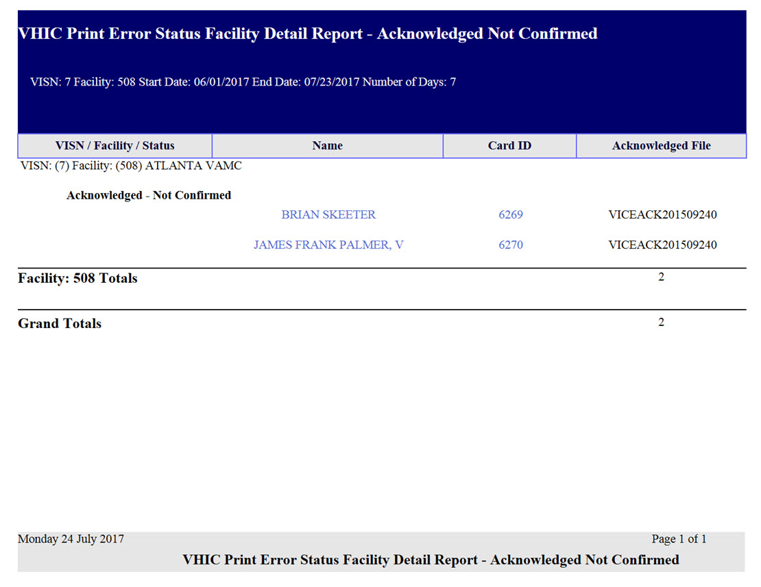

Figure ‑: VHIC Print Error Status Facility Detail Report – Acknowledged Not Confirmed

### Pending Not Sent

By selecting the Pending Not Sent radio button, the VHIC user will be able to see how many cards are sitting in the Pending Card Status state and have not been sent to the print vendor within the entered Number of Days (the default is three (3) days) after the card request has been submitted by the VHIC User within the selected Date Range.

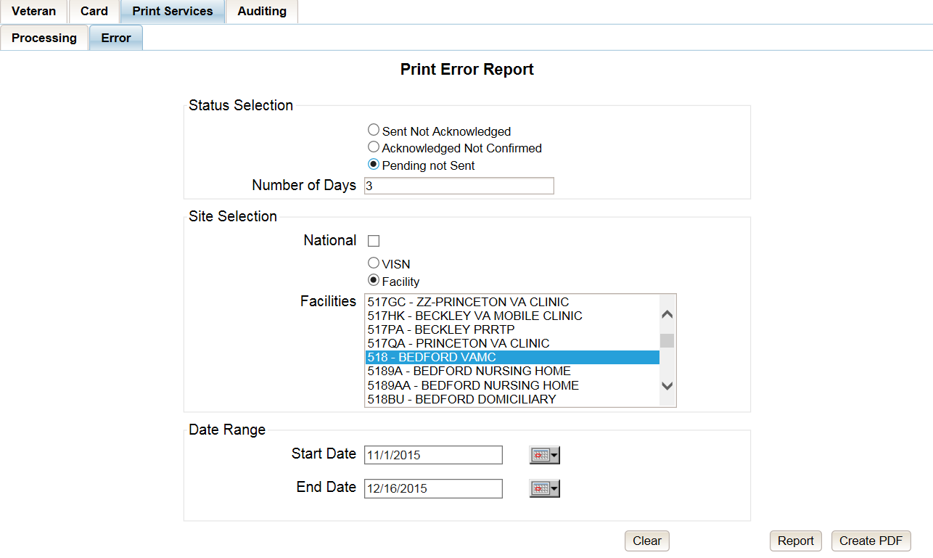

Figure ‑: VHIC Print Error Status National Summary Report – Pending Not Sent

The National Error Summary report lists all of the VISNs and the VISN # is a hyperlink to the VISN Error Summary Report.

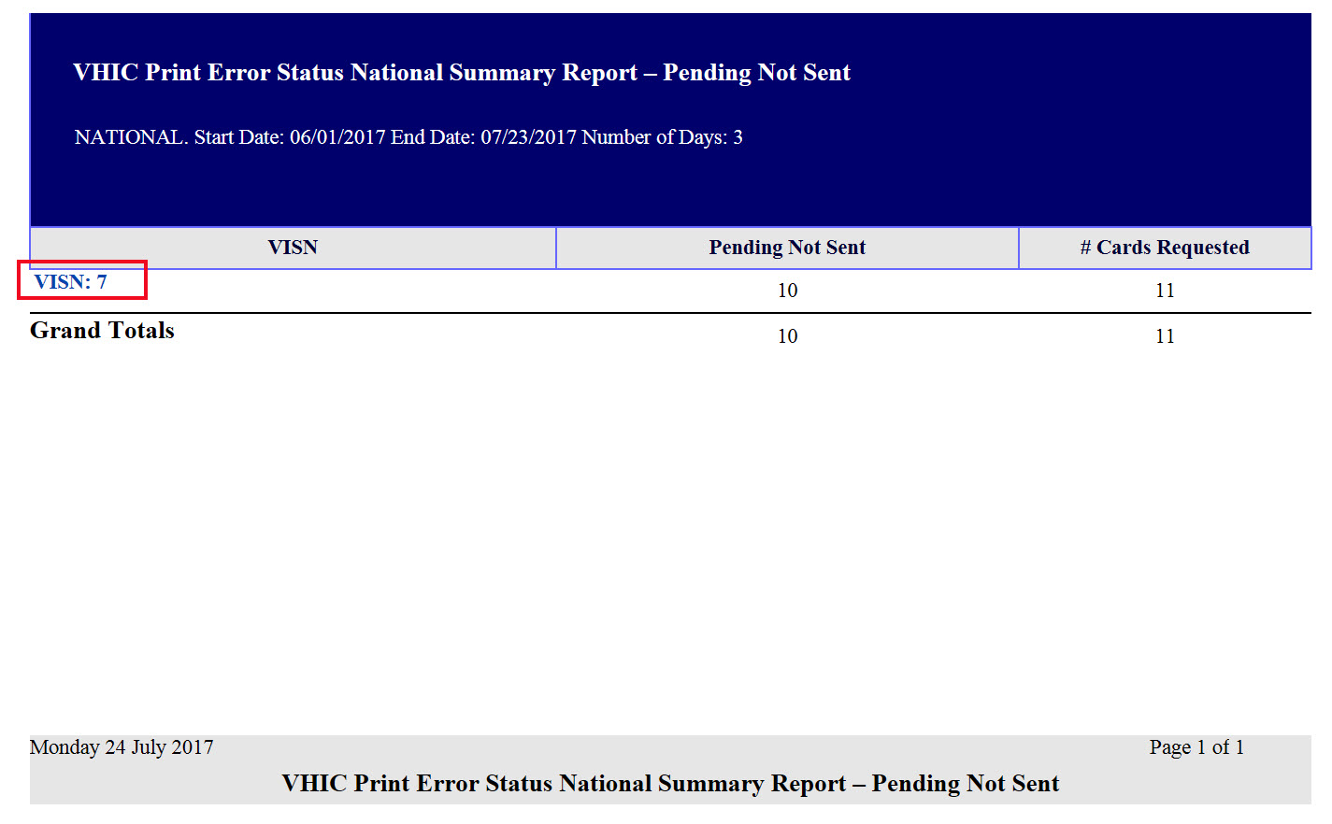

Figure ‑: VHIC Print Error Status National Summary Report – Pending Not Sent

The VISN Error Summary Report lists all of the Facilities for the selected VISN. The Facility # is a hyperlink to the Facility Error Summary Report.

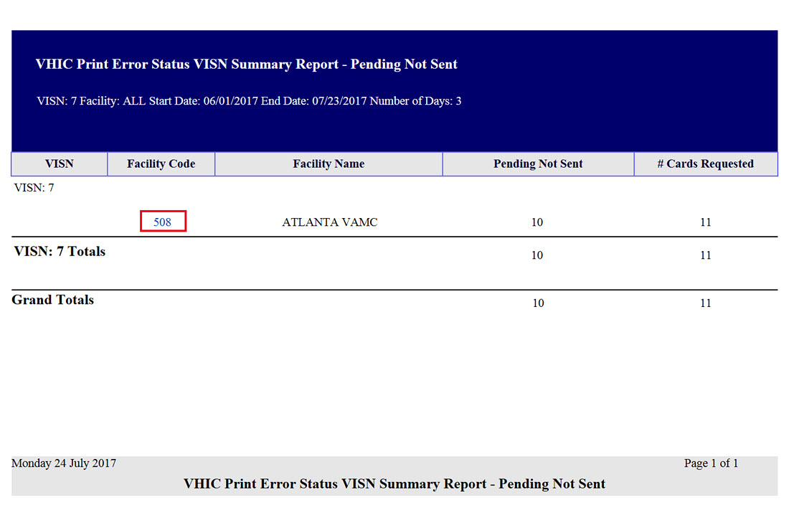

Figure ‑: VHIC Print Error Status VISN Summary Report – Pending Not Sent

The Facility Error Summary report shows the totals for the selected Facility. The Facility # is a hyperlink to the Facility Error Detail Report.

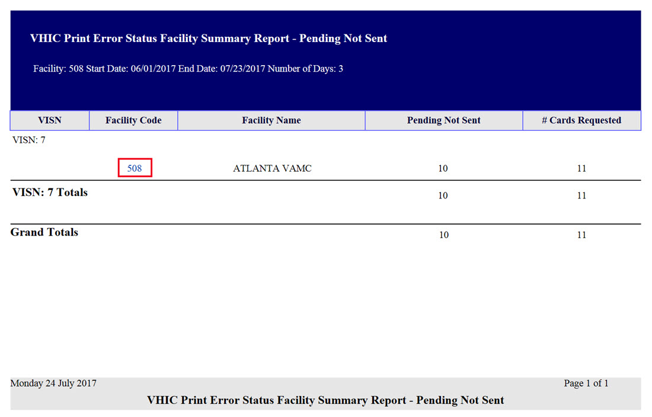

Figure ‑: VHIC Batch File Processing Error Status Summary Report – Facility

The Facility Error Detail Report gives a list of all of the cards that have NOT been sent to the print vendor will display the Veteran’s Name and Card ID.

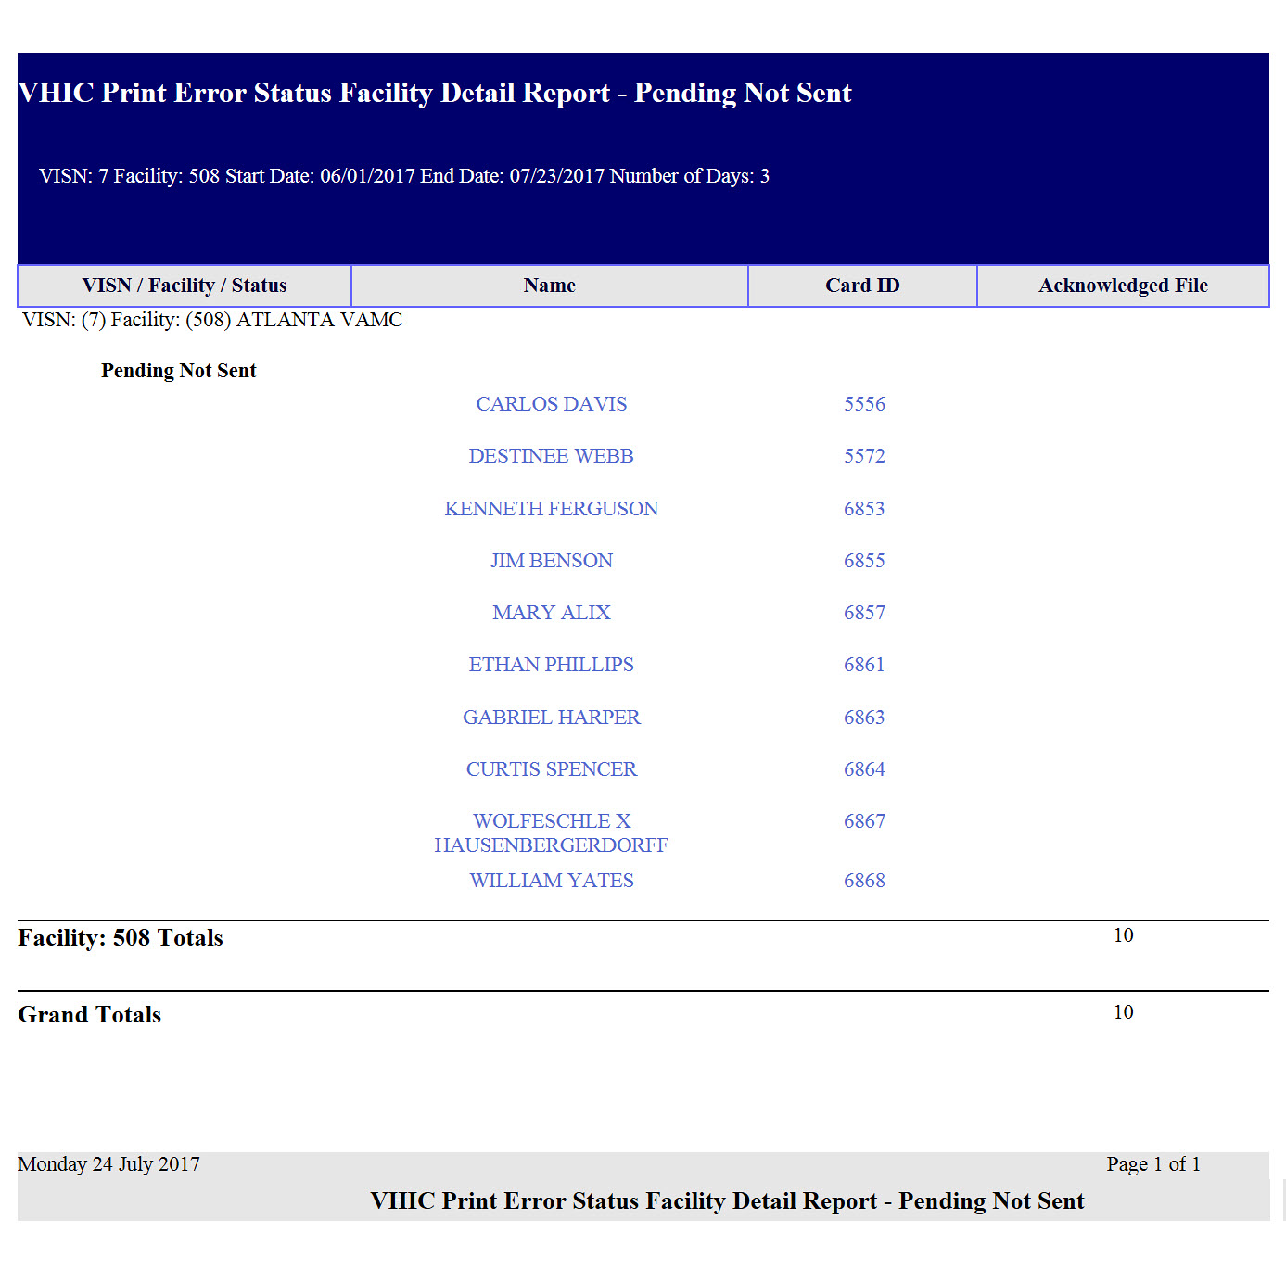

Figure ‑: VHIC Print Error Status Facility Detail Report – Pending Not Sent

## Auditing Report

Table 16: Audit Report at a Glance

| **At a Glance…** |  |
| --- | --- |
| Who can access this report? | *Administrator, Supervisor, Tech Admin (Tier 3), Auditor* |
| Who can access National version? | *N/A* |
| Date Range Allowed | *Admins, Tech Admin (Tier 3), Auditor – unlimited*  *Supervisor – one (1) year or less from date report is being run* |
| Search Criteria Available | *Login, Start Date, End Date* |

The *Auditing Report* provides a way to track all activity for individual users within the VHIC system. To run this report, the user must enter the login name/ID for the user being audited. The resulting report returns the following fields of information: Date/Time, Audit ID, Action, Person ID, Member ID, Card ID, and Query String. The query string shows all of the information that was entered into various fields and/or submitted by the associate page. Items in the audit report are listed in order of the Date/Time stamp.

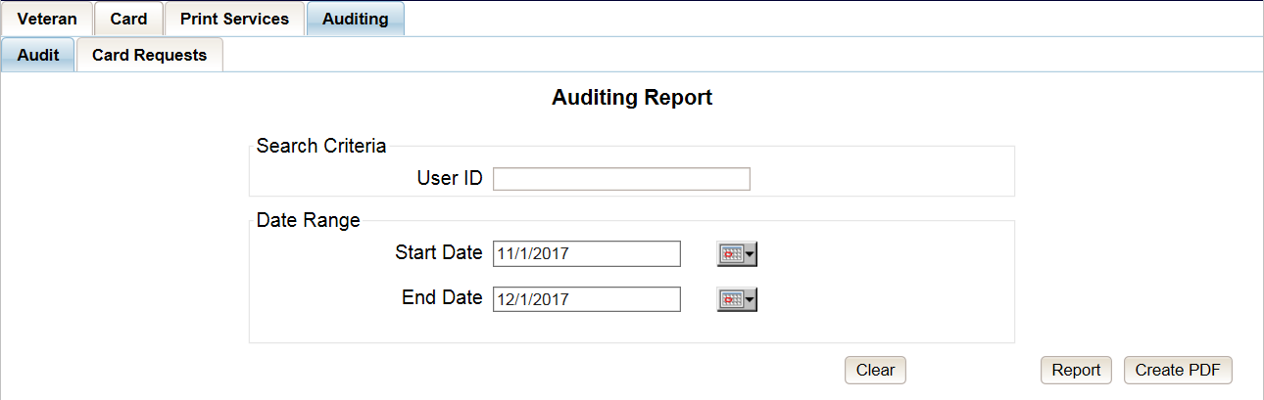

Figure ‑: Audit Report query screen – Administrators, Tech Administrators (Tier 3), and Auditors

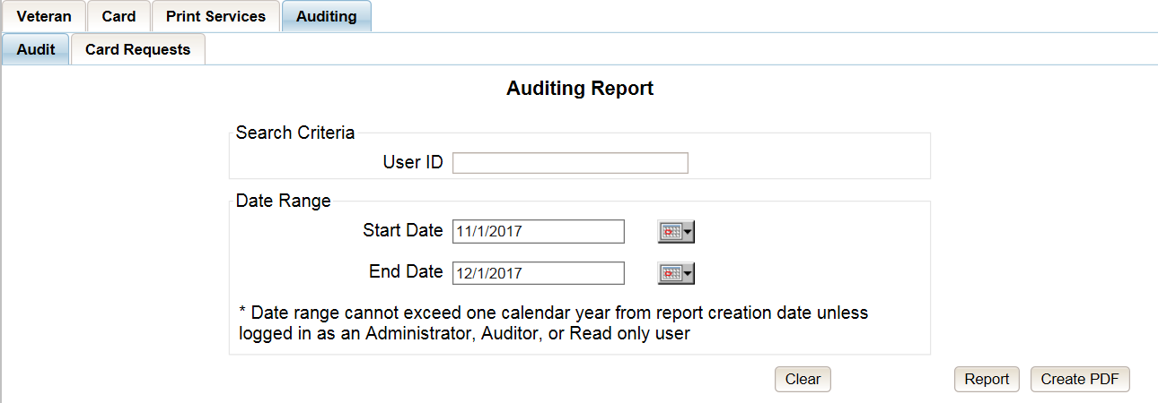

Figure ‑: Audit Report query screen – Supervisors

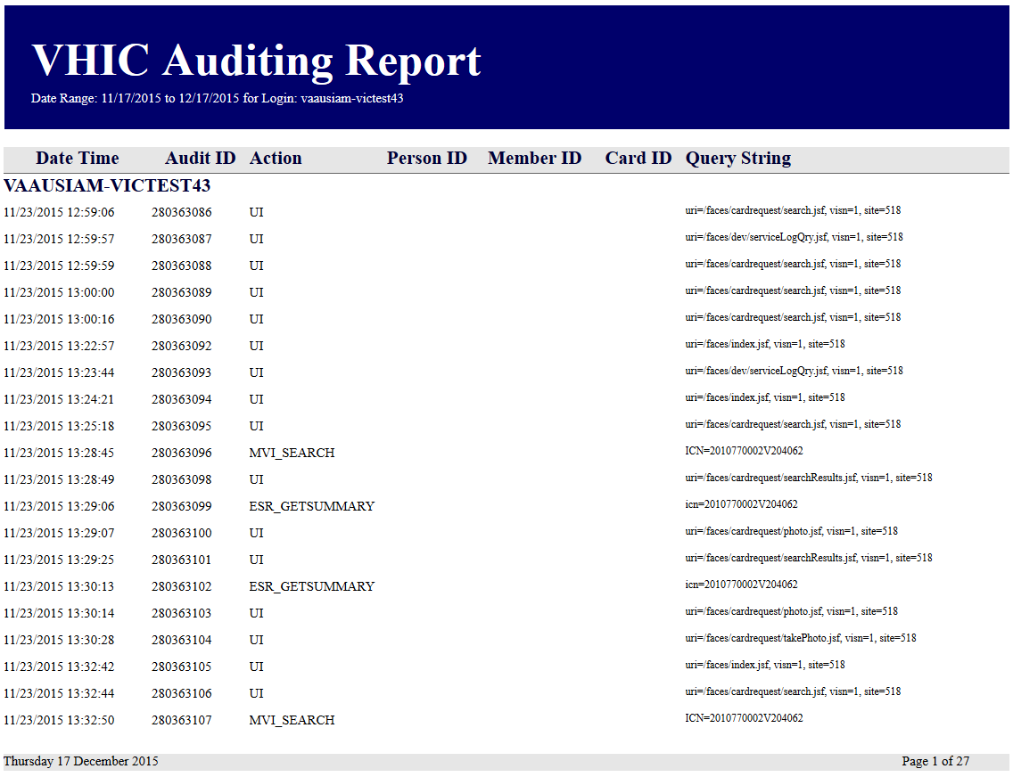

Figure ‑: VHIC Auditing Report

## Card Requests Report

Table 17: Card Request Report at a Glance

| **At a Glance…** |  |
| --- | --- |
| Who can access this report? | *Administrator, Supervisor, Tech Admin (Tier 3), Auditor* |
| Who can access National version? | *N/A* |
| Date Range Allowed | *Admins, Tech Admin (Tier 3) – unlimited*  *Supervisor – one (1) year or less from date report is being run* |
| Search Criteria Available | *Login, Start Date, End Date* |

The *Card Requests Report* provides the VHIC card requests by user for the selected VISN and/or Facility. Selecting either the VISN or the Facility radio button will update the list of available options accordingly (based on a user’s role). Selecting the National checkbox, if available, returns results for all VISNs and Facilities.

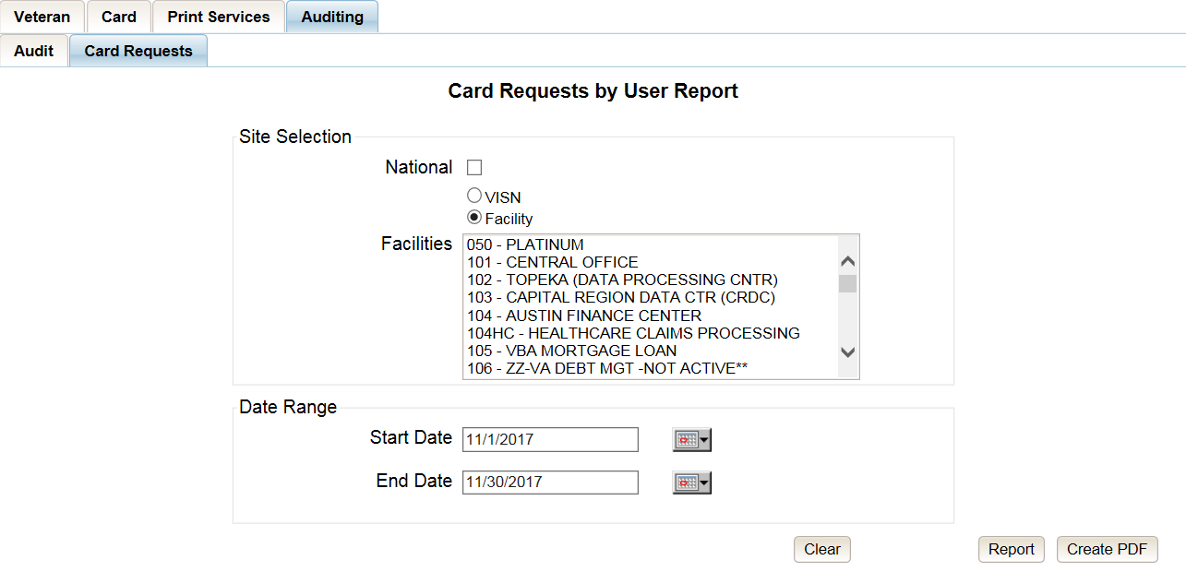

Figure ‑: Card Requests query screen – Administrators, Tech Administrators (Tier 3), and Auditors

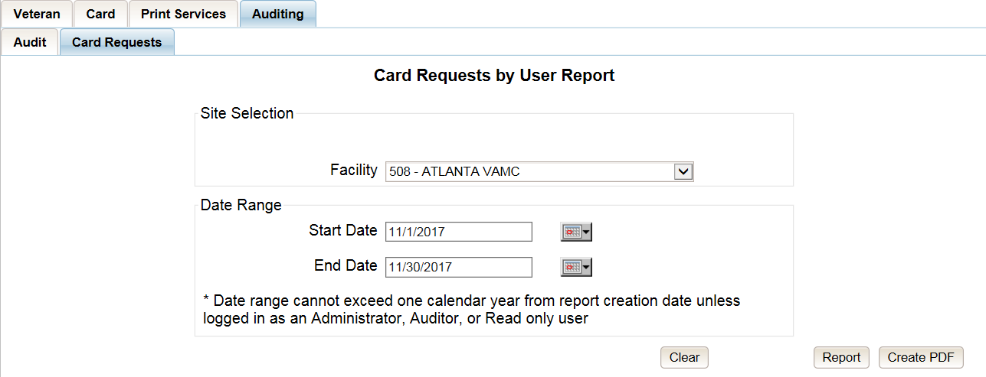

Figure ‑: Card Requests query screen – Supervisors

The Card Requests Report provides results by user. Each report contains links that open additional reports. The following example illustrates those reports using a Site Selection of “National.” This search returns data under the columns of VISN Name, VISN Number, and # of Card Requests. Click the VISN Number hyperlink to open the next report.

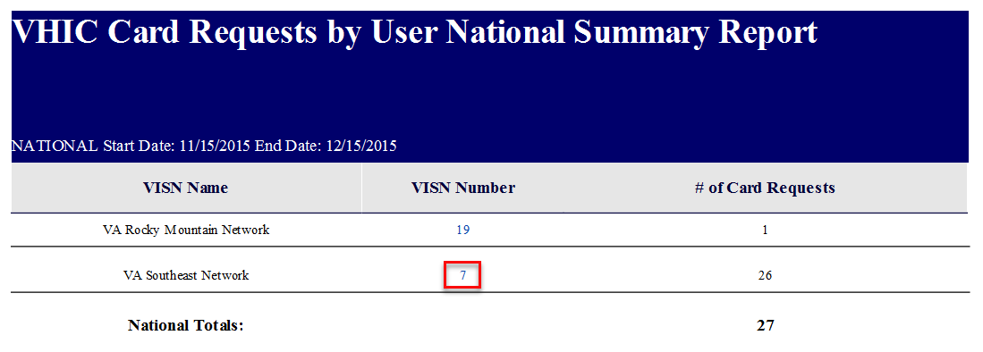

Figure ‑: VHIC Card Requests by User Summary Report – National

The VHIC Card Requests by User VISN Summary Report opens. This search returns data under the columns of Facility, Facility Number, and # of Card Requests. Click the Facility Number hyperlink to open the next report.

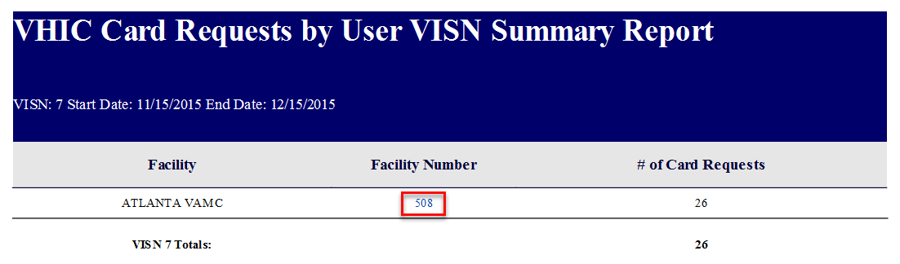

Figure ‑: VHIC Card Requests by User VISN Summary Report

The VHIC Card Requests by User Facility Summary Report opens. This search returns data under the columns of Facility Name, Facility Number, User ID, and 3 of Card Requests. Click the User ID hyperlink to open the next report.

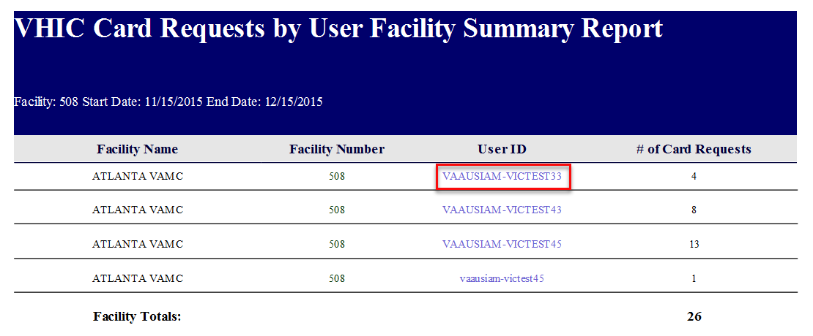

Figure ‑: VHIC Card Requests by User Facility Summary Report

The VHIC Card Requests by User Detail Report opens. This search returns data under the columns of Facility Name, Facility Number, User ID, Card Status, Last Name and Card ID. Both the Last Name column and the Card ID column offer hyperlinks to additional reports. Click the Last Name hyperlink to open the next report.

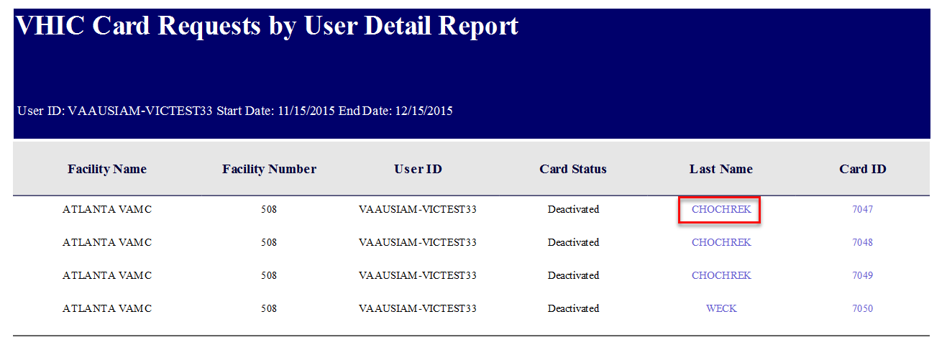

Figure ‑: VHIC Card Requests by User Detail Report – Last Name Hyperlink

The Veteran Detail Report opens. This search returns specific information relating to the last name clicked from the previous report.

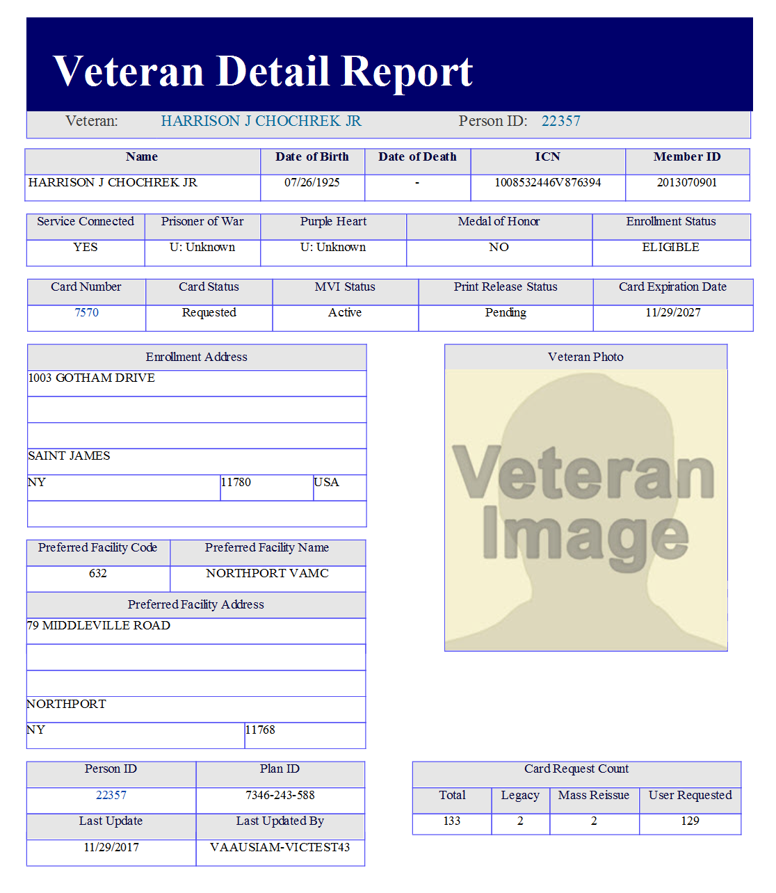

Figure ‑: Veteran Detail Report

The VHIC Card Requests by User Detail Report also contains a hyperlink for Card ID. Click the Card ID hyperlink to open the next report.

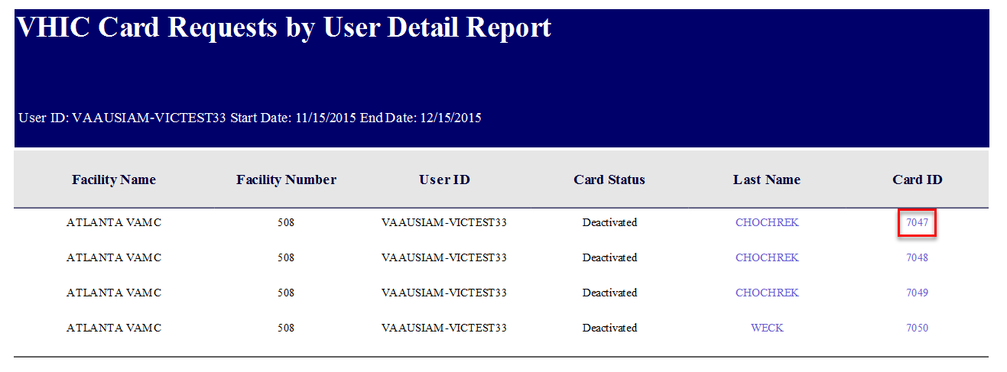

Figure ‑: VHIC Card Requests by User Detail Report – Card ID Hyperlink

The VHIC Card History by Card ID Report opens. This search returns specific information relating to the Card ID clicked from the previous report.

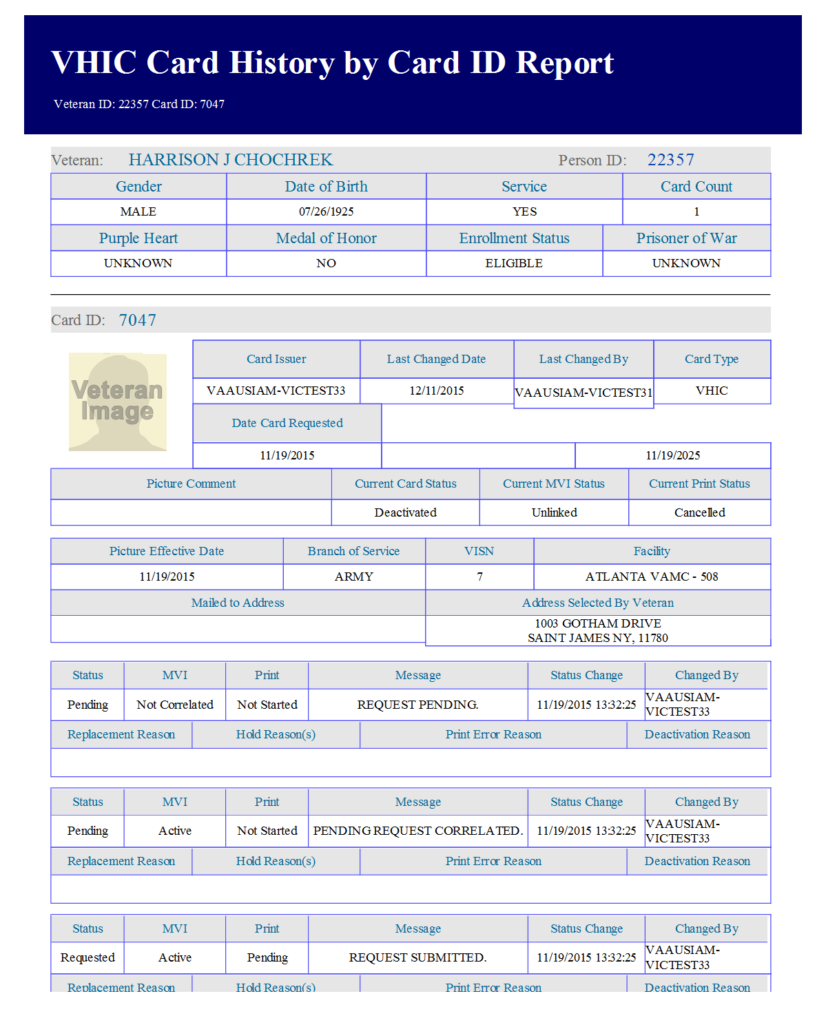

Figure ‑: VHIC Card History by Card ID Reportk

# Troubleshooting

For a through set of troubleshooting guidelines, please refer to the **Veteran Health Identification Card (VHIC 4.8) User Guide - Volume 4 - Troubleshooting** document.

# Appendix A: VHIC Roles

|  |  |  |  |  |  |  |  |  |  |  |  |  |  |
| --- | --- | --- | --- | --- | --- | --- | --- | --- | --- | --- | --- | --- | --- |
|  | | |  | |  | VHIC Role | | | | | | | |
| Function/Report Title | | | Navigation | | Selected Status from Drop Down Menu | Administrator | Technical Administrator Tier 3 | Supervisor | | Associate | | Auditor | Read-Only User |
| **CARD REQUESTS** | | | | | | | | | | | | | |
| Request Cards | | | (**Card Requests** icon on Home Screen/ **Card Requests** link in top Navigation Bar) | | N/A | X | X | X | | X | |  |  |
| Deactivate Cards | | | (**Card Management** icon on Home Screen/ **Card Management** link in top Navigation Bar) | | N/A | X | X |  | |  | |  |  |
| **REPORTS** | | | | | | | | | | | | | |
| **Veteran** (Direct Search) | | | (**Reports** icon on Home Screen/ **Reports** link in top Navigation Bar) | |  | | | | | | | | |
| Basic (*no national option*) | | | | | | | | | | | | | |
| Veteran Detail Report | | | Default view for Reports | | N/A | X | X | | X | | X | X | X |
| **Card Request Totals** | | | (**Card** menu tab - **Request Totals** sub-menu tab) | |  | | | | | | | | |
| *National* | | | | | | | | | | | | | |
| VHIC Card Request Totals | | | Click National Checkbox | | N/A | X | X | |  | |  | X |  |
| *VISN* | | | | | | | | | | | | | |
| VHIC Card Request Totals | | | Click VISN radio button | | N/A | X | X | |  | |  | X | X |
| *Facility* | | | | | | | | | | | | | |
| VHIC Card Request Totals | | | Click Facility ration button | | N/A | X | X | | X | | X | X | X |
| **Card Status - MVI Status Report** | | | (**Card** menu tab - **Status** sub-menu tab - **MVI Status** radio button) | |  | | | | | | | | |
| *National* | | | | | | | | | | | | | |
| VHIC MVI Status National Report | | | Click National Checkbox | | Active | X | X | |  | |  | X |  |
|  | | |  | | Not Correlated | X | X | |  | |  | X |  |
|  | | |  | | Rejected | X | X | |  | |  | X |  |
|  | | |  | | Unlinked | X | X | |  | |  | X |  |
| *VISN* | | | | | | | | | | | | | |
| VHIC MVI Status Summary Report | | | Click VISN radio button | | Active | X | X | |  | |  | X |  |
|  | | |  | | Not Correlated | X | X | |  | |  | X |  |
|  | | |  | | Rejected | X | X | |  | |  | X |  |
|  | | |  | | Unlinked | X | X | |  | |  | X |  |
| *Facility* | | | | | | | | | | | | | |
| VHIC MVI Status Summary Report | | | Click Facility ration button | | Active | X | X | | X | | X | X |  |
|  | | |  | | Not Correlated | X | X | | X | | X | X |  |
|  | | |  | | Rejected | X | X | | X | | X | X |  |
|  | | |  | | Unlinked | X | X | | X | | X | X |  |
| *Facility Detail* | | | | | | | | | | | | | |
| VHIC MVI Status Detail Report | | | Click on the Facility Number | | Active | X | X | | X | | X | X |  |
|  | | |  | | Not Correlated | X | X | | X | | X | X |  |
|  | | |  | | Rejected | X | X | | X | | X | X |  |
|  | | |  | | Unlinked | X | X | | X | | X | X |  |
|  | | |  | |  |  |  | |  | |  |  |  |
| **Card Status - Card Status Report** | | | (**Card** menu tab - **Status** sub-menu tab - **Card Status** radio button) | |  | | | | | | | | |
| *National* | | | | | | | | | | | | | |
| VHIC Card Status National Report | | | Click National Checkbox | | Replaced | X | X | |  | |  | X |  |
|  | | |  | | Deactivated | X | X | |  | |  | X |  |
|  | | |  | | Expired | X | X | |  | |  | X |  |
|  | | |  | | On Hold | X | X | |  | |  | X |  |
|  | | |  | | Pending | X | X | |  | |  | X |  |
|  | | |  | | Requested | X | X | |  | |  | X |  |
|  | | |  | | Defunct | X | X | |  | |  | X |  |
|  | | |  | | Pending Destruction | X | X | |  | |  | X |  |
|  | | |  | | Destroyed | X | X | |  | |  | X |  |
| *VISN* | | | | | | | | | | | | | |
| VHIC Card Status Summary Report | | | Click VISN radio button | | Replaced | X | X | |  | |  | X |  |
|  | | |  | | Deactivated | X | X | |  | |  | X |  |
|  | | |  | | Expired | X | X | |  | |  | X |  |
|  | | |  | | On Hold | X | X | |  | |  | X |  |
|  | | |  | | Pending | X | X | |  | |  | X |  |
|  | | |  | | Requested | X | X | |  | |  | X |  |
|  | | |  | | Defunct | X | X | |  | |  | X |  |
|  | | |  | | Pending Destruction | X | X | |  | |  | X |  |
|  | | |  | | Destroyed | X | X | |  | |  | X |  |
| *Facility* | | | | | | | | | | | | | |
| VHIC Card Status Summary Report | | | Click Facility ration button | | Replaced | X | X | | X | | X | X |  |
|  | | |  | | Deactivated | X | X | | X | | X | X |  |
|  | | |  | | Expired | X | X | | X | | X | X |  |
|  | | |  | | On Hold | X | X | | X | | X | X |  |
|  | | |  | | Pending | X | X | | X | | X | X |  |
|  | | |  | | Requested | X | X | | X | | X | X |  |
|  | | |  | | Defunct | X | X | | X | | X | X |  |
|  | | |  | | Pending Destruction | X | X | | X | | X | X |  |
|  | | |  | | Destroyed | X | X | | X | | X | X |  |
| *Facility Detail* | | | | | | | | | | | | | |
| VHIC Card Status Detail Report | | | Click on the Facility Number | | Replaced | X | X | | X | | X | X |  |
|  | | |  | | Deactivated | X | X | | X | | X | X |  |
|  | | |  | | Expired | X | X | | X | | X | X |  |
|  | | |  | | On Hold | X | X | | X | | X | X |  |
|  | | |  | | Pending | X | X | | X | | X | X |  |
|  | | |  | | Requested | X | X | | X | | X | X |  |
|  | | |  | | Defunct | X | X | | X | | X | X |  |
|  | | |  | | Pending Destruction | X | X | | X | | X | X |  |
|  | | |  | | Destroyed | X | X | | X | | X | X |  |
| **Card Status - Print Release Status Report** | | | (**Card** menu tab - **Status** sub-menu tab - **Print Status** radio button) | |  | | | | | | | | |
| *National* | | | | | | | | | | | | | |
| VHIC Print Status National Report | | | Click National Checkbox | | Cancelled | X | X | |  | |  | X |  |
|  | | |  | | Error | X | X | |  | |  | X |  |
|  | | |  | | Mailed | X | X | |  | |  | X |  |
|  | | |  | | Not Started | X | X | |  | |  | X |  |
|  | | |  | | Pending | X | X | |  | |  | X |  |
|  | | |  | | Received | X | X | |  | |  | X |  |
|  | | |  | | Rejected | X | X | |  | |  | X |  |
|  | | |  | | Sent | X | X | |  | |  | X |  |
| *VISN* | | | | | | | | | | | | | |
| VHIC Print Status Detail Report | | | Click VISN radio button | | Cancelled | X | X | |  | |  | X |  |
|  | | |  | | Error | X | X | |  | |  | X |  |
|  | | |  | | Mailed | X | X | |  | |  | X |  |
|  | | |  | | Not Started | X | X | |  | |  | X |  |
|  | | |  | | Pending | X | X | |  | |  | X |  |
|  | | |  | | Received | X | X | |  | |  | X |  |
|  | | |  | | Rejected | X | X | |  | |  | X |  |
|  | | |  | | Sent | X | X | |  | |  | X |  |
| *Facility* | | | | | | | | | | | | | |
| VHIC Print Status Detail Report | | | Click Facility ration button | | Cancelled | X | X | | X | | X | X |  |
|  | | |  | | Error | X | X | | X | | X | X |  |
|  | | |  | | Mailed | X | X | | X | | X | X |  |
|  | | |  | | Not Started | X | X | | X | | X | X |  |
|  | | |  | | Pending | X | X | | X | | X | X |  |
|  | | |  | | Received | X | X | | X | | X | X |  |
|  | | |  | | Rejected | X | X | | X | | X | X |  |
|  | | |  | | Sent | X | X | | X | | X | X |  |
| *Facility Detail* | | | | | | | | | | | | | |
| VHIC Print Status Detail Report | | | Click on the Facility Number | | Cancelled | X | X | | X | | X | X |  |
|  | | |  | | Error | X | X | | X | | X | X |  |
|  | | |  | | Mailed | X | X | | X | | X | X |  |
|  | | |  | | Not Started | X | X | | X | | X | X |  |
|  | | |  | | Pending | X | X | | X | | X | X |  |
|  | | |  | | Received | X | X | | X | | X | X |  |
|  | | |  | | Rejected | X | X | | X | | X | X |  |
|  | | |  | | Sent | X | X | | X | | X | X |  |
| **Card Request Progress** | | | (**Card** menu tab - **Request Progress** sub-menu tab) | |  | | | | | | | | |
| *National* | | | | | | | | | | | | | |
| VHIC Card Request Progress National Summary Report | | | Click National Checkbox | | N/A | X | X | |  | |  | X |  |
| *VISN* | | | | | | | | | | | | | |
| VHIC Card Request Progress VISN Summary Report | | | Click VISN radio button | | N/A | X | X | |  | |  | X |  |
| *Facility* | | | | | | | | | | | | | |
| VHIC Card Request Progress Facility Summary Report | | | Click Facility ration button | | N/A | X | X | | X | | X | X |  |
| *Facility Detail* | | | | | | | | | | | | | |
| VHIC Card Request Progress Facility Detail Report | | | Click on the Facility Number | | N/A | X | X | | X | | X | X |  |
| **Multiple Requests** | | | (**Card** menu tab - **Multiple Requests** sub-menu tab) | |  | | | | | | | | |
| **Cards Requested** |  | | (**Cards Requested** radio button) | |  |  |  | |  | |  |  |  |
| *National* | | | | | | | | | | | | | |
| VHIC Summary Report for Number of Cards Requested | | | Click National Checkbox | | N/A | X | X | |  | |  | X |  |
| *VISN* | | | | | | | | | | | | | |
| VHIC Summary Report for Number of Cards Requested | | | Click VISN radio button | | N/A | X | X | |  | |  | X |  |
| *Facility* | | | | | | | | | | | | | |
| VHIC Detailed Report for Number of Cards Requested | | | Click Facility ration button | | N/A | X | X | | X | | X | X |  |
| *Facility Detail* | | | | | | | | | | | | | |
| VHIC Facility Detail Report for Number of Cards Requested | | | Click on the Facility Number | | N/A | X | X | | X | | X | X |  |
| **Cards Mailed** |  | | (**Cards Mailed** radio button) | |  |  |  | |  | |  |  |  |
| *National* | | | | | | | | | | | | | |
| VHIC Summary Report for Number of Cards Requested | | | Click National Checkbox | | N/A | X | X | |  | |  | X |  |
| *VISN* | | | | | | | | | | | | | |
| VHIC Summary Report for Number of Cards Requested | | | Click VISN radio button | | N/A | X | X | |  | |  | X |  |
| *Facility* | | | | | | | | | | | | | |
| VHIC Detailed Report for Number of Cards Mailed | | | Click Facility ration button | | N/A | X | X | | X | | X | X |  |
| *Facility Detail* | | | | | | | | | | | | | |
| VHIC Facility Detail Report for Number of Cards Mailed | | | Click on the Facility Number | | N/A | X | X | | X | | X | X |  |
| **Card History** | | | (**Card** menu tab - **History** sub-menu tab) | |  | | | | | | | | |
| *Card ID* | | | | | | | | | | | | | |
| VHIC Card History | | | Enter Veteran's Card ID in the Card ID field | | N/A | X | X | | X | | X | X | X |
| *Person ID* | | | | | | | | | | | | | |
| VHIC Card History | | | Enter Veteran's Person ID in the Person ID field | | N/A | X | X | | X | | X | X | X |
| **Expiration** | | | (**Card** menu tab - **Expiration** sub-menu tab) | |  | | | | | | | | |
| *National* | | | | | | | | | | | | | |
| VHIC Card Expiration Summary Report | | | Click National Checkbox | | N/A | X | X | |  | |  | X |  |
| *VISN* | | | | | | | | | | | | | |
| VHIC Card Expiration Summary Report | | | Click VISN radio button | | N/A | X | X | |  | |  | X |  |
| *Facility* | | | | | | | | | | | | | |
| VHIC Card Expiration Site Report | | | Click Facility ration button | | N/A | X | X | | X | | X | X |  |
| *Facility Detail* | | | | | | | | | | | | | |
| VHIC Card Expiration Detail Report | | | Click on the Facility Number | | N/A | X | X | | X | | X | X |  |
| **Replacement** | | | (**Card** menu tab - **Replacement** sub-menu tab) | |  | | | | | | | | |
| *National* | | | | | | | | | | | | | |
| VHIC Card Replacement Summary Report | | | Click National Checkbox | | N/A | X | X | |  | |  | X |  |
| *VISN* | | | | | | | | | | | | | |
| VHIC Card Replacement Summary Report | | | Click VISN radio button | | N/A | X | X | |  | |  | X |  |
| *Facility* | | | | | | | | | | | | | |
| VHIC Card Replacement Facility Report | | | Click Facility ration button | | N/A | X | X | | X | | X | X |  |
| *Facility Sub-Reason Summary* | | | | | | | | | | | | | |
| VHIC Card Replacement Facility Subreason Report | | | Click # of Cards Replaced | | N/A | X | X | | X | | X | X |  |
| *Facility Sub-Reason Detail* | | | | | | | | | | | | | |
| VHIC Card Replacement Facility Subreason Detail | | | Click # of Cards Replaced | | N/A | X | X | | X | | X | X |  |
| **On Hold** | | | (**Card** menu tab - **On-Hold** sub-menu tab) | |  | | | | | | | | |
| *National* | | | | | | | | | | | | | |
| VHIC On Hold Card Status National Summary Report | | | Click National Checkbox | | Not Proofed | X | X | |  | |  | X |  |
|  | | |  | | Eligibility Pending | X | X | |  | |  | X |  |
|  | | |  | | Enrollment Services Unavailable | X | X | |  | |  | X |  |
|  | | |  | | Bad Data | X | X | |  | |  | X |  |
|  | | |  | | All | X | X | |  | |  | X |  |
| *VISN* | | | | | | | | | | | | | |
| VHIC On Hold Card Status VISN Summary Report | | | Click VISN radio button | | Not Proofed | X | X | |  | |  | X |  |
|  | | |  | | Eligibility Pending | X | X | |  | |  | X |  |
|  | | |  | | Enrollment Services Unavailable | X | X | |  | |  | X |  |
|  | | |  | | Bad Data | X | X | |  | |  | X |  |
|  | | |  | | All | X | X | |  | |  | X |  |
| *Facility* | | | | | | | | | | | | | |
| VHIC On Hold Card Status Facility Summary Report | | | Click Facility ration button | | Not Proofed | X | X | | X | | X | X |  |
|  | | |  | | Eligibility Pending | X | X | | X | | X | X |  |
|  | | |  | | Enrollment Services Unavailable | X | X | | X | | X | X |  |
|  | | |  | | Bad Data | X | X | | X | | X | X |  |
|  | | |  | | All | X | X | | X | | X | X |  |
| *Facility Detail* | | | | | | | | | | | | | |
| VHIC On Hold Card Status Facility Detail Report | | | Click on Facility # | | Not Proofed | X | X | | X | | X | X |  |
|  | | |  | | Eligibility Pending | X | X | | X | | X | X |  |
|  | | |  | | Enrollment Services Unavailable | X | X | | X | | X | X |  |
|  | | |  | | Bad Data | X | X | | X | | X | X |  |
|  | | |  | | All | X | X | | X | | X | X |  |
| **Card Destruction** | | | **(Card menu tab – Destruction sub-menu tab)** | |  | | | | | | | | |
| Pending Destruction | | | (Pending Destruction radio button) | |  |  |  | |  | |  |  |  |
| Basic (no national option) | | |  | |  |  |  | |  | |  |  |  |
| VHIC Card Destruction Report – Pending Destruction | | | Select Status and Date Range | | All | X | X | |  | |  | X |  |
|  | | |  | | Legacy | X | X | |  | |  | X |  |
|  | | |  | | Mass Reissuance | X | X | |  | |  | X |  |
|  | | |  | | VHIC | X | X | |  | |  | X |  |
| Destroyed | | | (Destroyed radio button) | |  |  |  | |  | |  |  |  |
| Basic (no national option) | | |  | |  |  |  | |  | |  |  |  |
| VHIC Card Destruction Report – Destroyed | | | Select Status and Date Range | | All | X | X | |  | |  | X |  |
|  | | |  | | Legacy | X | X | |  | |  | X |  |
|  | | |  | | Mass Reissuance | X | X | |  | |  | X |  |
|  | | |  | | VHIC | X | X | |  | |  | X |  |
| **Print Services Processing** | | | (**Print Services** menu tab - **Processing** sub-menu tab) | |  | | | | | | | | |
| *National* | | | | | | | | | | | | | |
| VHIC Batch File Processing Status National Report | | | Click National Checkbox | | N/A | X | X | |  | |  | X |  |
| *VISN* | | | | | | | | | | | | | |
| VHIC Batch File Processing Status Summary Report | | | Click VISN radio button | | N/A | X | X | |  | |  | X |  |
| *Facility* | | | | | | | | | | | | | |
| VHIC Batch File Processing Status Summary Report | | | Click Facility ration button | | N/A | X | X | | X | | X | X |  |
| *Facility Detail* | | | | | | | | | | | | | |
| VHIC Batch File Processing Status Detail Report | | | Click on the Facility Code | | N/A | X | X | | X | | X | X |  |
| **Print Error** | | | (**Print Services** menu tab - **Error** sub-menu tab) | |  | | | | | | | | |
| **Pending Not Sent** |  | | (**Pending Not Sent** radio button) | |  |  |  | |  | |  |  |  |
| *National* | | | | | | | | | | | | | |
| VHIC Batch File Processing Error Status Summary Report – National | | | Click National Checkbox | | N/A | X | X | |  | |  | X |  |
| *VISN* | | | | | | | | | | | | | |
| VHIC Batch File Processing Error Status Summary Report - VISN | | | Click VISN radio button | | N/A | X | X | |  | |  | X |  |
| *Facility* | | | | | | | | | | | | | |
| VHIC Batch File Processing Error Status Summary Report - Facility | | | Click Facility ration button | | N/A | X | X | | X | |  | X |  |
| *Facility Detail* | | | | | | | | | | | | | |
| VHIC Batch File Processing Error Detail Report - Pending Not Sent | | | Click on the Facility Number | | N/A | X | X | | X | |  | X |  |
| **Sent Not Acknowledged** | |  | | (**Sent Not Acknowledged** radio button) |  |  |  | |  | |  |  |  |
| *National* | | | | | | | | | | | | | |
| VHIC Batch File Processing Error Status Summary Report – National | | | Click National Checkbox | | N/A | X | X | |  | |  | X |  |
| *VISN* | | | | | | | | | | | | | |
| VHIC Batch File Processing Error Status Summary Report - VISN | | | Click VISN radio button | | N/A | X | X | |  | |  | X |  |
| *Facility* | | | | | | | | | | | | | |
| VHIC Batch File Processing Error Status Summary Report - Facility | | | Click Facility ration button | | N/A | X | X | | X | |  | X |  |
| *Facility Detail* | | | | | | | | | | | | | |
| VHIC Batch File Processing Error Detail Report - Not Acknowledged | | | Click on the Facility Number | | N/A | X | X | | X | |  | X |  |
| **Acknowledged Not Confirmed** | | | (**Acknowledged Not Confirmed** radio button) | |  |  |  | |  | |  |  |  |
| *National* | | | | | | | | | | | | | |
| VHIC Batch File Processing Error Status Summary Report – National | | | Click National Checkbox | | N/A | X | X | |  | |  | X |  |
| *VISN* | | | | | | | | | | | | | |
| VHIC Batch File Processing Error Status Summary Report - VISN | | | Click VISN radio button | | N/A | X | X | |  | |  | X |  |
| *Facility* | | | | | | | | | | | | | |
| VHIC Batch File Processing Error Status Summary Report - Facility | | | Click Facility ration button | | N/A | X | X | | X | |  | X |  |
| *Facility Detail* | | | | | | | | | | | | | |
| VHIC Batch File Processing Error Detail Report - Acknowledged Not Confirmed | | | Click on the Facility Number | | N/A | X | X | | X | |  | X |  |
| **Cards printed without Member ID** | | | (**Print Services** menu tab - **No Member ID** sub-menu tab) | |  | | | | | | | | |
| *National* | | | | | | | | | | | | | |
| VHIC Cards Printed Without Member ID Report | | | Click National Checkbox | | N/A | X | X | |  | |  | X |  |
| *VISN* | | | | | | | | | | | | | |
| VHIC Cards Printed Without Member ID Report | | | Click VISN radio button | | N/A | X | X | |  | |  | X |  |
| *Facility* | | | | | | | | | | | | | |
| VHIC Cards Printed Without Member ID Report | | | Click Facility ration button | | N/A | X | X | | X | | X | X |  |
| Auditing |  | | (**Auditing** menu tab) | |  | | | | | | | | |
| *Basic (no national option)* | | | | | | | | | | | | | |
| VHIC Auditing Report | | | Default view for Auditing menu tab | | N/A | X | X | | X | |  | X |  |
| **Card Requests by User** | | | **(Auditing menu tab –** **Card Requests sub-menu tab)** | |  | | | | | | | | |
| **Card Requests by User** | | |  | |  |  |  | |  | |  |  |  |
| *National* | | | | | | | | | | | | | |
| VHIC Card Requests by User National Summary Report | | | Click National Checkbox | | N/A | X | X | |  | |  | X |  |
| *VISN* | | | | | | | | | | | | | |
| VHIC Card Requests by User VISN Summary Report | | | Click VISN radio button | | N/A | X | X | |  | |  | X |  |
| *Facility* | | | | | | | | | | | | | |
| VHIC Card Requests by User Facility Summary Report | | | Click Facility ration button | | N/A | X | X | | X | |  | X |  |
| *User Detail* | | | | | | | | | | | | | |
| VHIC Card Requests by User Detail Report | | | Click on the User ID | | N/A | X | X | | X | |  | X |  |

Template Revision History

| Date | Version | Description | Author |
| --- | --- | --- | --- |
| December 2015 | 1.6 | Updated to align with current OI&T Documentation Standards, edited to conform with latest Section 508 guidelines, and remediated with Common Look Office tool | Process Management |
| June 2015 | 1.5 | Edited to conform with Section 508 guidelines and remediated with Common Look Office tool | Process Management |
| May 2015 | 1.4 | Reviewed and approved by PMAS Process Improvement Lockdown. Updated instructional test. | Process Management |
| November 2014 | 1.3 | Updated to conform with latest Section 508 guidelines and remediated with Common Look Office tool | Process Management |
| April 2014 | 1.2 | Changed title page to clarify that version number refers to software version | Process Management |
| April 2011 | 1.1 | Formatted to current ProPath documentation standards and edited to conform with latest Alternative Text (Section 508) guidelines | Process Management |
| June 2009 | 1.0 | Initial Version | PMAS Business Office |